University of Seville  
 School of Computer Engineering

**Performance Report**



Software engineering  
Design and testing 2

2018 – 2019

04/21/2019

Group 26

**Index**

1. Observations 4

2. Package 4

Create 4

Edit LUIS 5

Delete 7

Conclusion 8

3. Evaluation 9

Create 9

Delete 11

Conclusion 12

4. TODO DE AQUI PABAJO SE BORRA 13

5. Position 13

Create 13

Edit 15

Delete 17

Conclusion 19

6. Mess 20

Search by tags, list by that tag and display a mess 20

Send a message 21

Delete a message 23

Send a broadcast mess 25

Conclusion 26

7. Dashboard 27

Display the dashboard and set the spammers 27

Conclusion 28

8. Configuration 29

Display the configuration and edit it 29

Conclusion 31

9. Problem 31

Create 31

Edit 33

Delete 35

Conclusion 37

10. Finder 37

Search and clear 37

Conclusion 39

11. Curricula 39

Create a curriculum 39

Delete a curriculum 41

12. Datas (Personal, Education, Position and Miscellaneous data) 43

Create all datas 43

Edit a position data 45

Edit a education data 47

Edit a miscellaneous data 49

Delete a position data 50

Delete a education data 52

Delete a miscellaneous data 54

Conclusion 56

13. Social profile 56

Create 56

Edit 58

Delete 61

Conclusion 62

14. Actor 63

Create 63

Edit 65

Delete 67

Conclusion 69

15. Application 69

Create 69

Edit 71

Delete 73

Conclusion 75

16. Audit 75

Assign 75

Create 77

Edit 80

Delete 82

Conclusion 84

17. Sponsorship 85

Create 85

Edit 87

Delete 89

Conclusion 90

18. Item 91

Create 91

Edit 93

Delete 95

Conclusion 96

19. Conclusion of the performance 97

# Observations

We have considered that our performance tests were valid as long as they were lasting between 2’5 and 3 seconds and no error was showed.

# Package

## Create

Sequence:

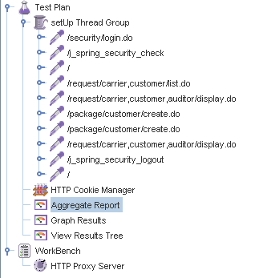

Aggregate Report:

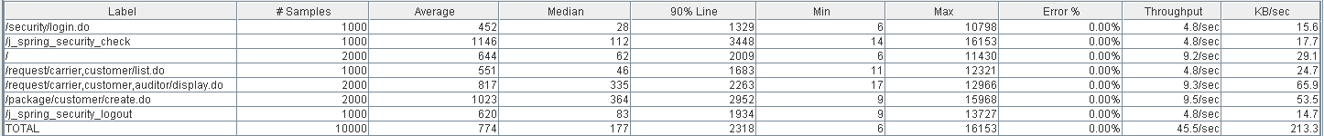



Thread properties:

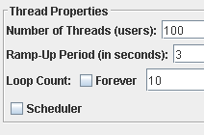

Graph Results:

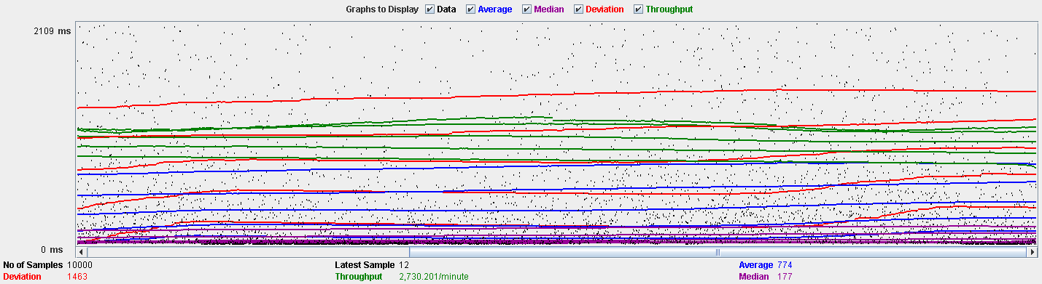

Performance Results:

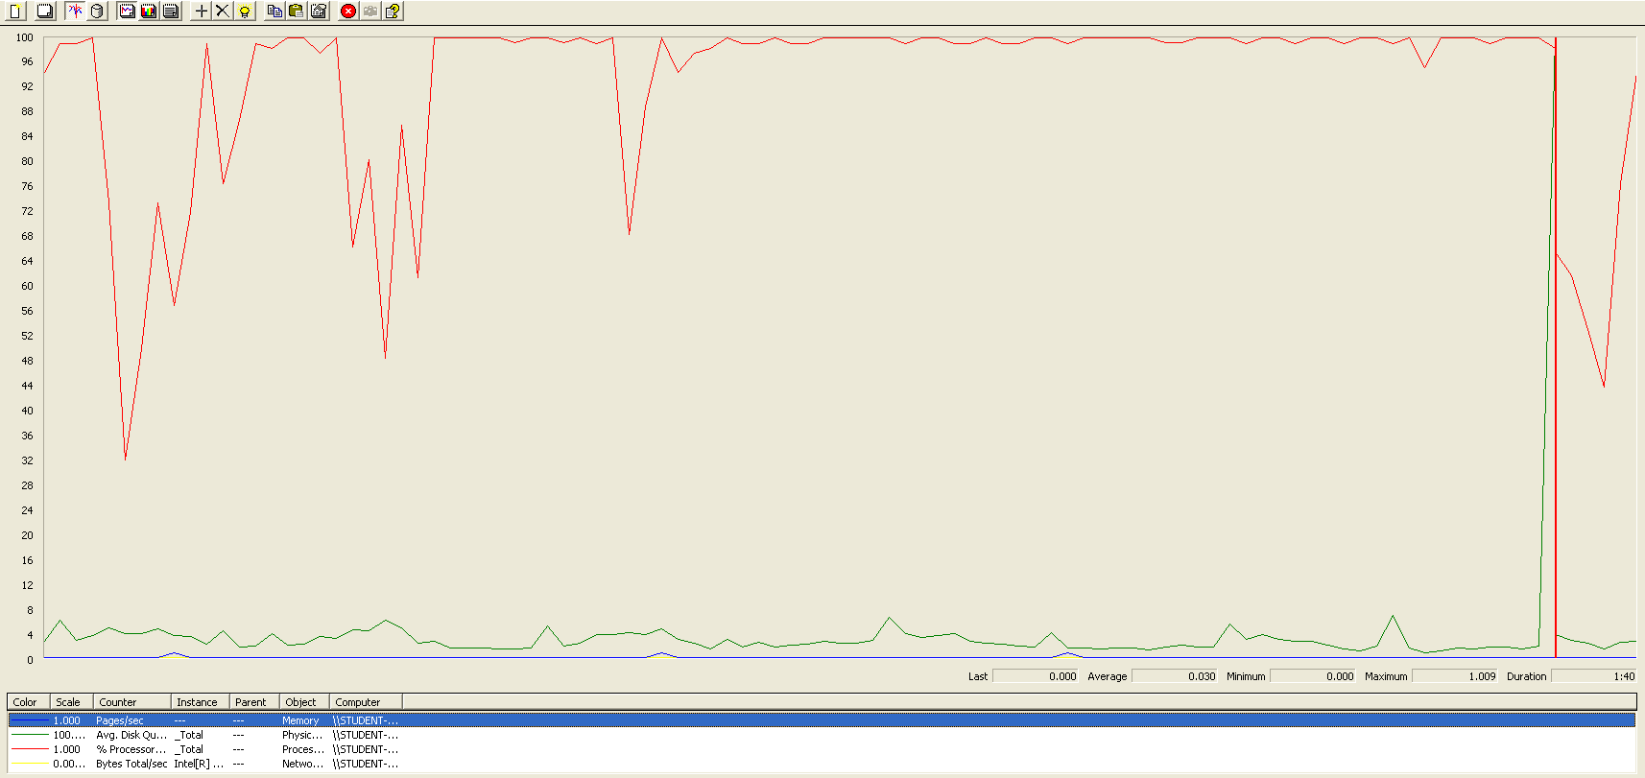

The CPU is always being used while the disk usage is barely noticeable..

## Edit LUIS

Sequence:

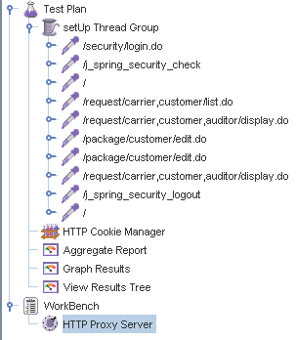

Aggregate Report:

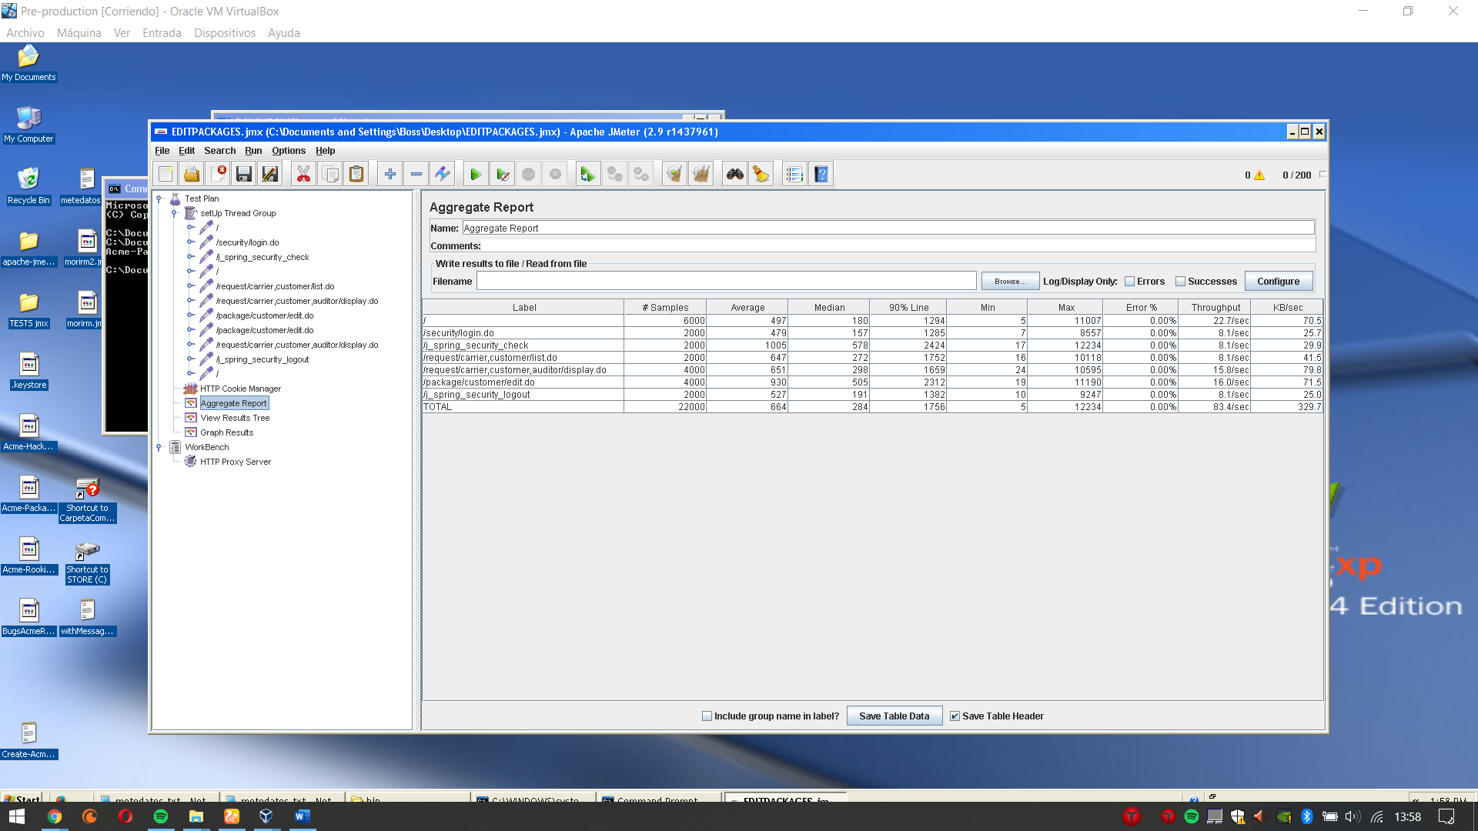

Thread properties:

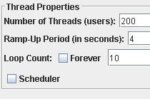

Graph Results:

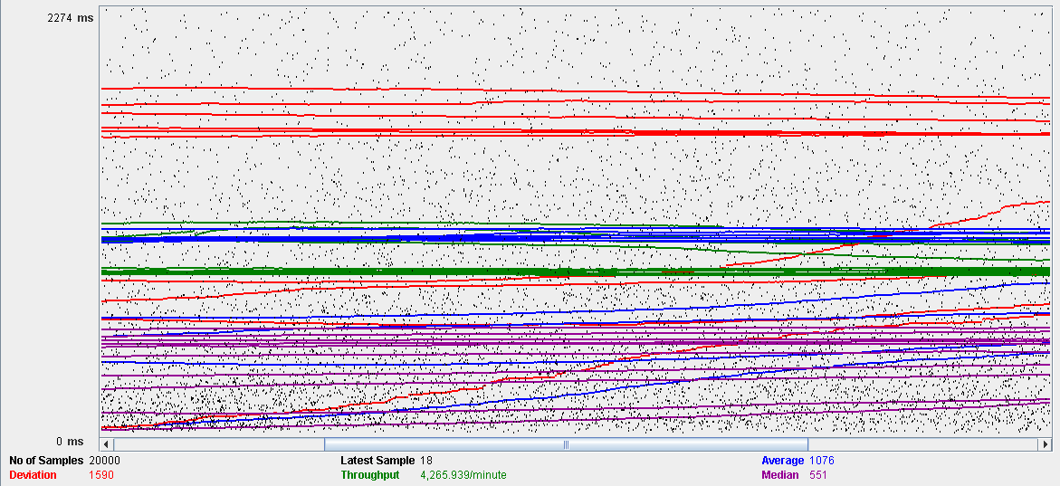

Performance Results:

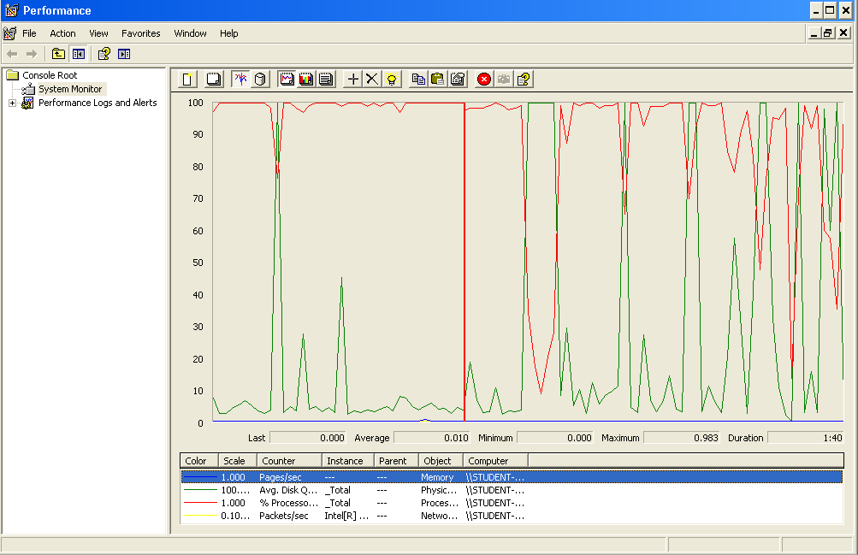

Again we can see that the CPU is always being used while the disk usage shows some periodic peaks.

## Delete

Sequence:

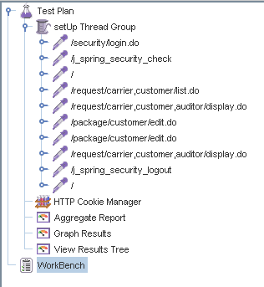

Aggregate Report:

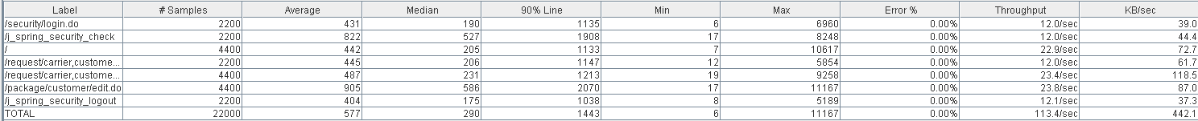



Thread properties:

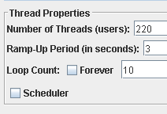.

Graph Results:

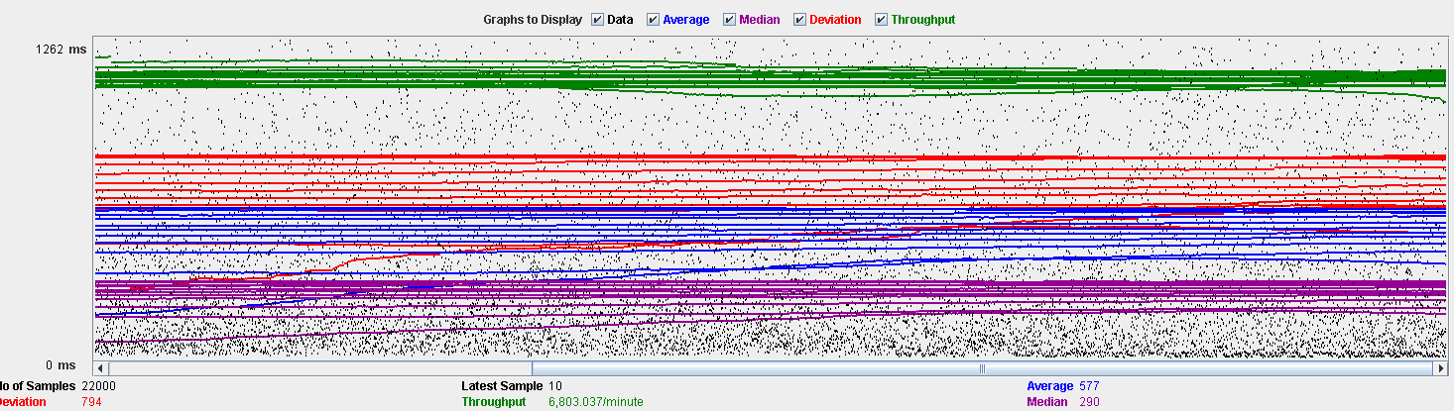

Performance Results:

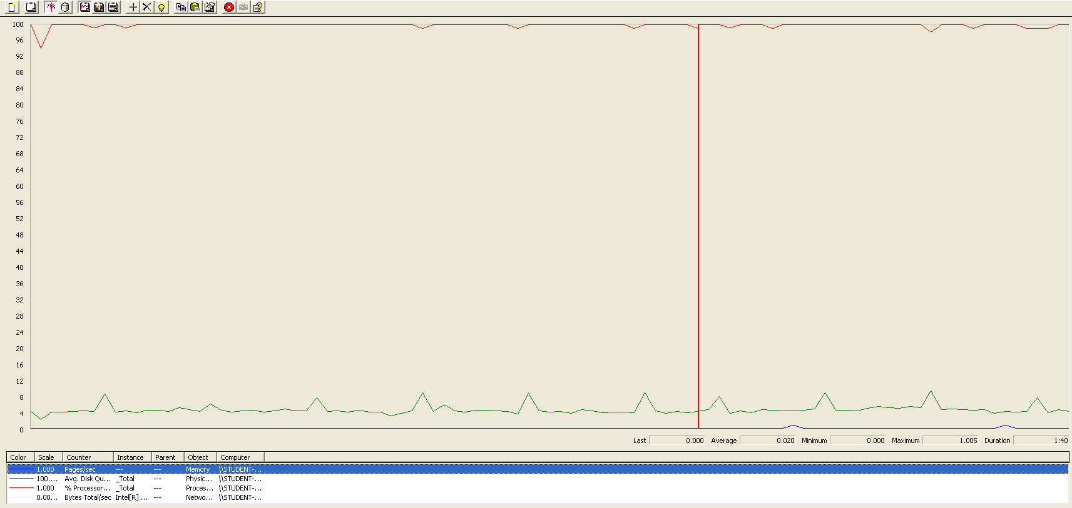

Again we can see that the CPU is always being used while the disk usage shows some peaks. The times are a little bit lower in order to avoid errors.

## Conclusion

The test was performed using:

CPU: i7 6700hq (2 cores in the virtual machine)

RAM: 4 GB (virtual machine)

For this use case we can say that the limitation occurs during the creation process, being the maximum of concurrent users 100. The times during the delete process did not reach the 3 seconds mark in order to avoid errors.

# Evaluation

## Create

Sequence:

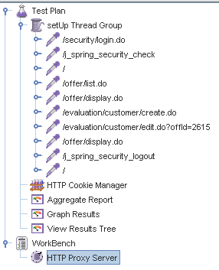

Aggregate Report:

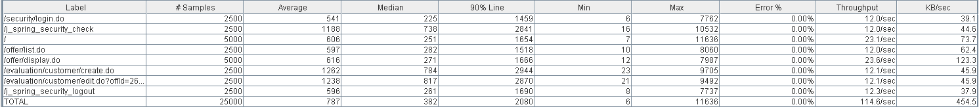



Thread properties:

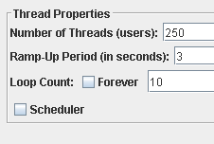

Graph Results:

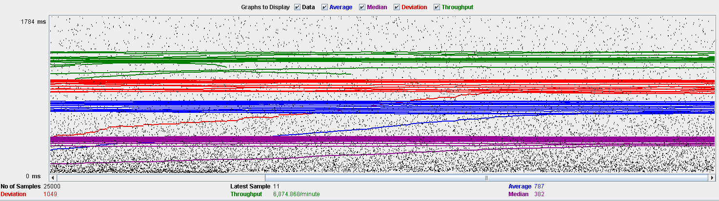

Performance Results:

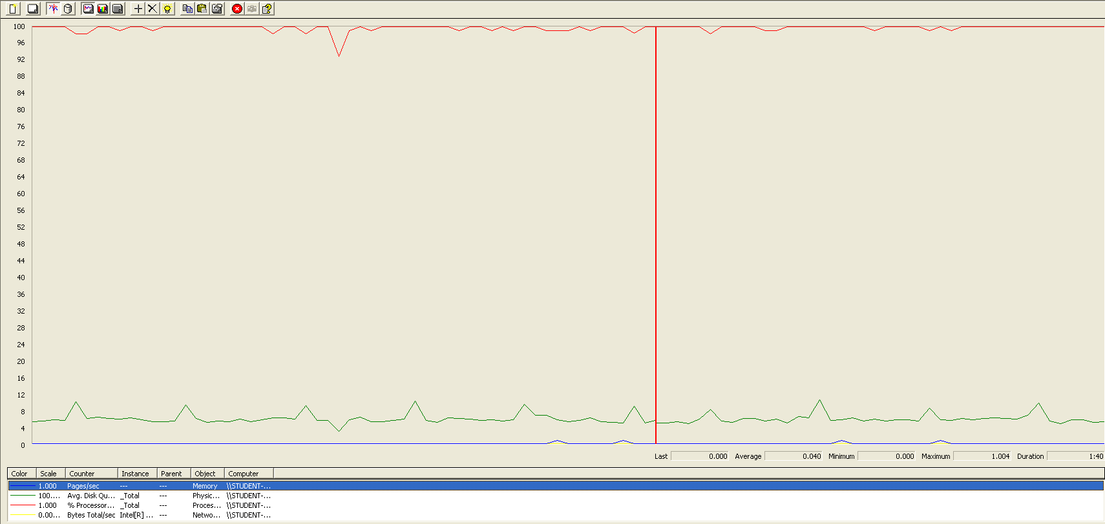

The CPU is always being used while the disk usage is barely noticeable.

## Delete

Sequence:

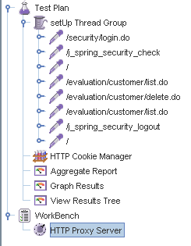

Aggregate Report:





Thread properties:

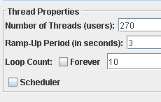

Graph Results:

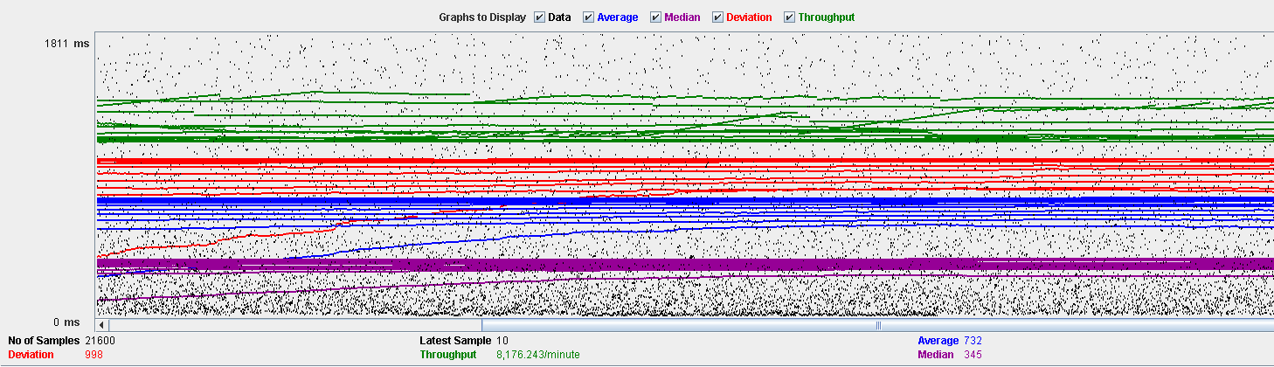

Performance Results:

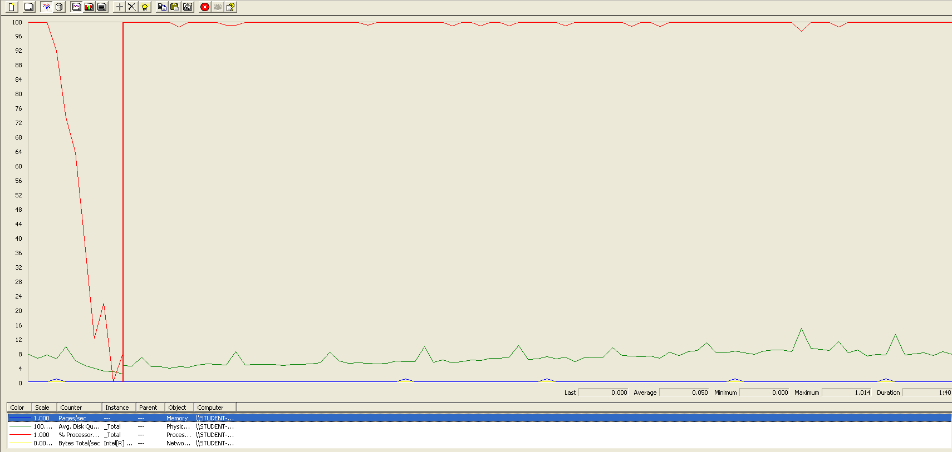

The CPU is always being used while the disk usage is barely noticeable.

## Conclusion

The test was performed using:

CPU: i7 7700hq (2 cores in the virtual machine)

RAM: 4 GB (virtual machine)

For this use case we can say that the limitation occurs during the creation process, being the maximum of concurrent users 250.

# Message

## Send

Sequence:

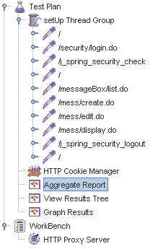

Aggregate Report:

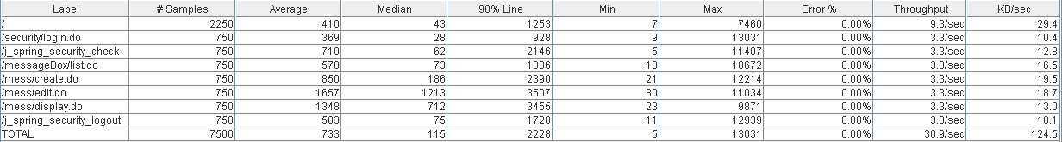

Thread properties:

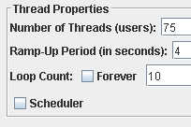

Graph Results:

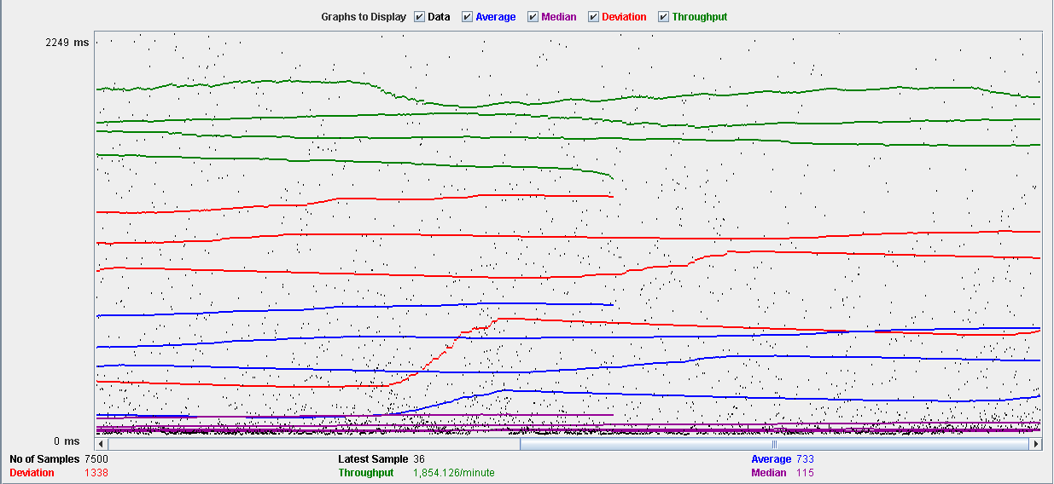

Performance Results:

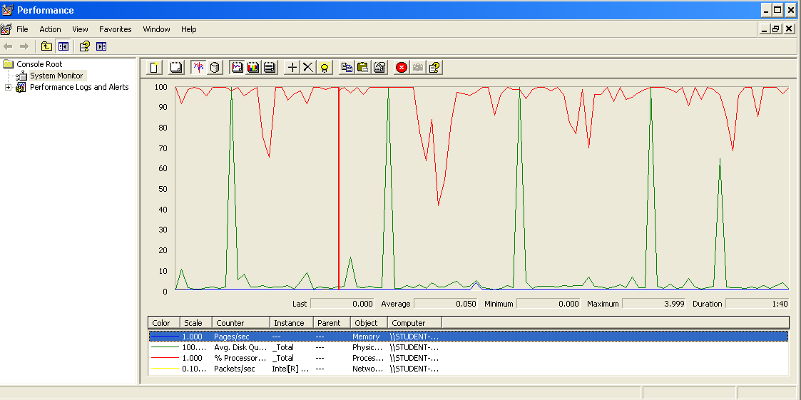

The CPU is always being used and some picks of physical disk.

## Move

Sequence:

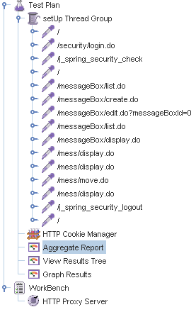

Aggregate Report:

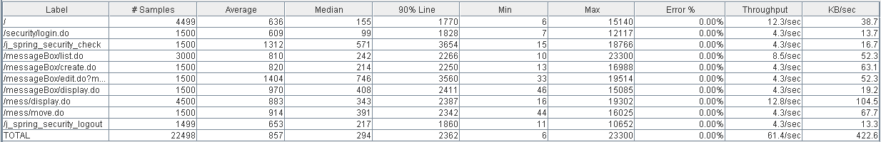

Thread properties:

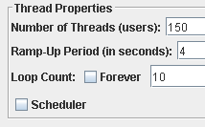

Graph Results:

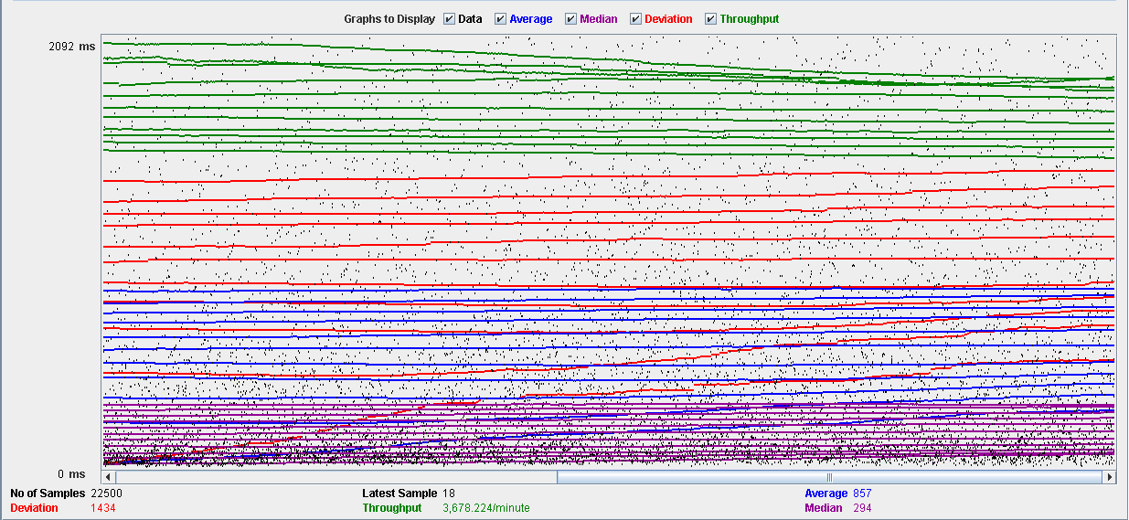

Performance Results:

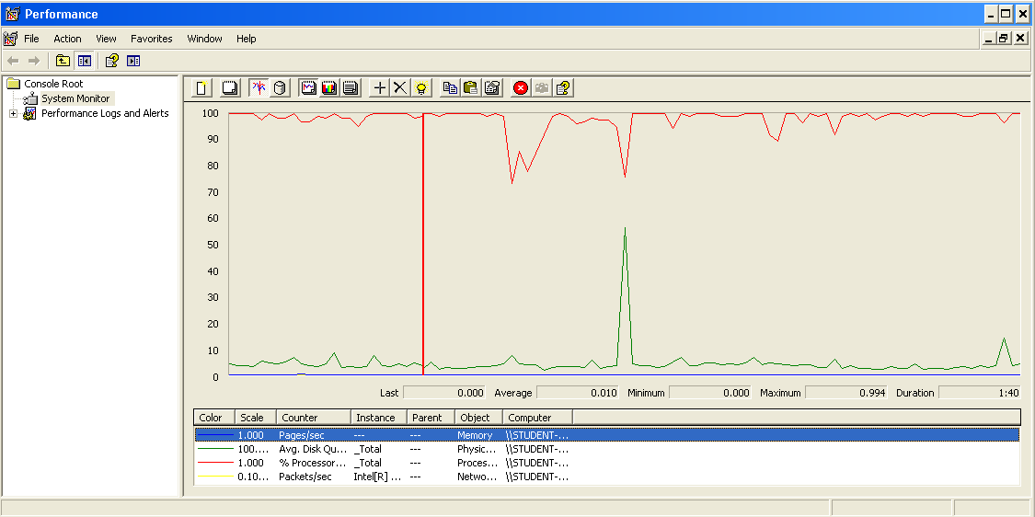

The CPU is always being used and some picks of physical disk.

## Copy

Sequence:

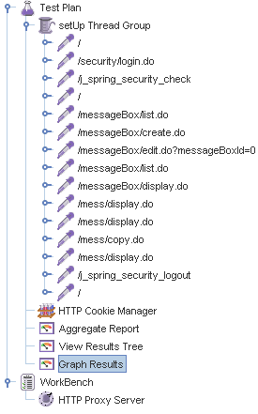

Aggregate Report:

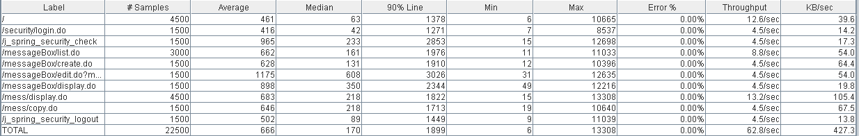

Thread properties:



Graph Results:

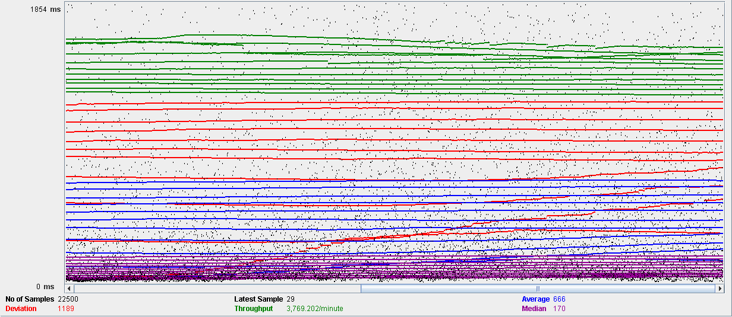

Performance Results:

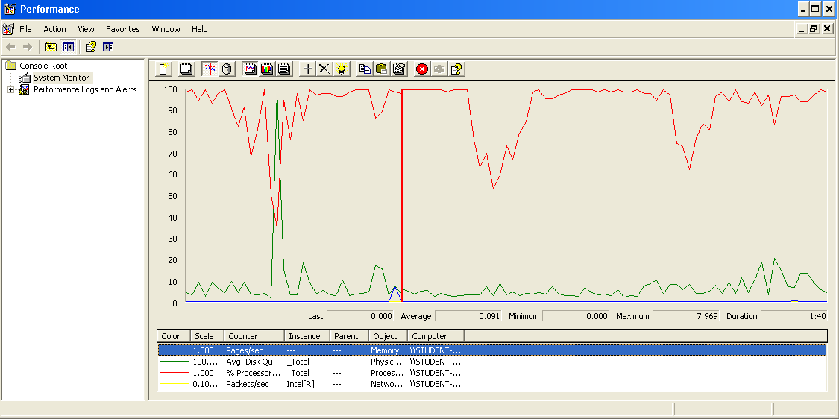

The CPU is always being used and a pick of physical disk.

## Delete

Sequence:

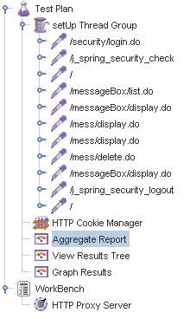

Aggregate Report:

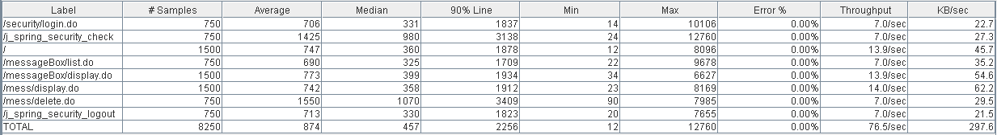

Thread properties:



Graph Results:

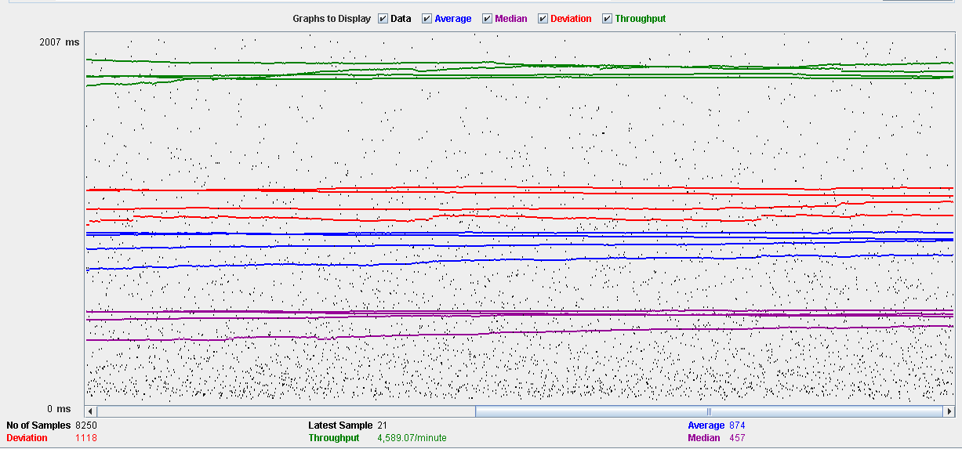

Performance Results:

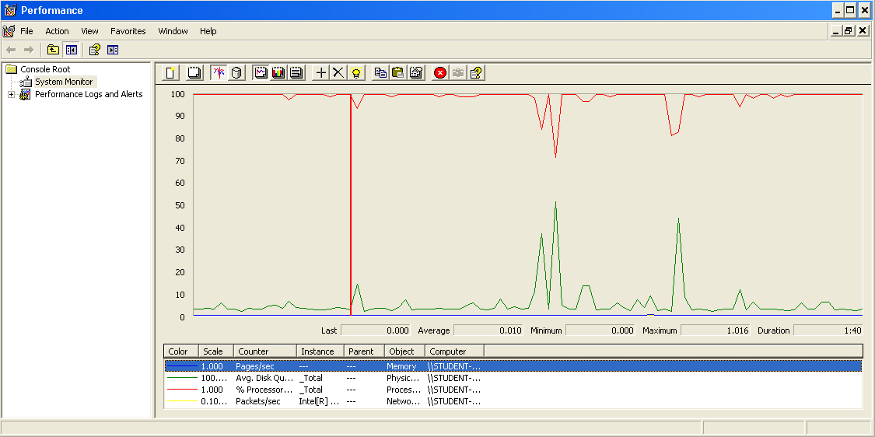

The CPU is always being used while the physical disk has some picks.

## Conclusion

The test was performed using:

CPU: i7 7700hq (2 cores in the virtual machine)

RAM: 2 GB (virtual machine)

For this use case we can say that the limitation occurs during the send and delete process, being the maximum of concurrent users 75.

# Message box

## Create

Sequence:

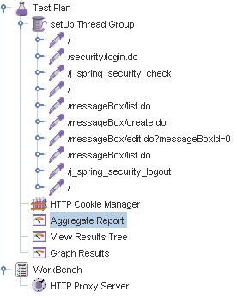

Aggregate Report:

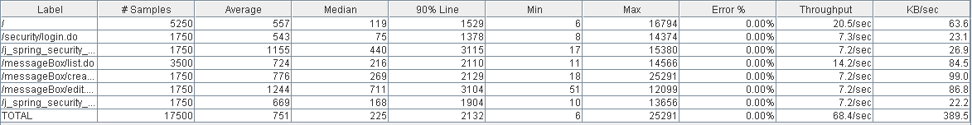

Thread properties:

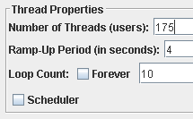

Graph Results:

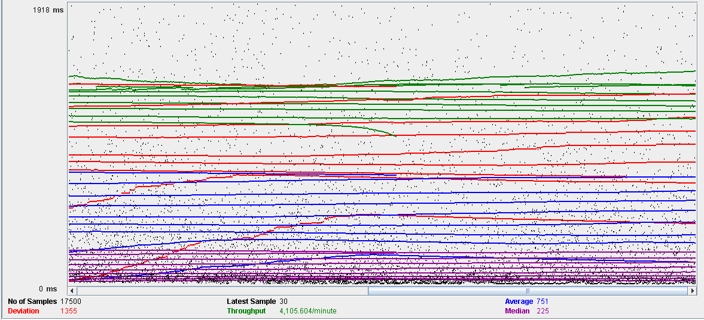

Performance Results:

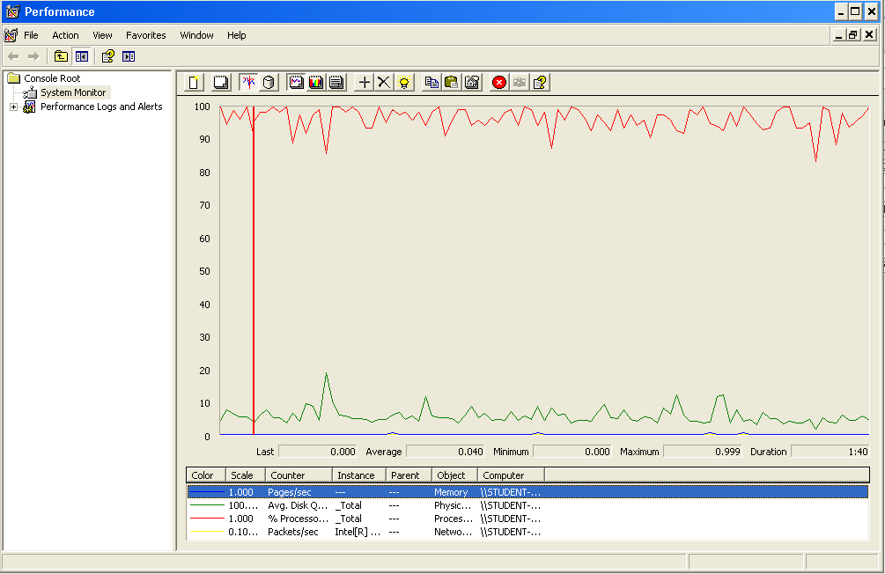

The CPU is always being used and physical disk usage is barely noticeable.

## Edit

Sequence:

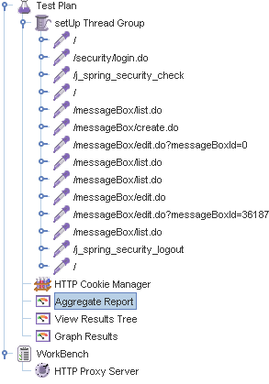

Aggregate Report:

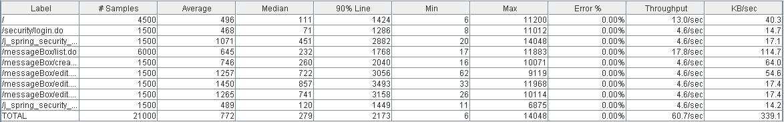

Thread properties:



Graph Results:

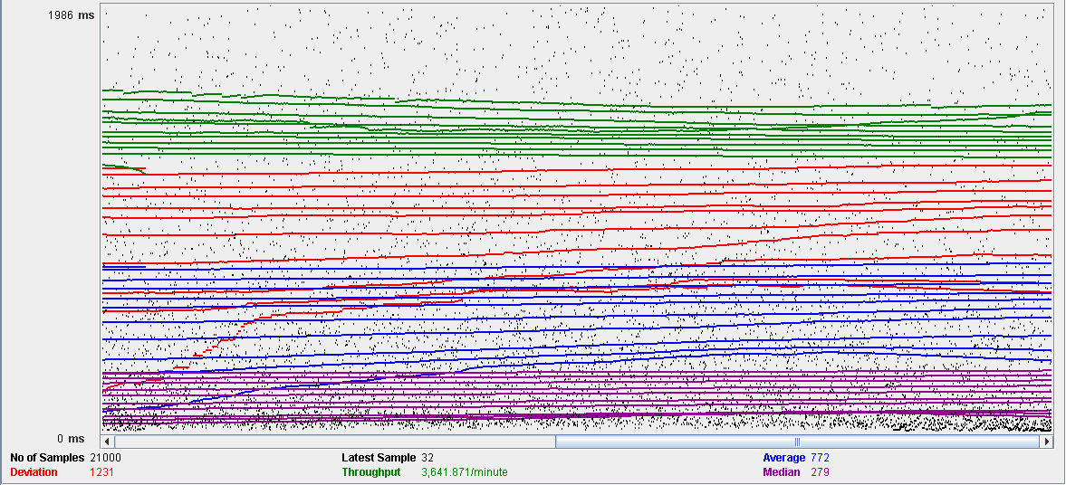

Performance Results:

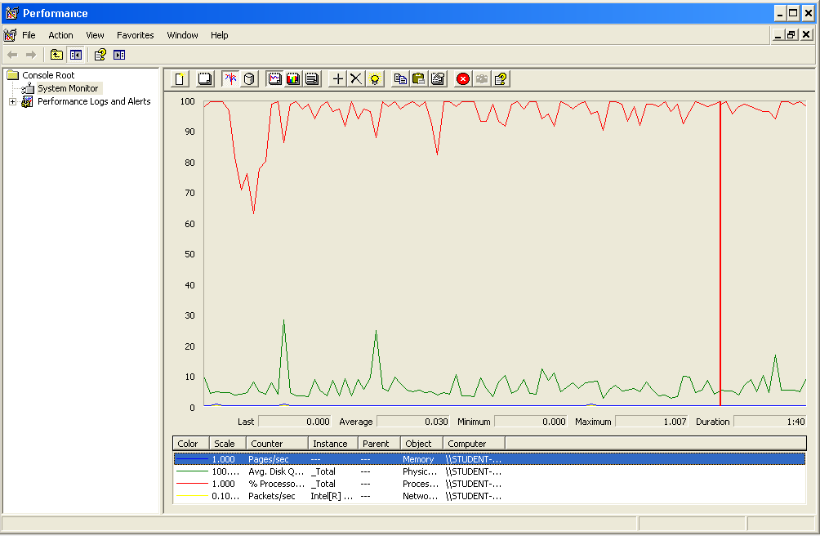

The CPU is always being used and small picks of physical disk

## Delete

Sequence:

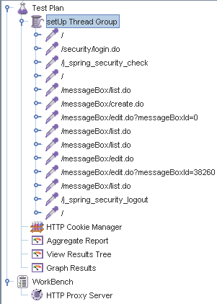

Aggregate Report:

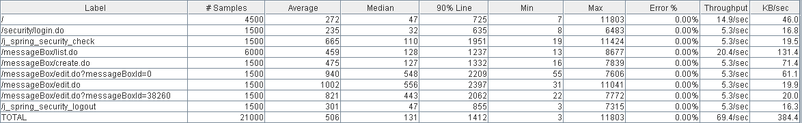

Thread properties:



Graph Results:

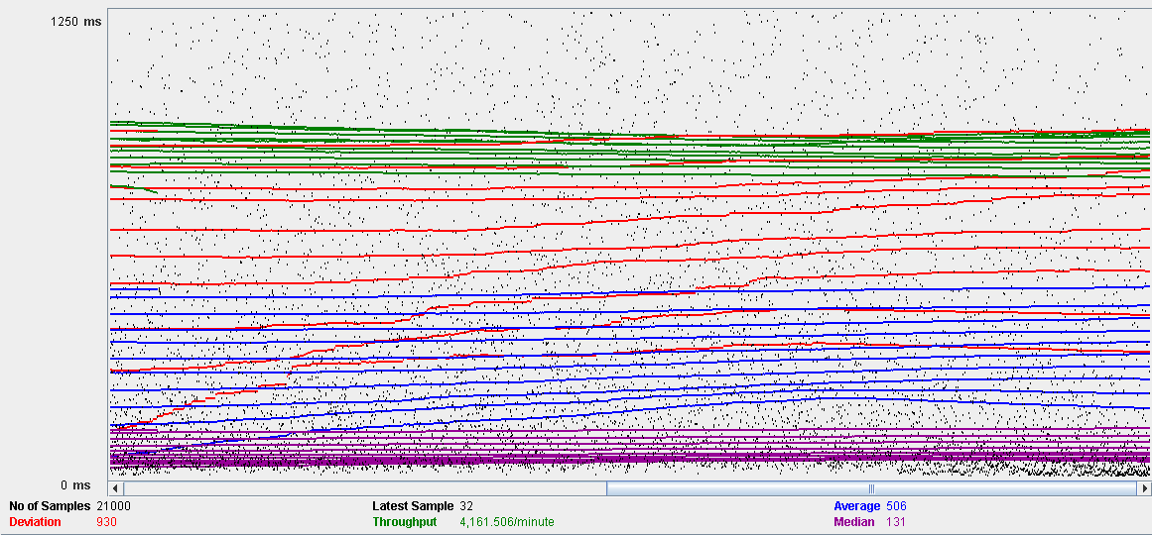

Performance Results:

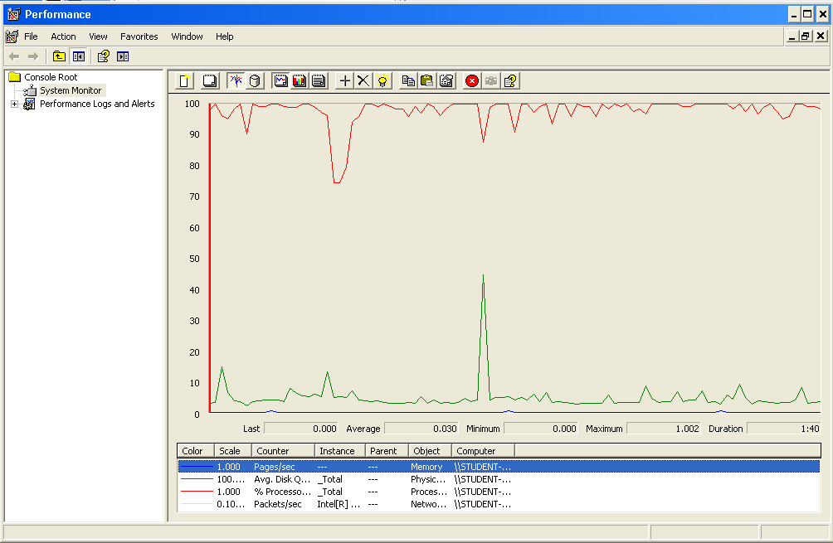

The CPU is always being used while the memory has some picks.

## Conclusion

The test was performed using:

CPU: i7 7700hq (2 cores in the virtual machine)

RAM: 2 GB (virtual machine)

For this use case we can say that the limitation occurs during the edition process, being the maximum of concurrent users 150.

# Social profile

## Create

Sequence:

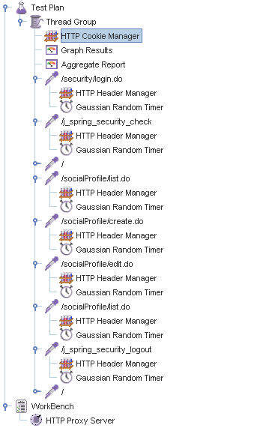

Aggregate Report:

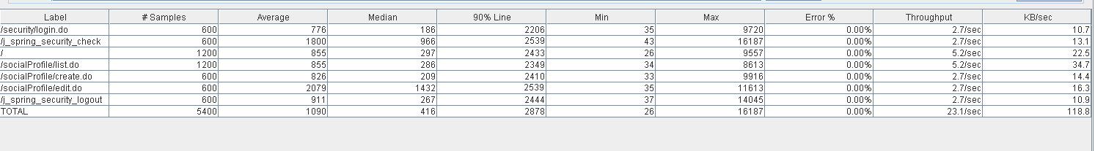

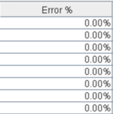

Thread properties:

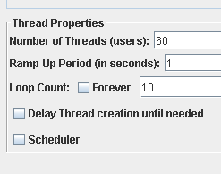

Graph Results:

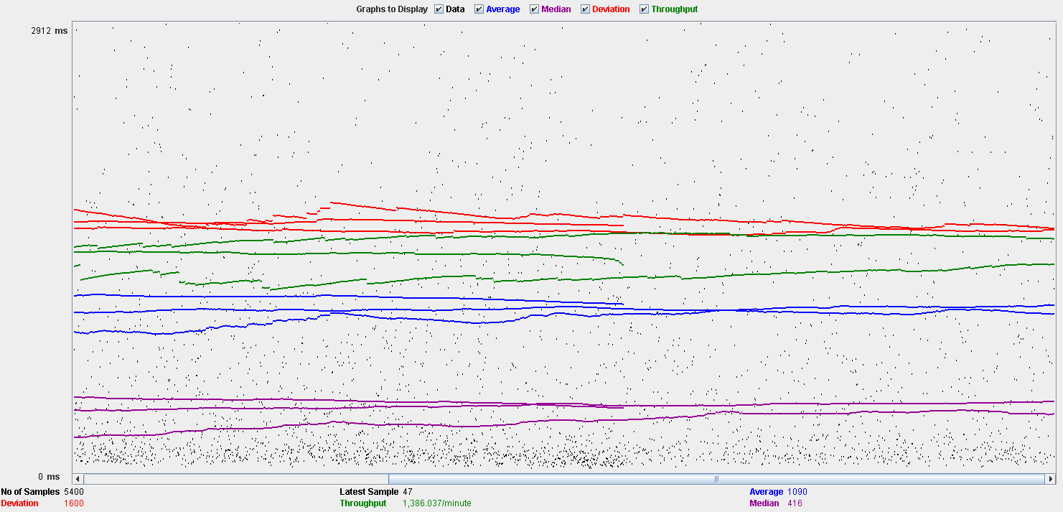

Performance Results:

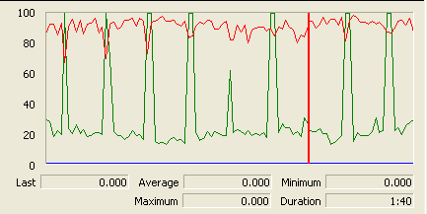

The CPU is always being used while the disk show many peaks.

## Edit

Sequence:

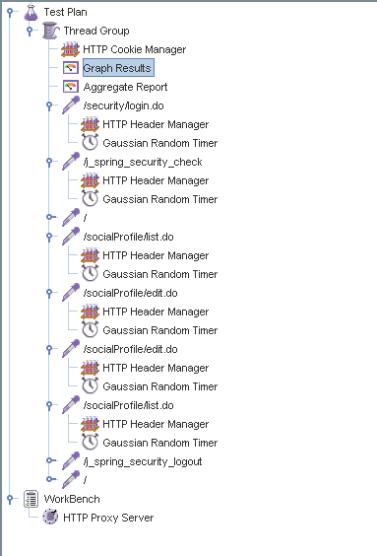

Aggregate Report:

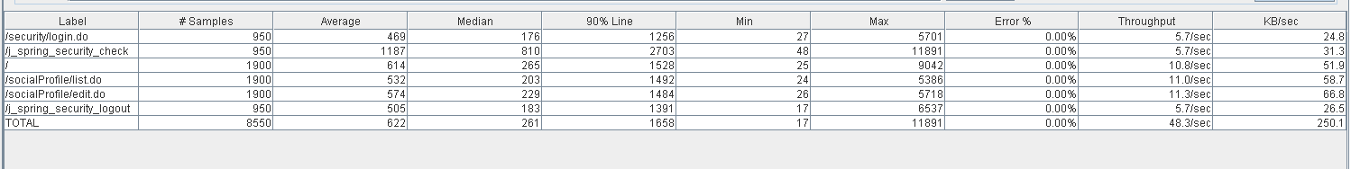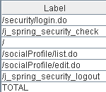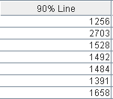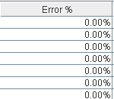

Thread properties:

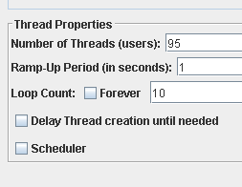

Graph Results:

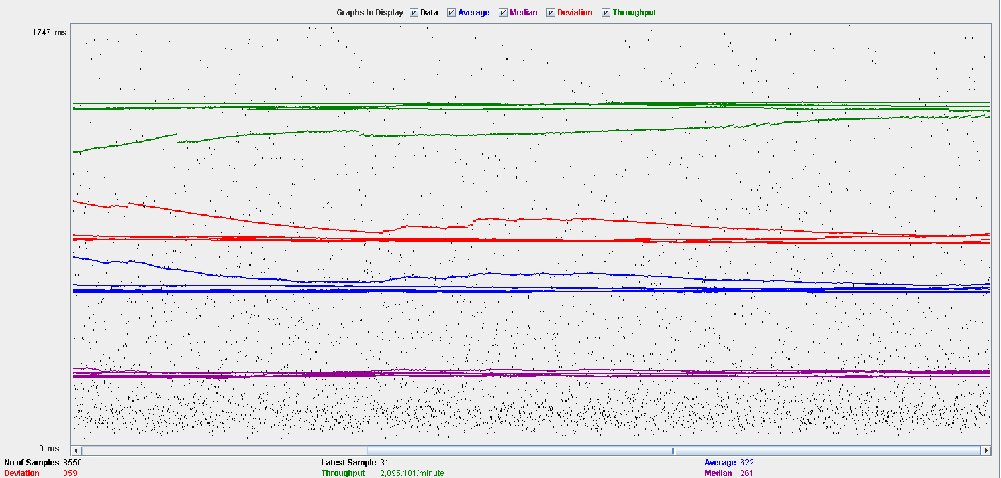

Performance Results:

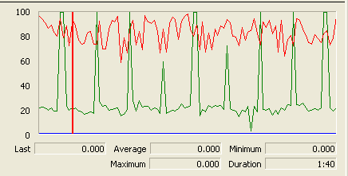

Again we can see that the CPU is always being used while the disk usage shows some periodic peaks.

## Delete

Sequence:

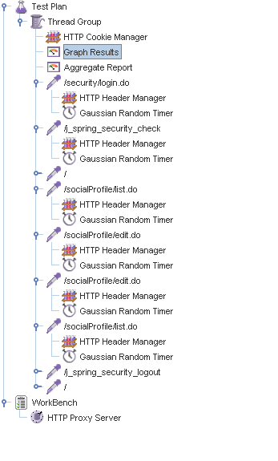

Aggregate Report:

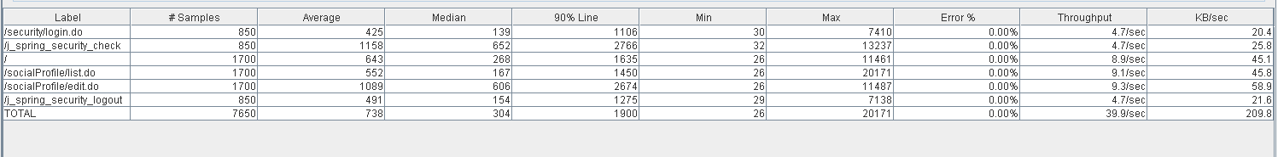

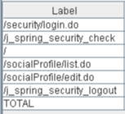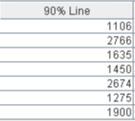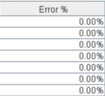

Thread properties:

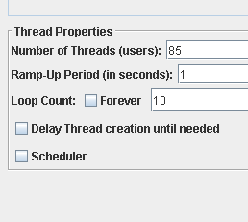.

Graph Results:

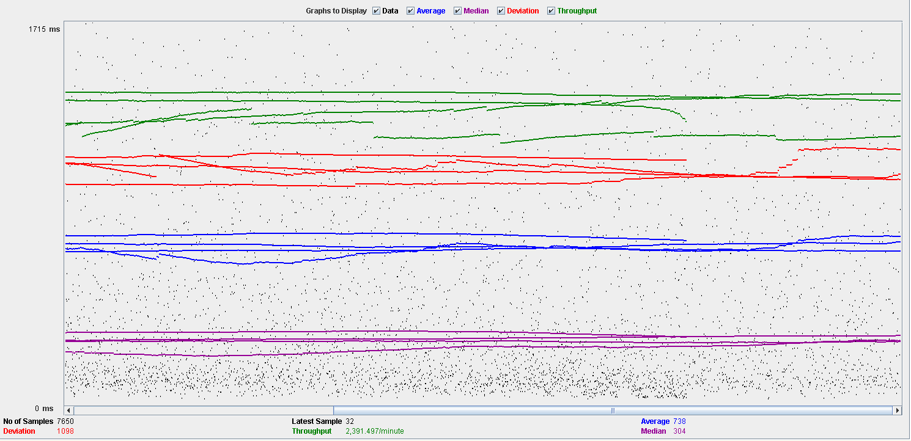

Performance Results:

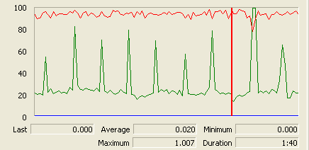

Again we can see that the CPU is always being used while the disk usage shows some peaks.

## Conclusion

The test was performed using:

CPU: i5 2500k (2 cores in the virtual machine)

RAM: 2 GB (virtual machine)

For this use case we can say that the limitation occurs during the creation process, being the maximum of concurrent users 60.

# Dashboard

## Show dashboard and launch all process

Sequence:

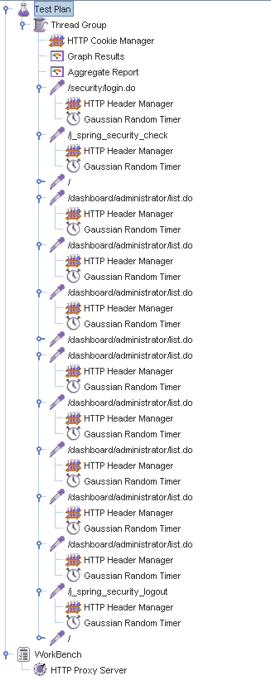

Aggregate Report:

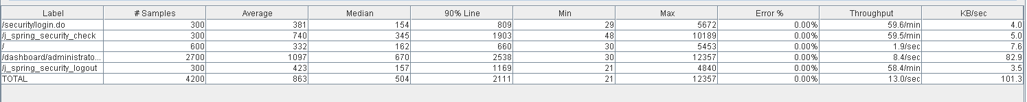

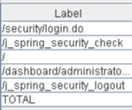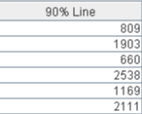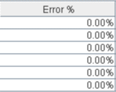

Thread properties:

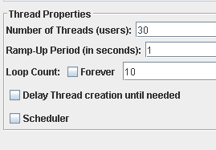

Graph Results:

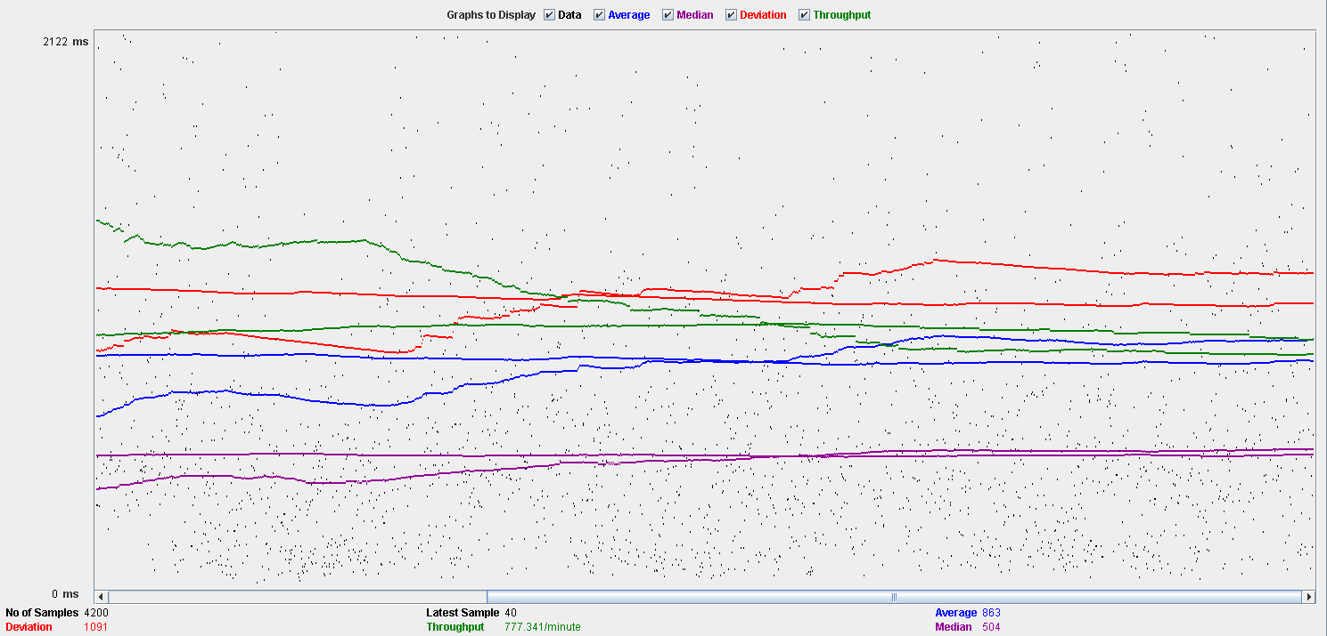

Performance Results:

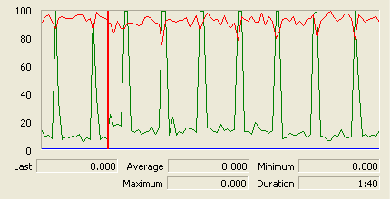

The CPU is always being used while the disk show some peaks.

## Conclusion

The test was performed using:

CPU: i5 2500k (2 cores in the virtual machine)

RAM: 2 GB (virtual machine)

For this use case we can say that the limitation around 30 users.

# Category

## Create

Sequence:

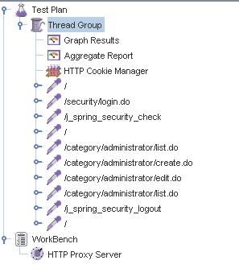

Aggregate Report:

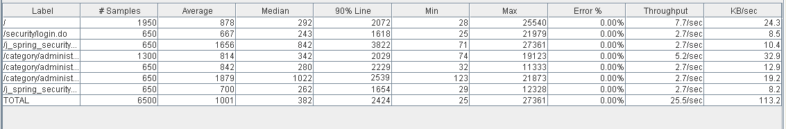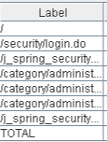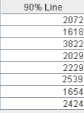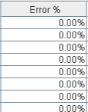

Thread properties:

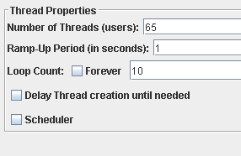

Graph Results:

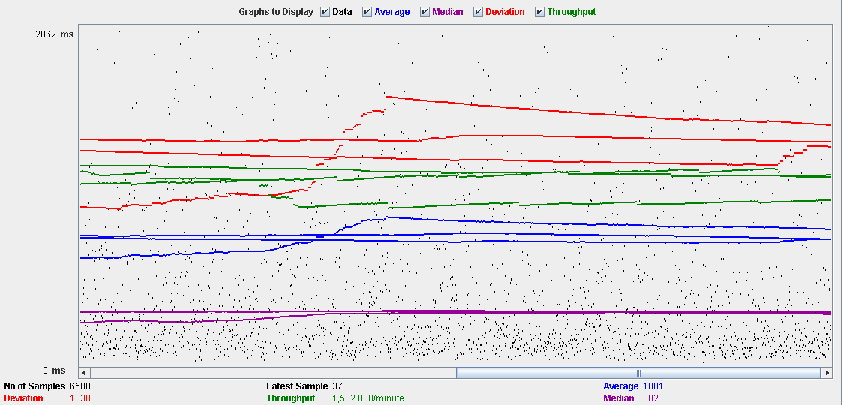

Performance Results:

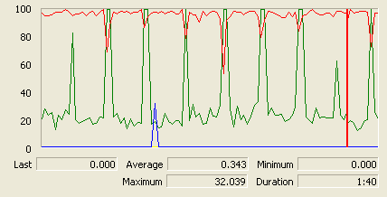

The CPU is always being used and disk show some peaks.

## Edit

Sequence:

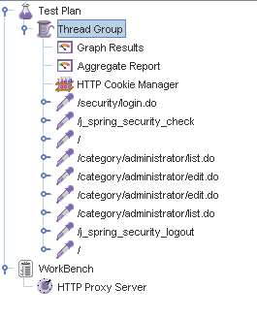

Aggregate Report:

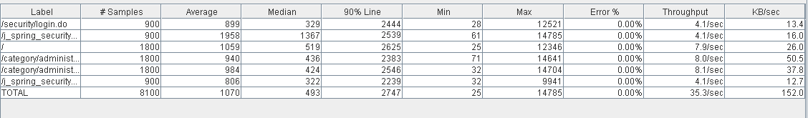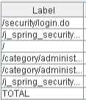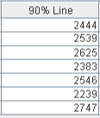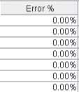

Thread properties:

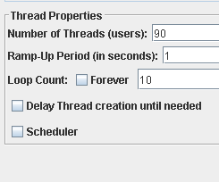

Graph Results:

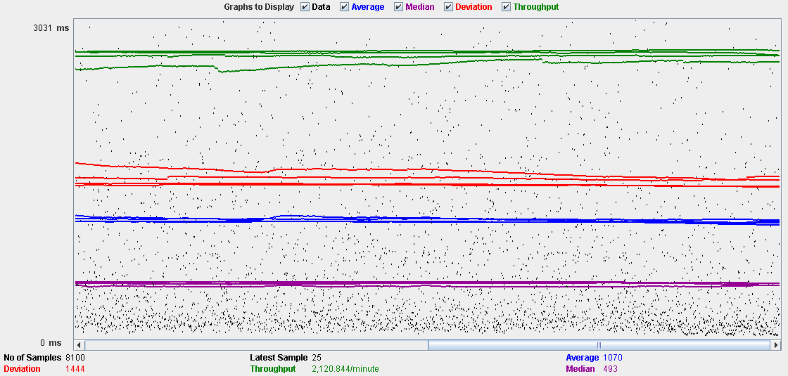

Performance Results:

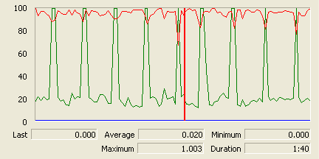

The CPU is always being used and the disk show som peaks.

## Delete

Sequence:

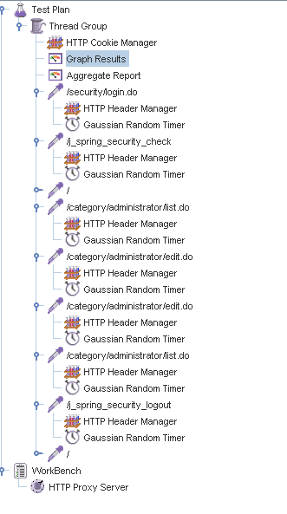

Aggregate Report:

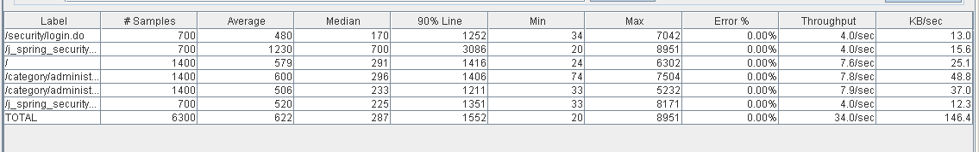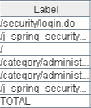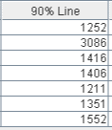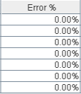

Thread properties:

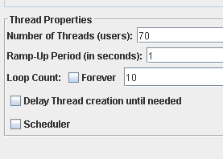

Graph Results:

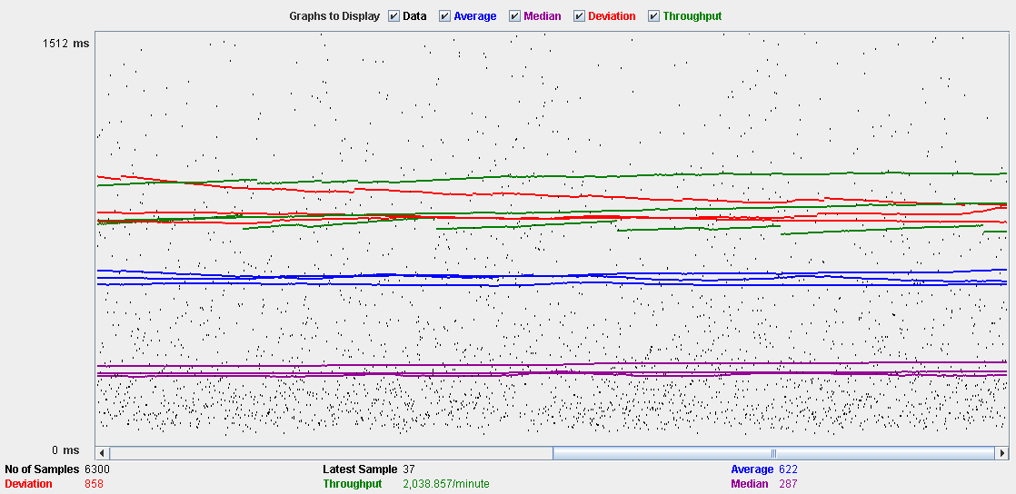

Performance Results:

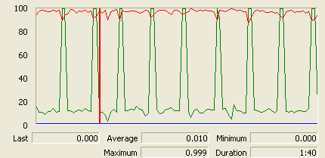

The CPU is always being used and disk show some peaks.

## Conclusion

The test was performed using:

CPU: i5 2500k (2 cores in the virtual machine)

RAM: 2 GB (virtual machine)

For this use case we can say that the limitation occurs during the create process, being the maximum of concurrent users 65.

# Request

## Create

Sequence:

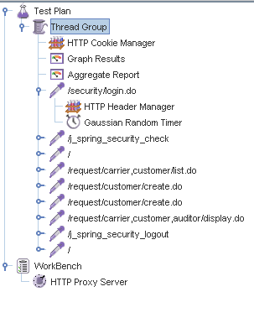

Aggregate Report:

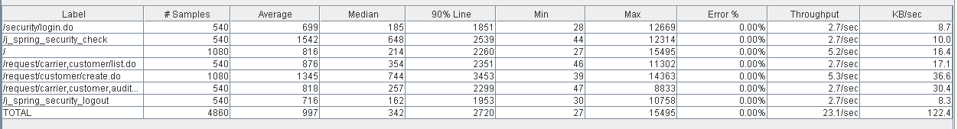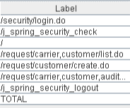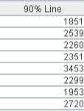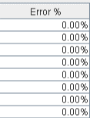

Thread properties:

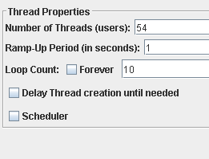

Graph Results:

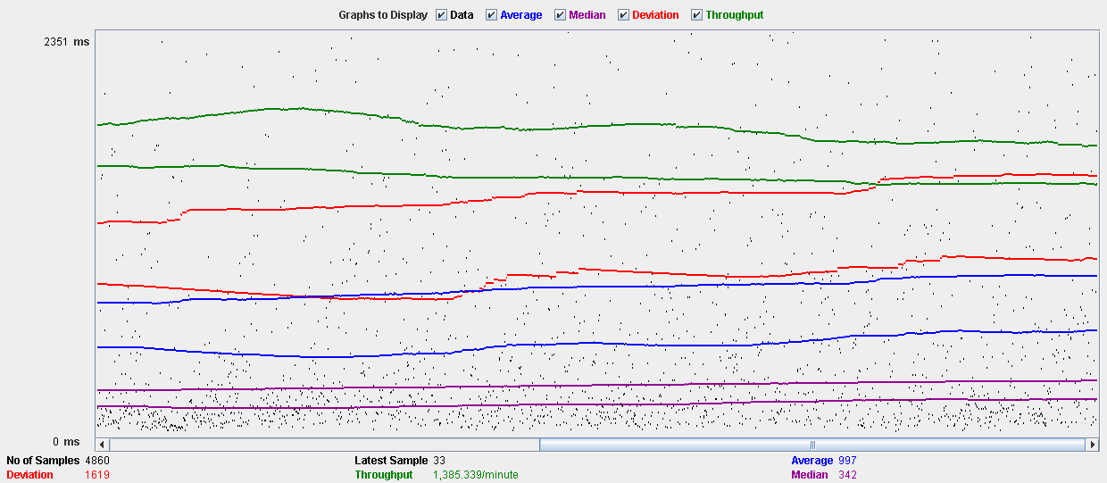

Performance Results:

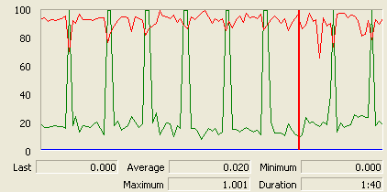

The CPU is always being used and physical disk show some peaks.

## Edit

Sequence:

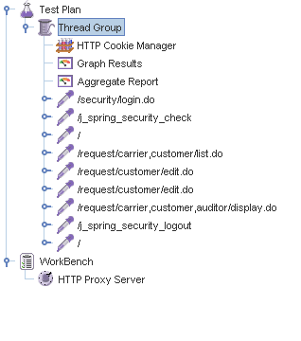

Aggregate Report:

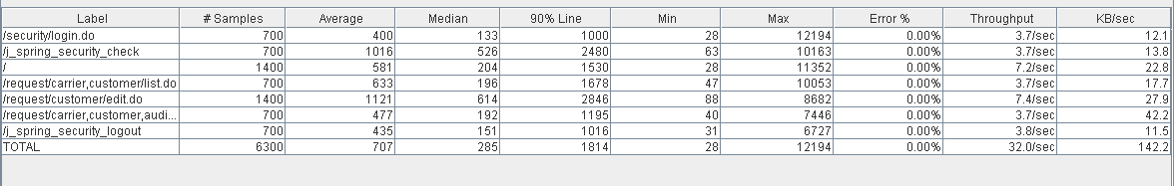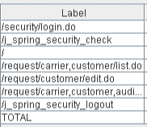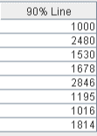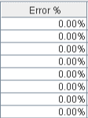

Thread properties:

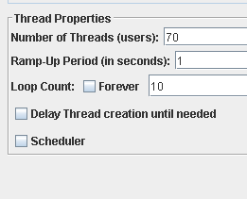

Graph Results:

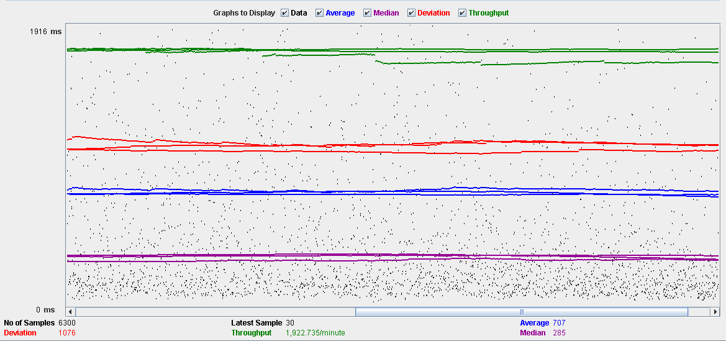

Performance Results:

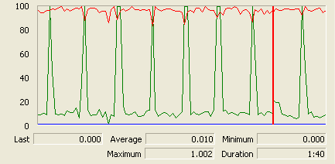

The CPU is always being used and disk show some peaks.

## Delete

Sequence:

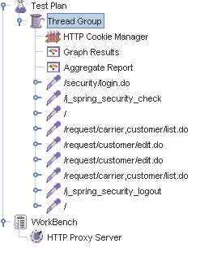

Aggregate Report:

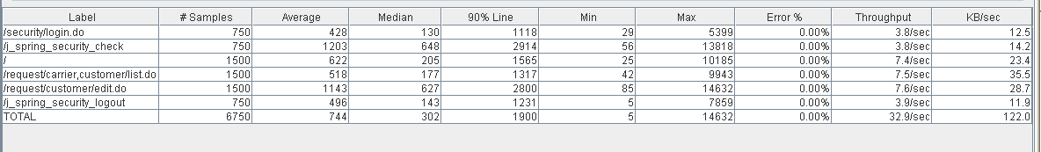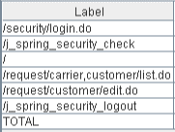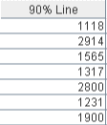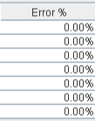

Thread properties:

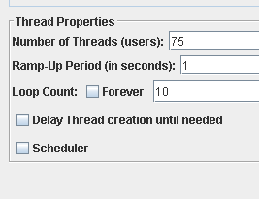

Graph Results:

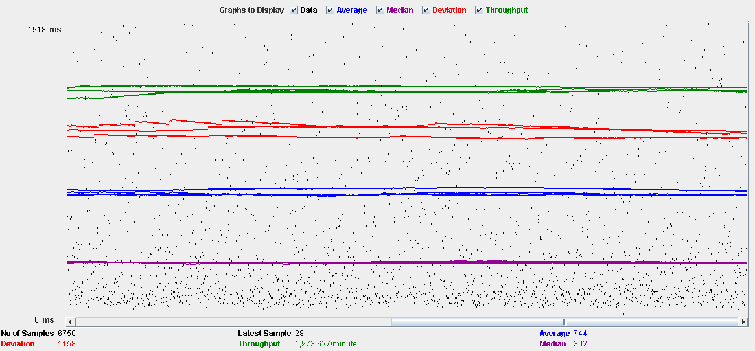

Performance Results:

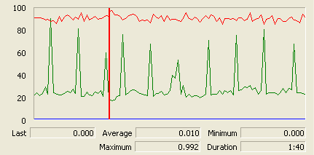

The CPU is always being used while the memory has some peaks.

## Conclusion

The test was performed using:

CPU: i5 2500kk (2 cores in the virtual machine)

RAM: 2 GB (virtual machine)

For this use case we can say that the limitation occurs during the creation process, being the maximum of concurrent users 54.

# TraverseTown

## Create

Sequence:

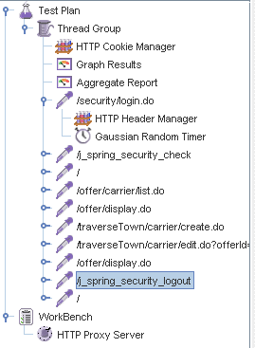

Aggregate Report:

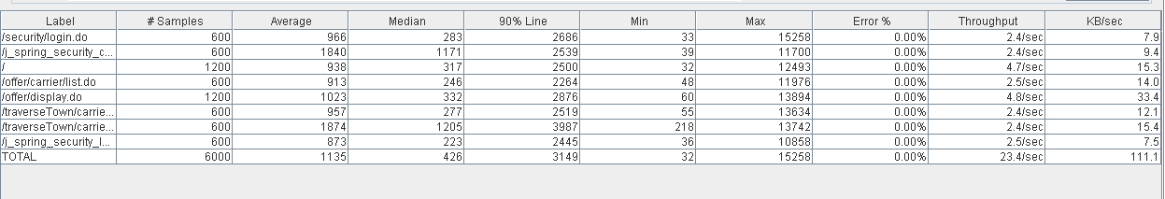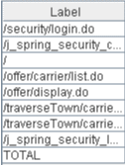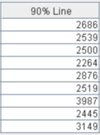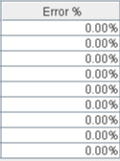

Thread properties:

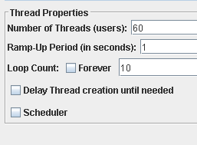

Graph Results:

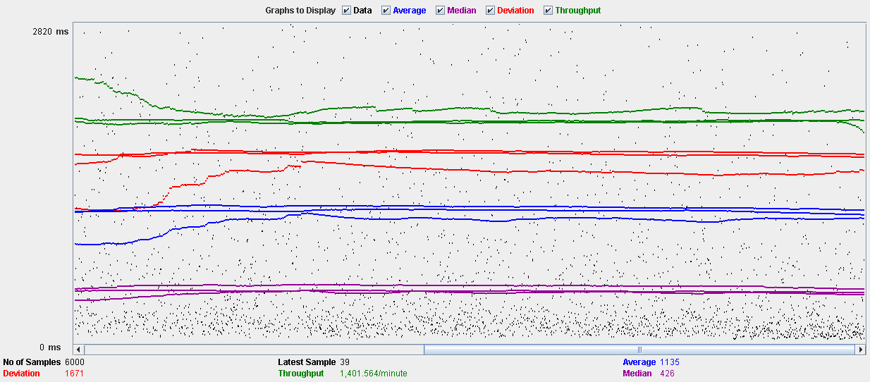

Performance Results:

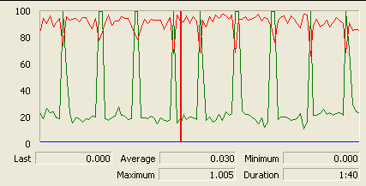

The CPU is always being used and physical disk show some peaks.

## Edit

Sequence:

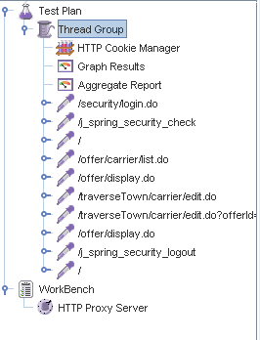

Aggregate Report:

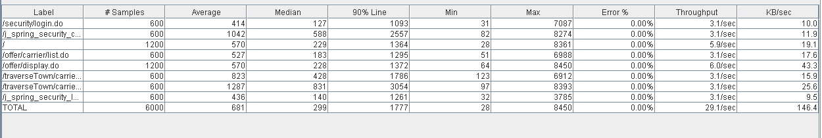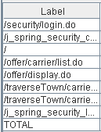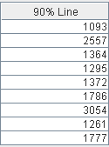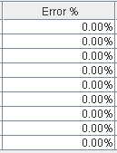

Thread properties:

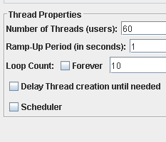

Graph Results:

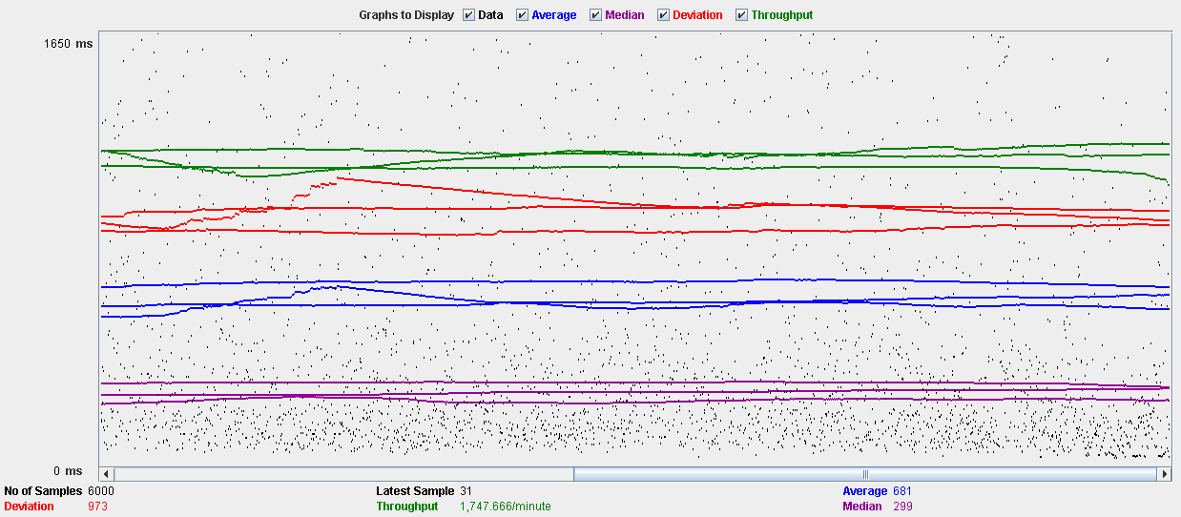

Performance Results:

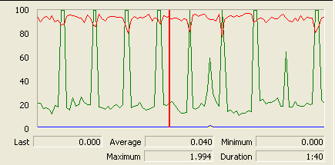

The CPU is always being used and disk show some peaks

## Delete

Sequence:

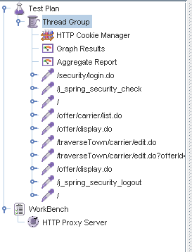

Aggregate Report:

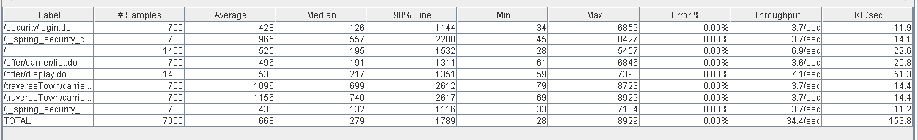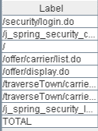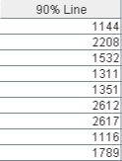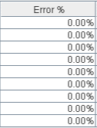

Thread properties:

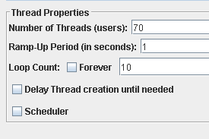

Graph Results:

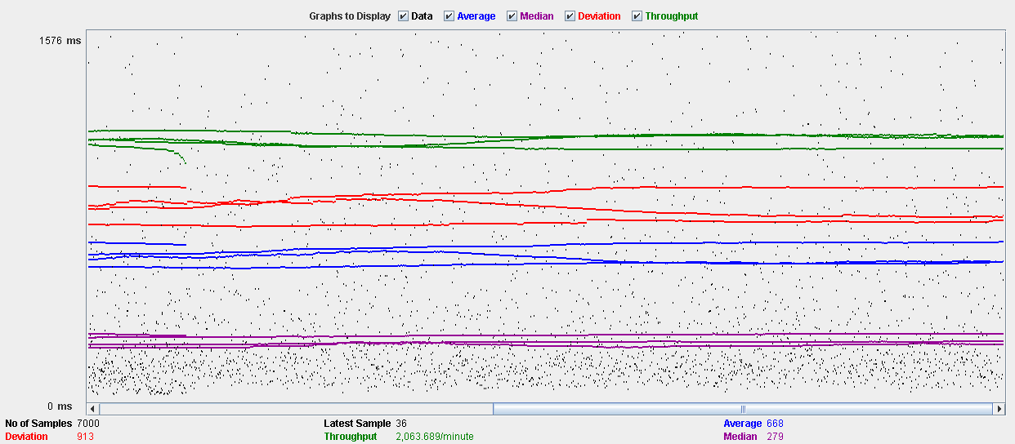

Performance Results:

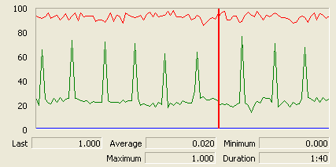

The CPU is always being used while the memory has some peaks.

## Conclusion

The test was performed using:

CPU: i5 2500k (2 cores in the virtual machine)

RAM: 2 GB (virtual machine)

For this use case we can say that the limitation occurs during the creation and edition process, being the maximum of concurrent users 60.

# Issue

## Create

Sequence:

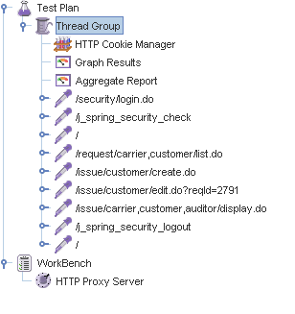

Aggregate Report:

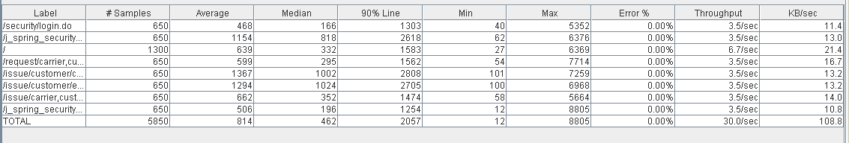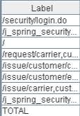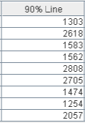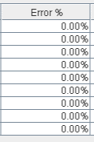

Thread properties:

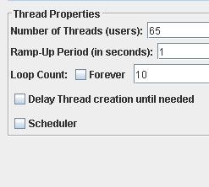

Graph Results:

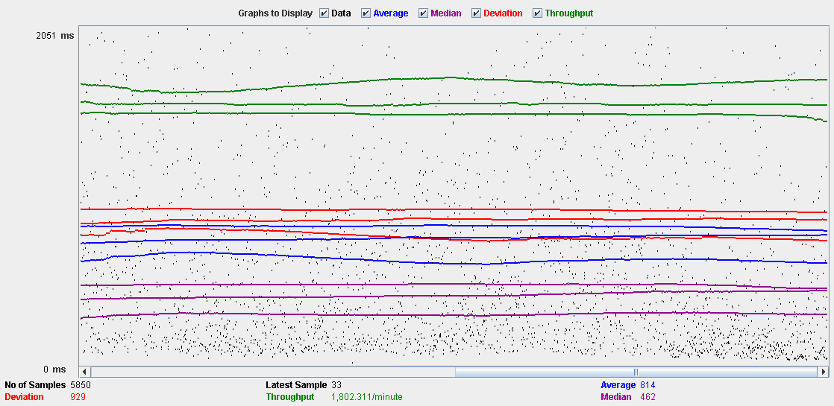

Performance Results:

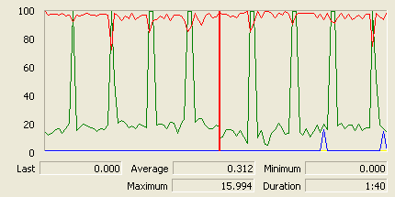

The CPU is always being used and physical disk usage show some peaks.

## Delete

Sequence:

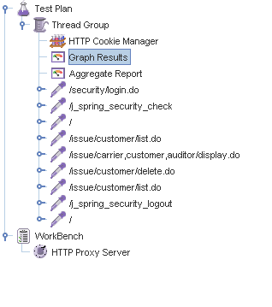

Aggregate Report:

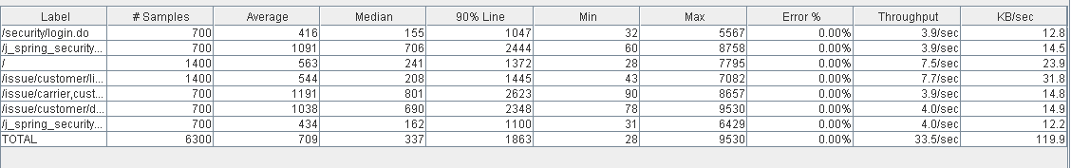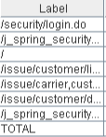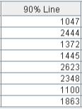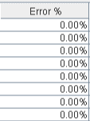

Thread properties:

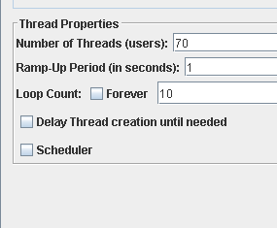

Graph Results:

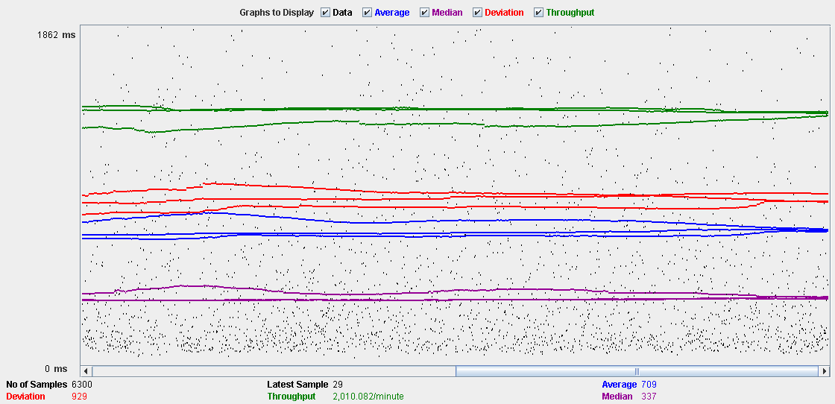

Performance Results:

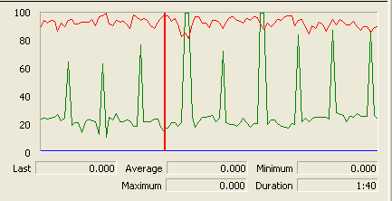

The CPU is always being used and disk show some peaks-

## Conclusion

The test was performed using:

CPU: i5 2500k (2 cores in the virtual machine)

RAM: 2 GB (virtual machine)

For this use case we can say that the limitation occurs during the create process, being the maximum of concurrent users 65.

# Town

## Create

Sequence:

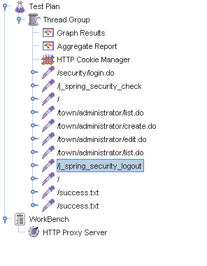

Aggregate Report:

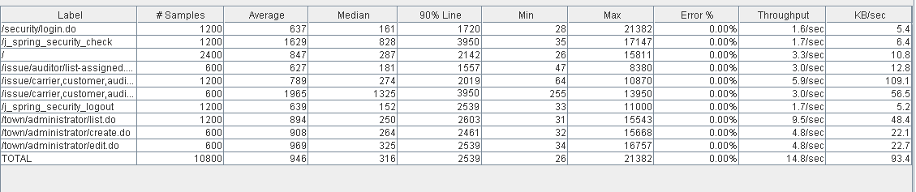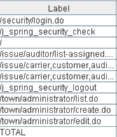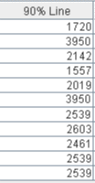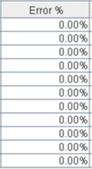

Thread properties:

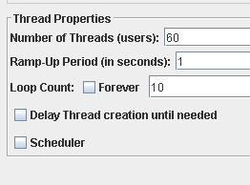

Graph Results:

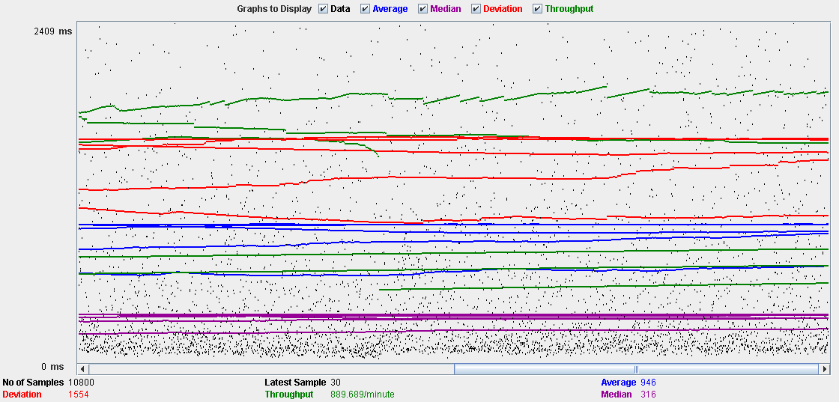

Performance Results:

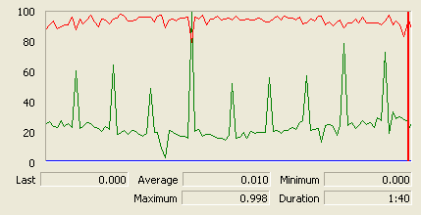

The CPU is always being used and physical disk usage show some peaks.

## Edit

Sequence:

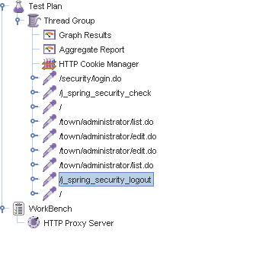

Aggregate Report:

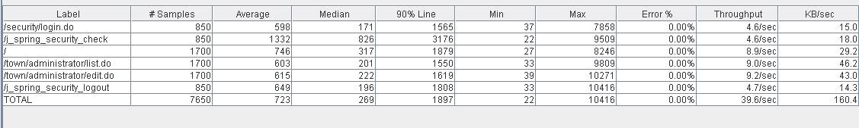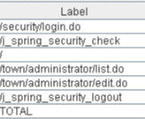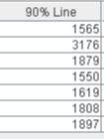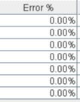

Thread properties:

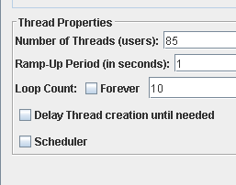

Graph Results:

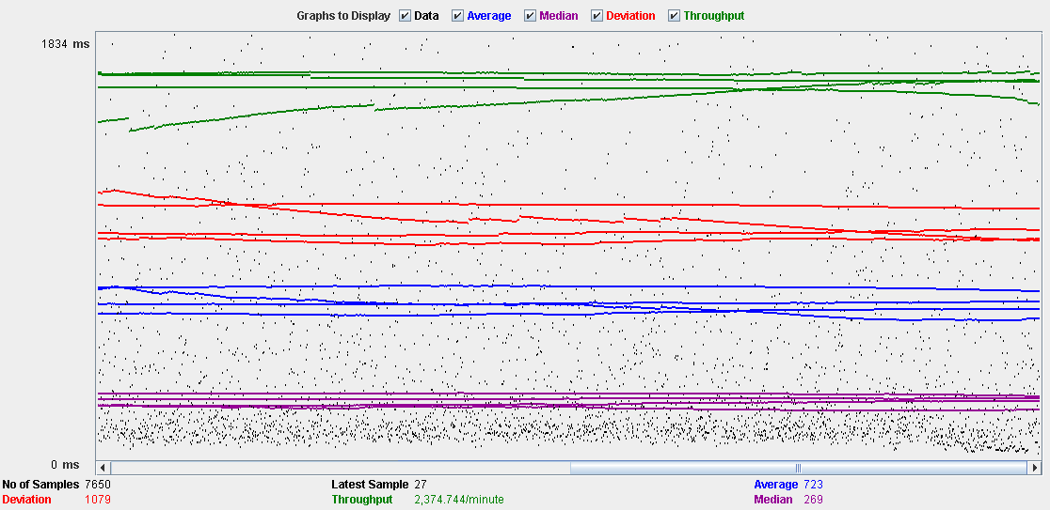

Performance Results:

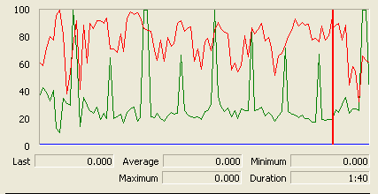

The CPU is always being used and small picks of physical disk

## Delete

Sequence:

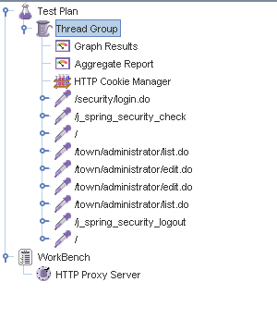

Aggregate Report:

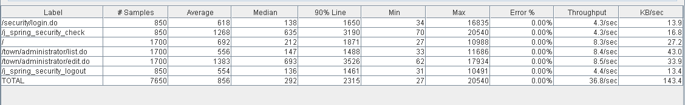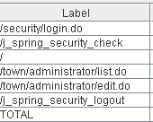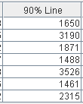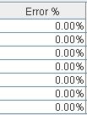

Thread properties:

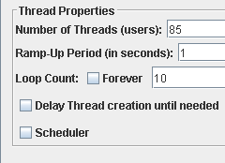

Graph Results:

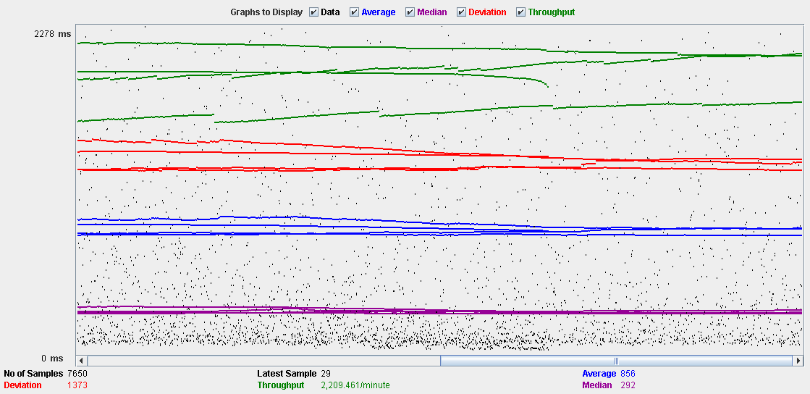

Performance Results:

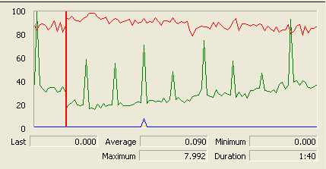

The CPU is always being used while the memory has some peaks.

## Conclusion

The test was performed using:

CPU: i5 2500k (2 cores in the virtual machine)

RAM: 2 GB (virtual machine)

For this use case we can say that the limitation occurs during the create process, being the maximum of concurrent users 60.

# Comment

## Create

Sequence:

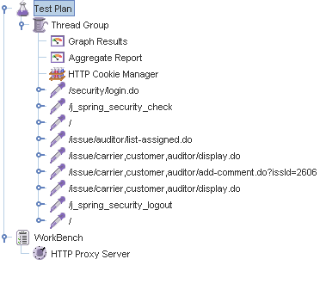

Aggregate Report:

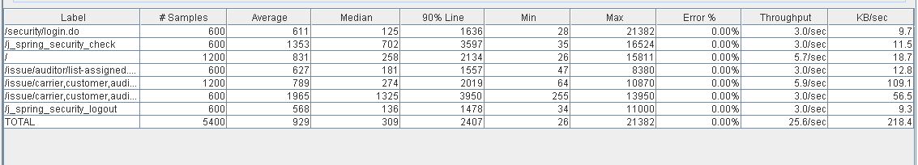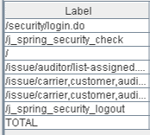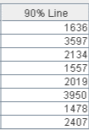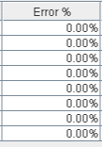

Thread properties:

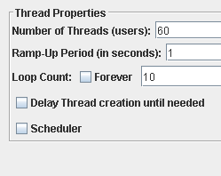

Graph Results:

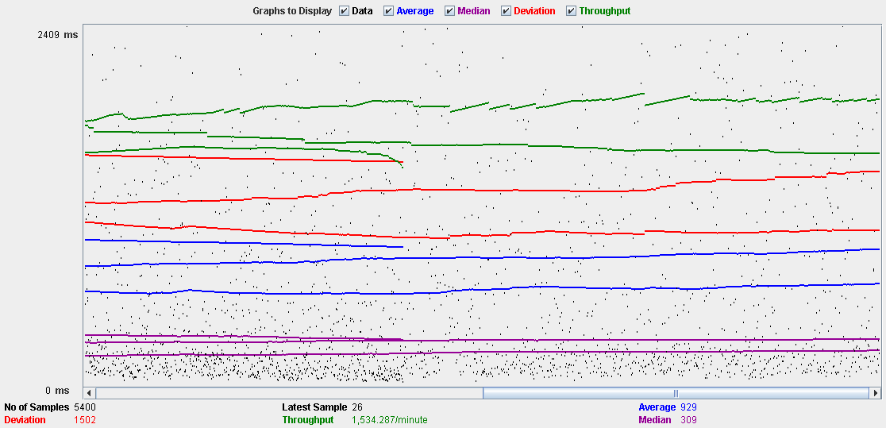

Performance Results:

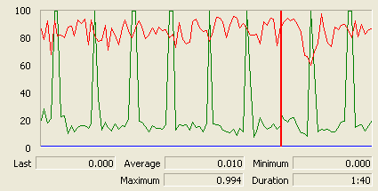

The CPU is always being used and physical disk usage is barely noticeable.

## Conclusion

The test was performed using:

CPU: i5 2500k (2 cores in the virtual machine)

RAM: 2 GB (virtual machine)

For this use case we can say that the limitation occurs with 60 users.

# Configuration

## Display and edit

Sequence:

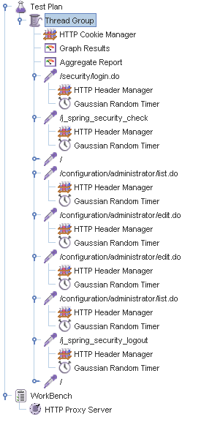

Aggregate Report:

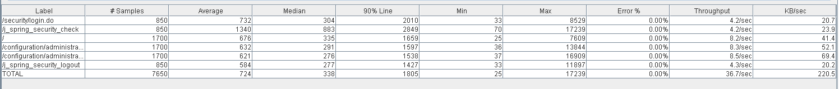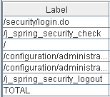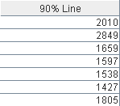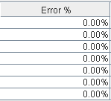

Thread properties:

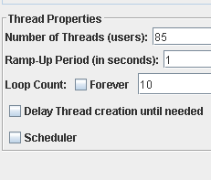

Graph Results:

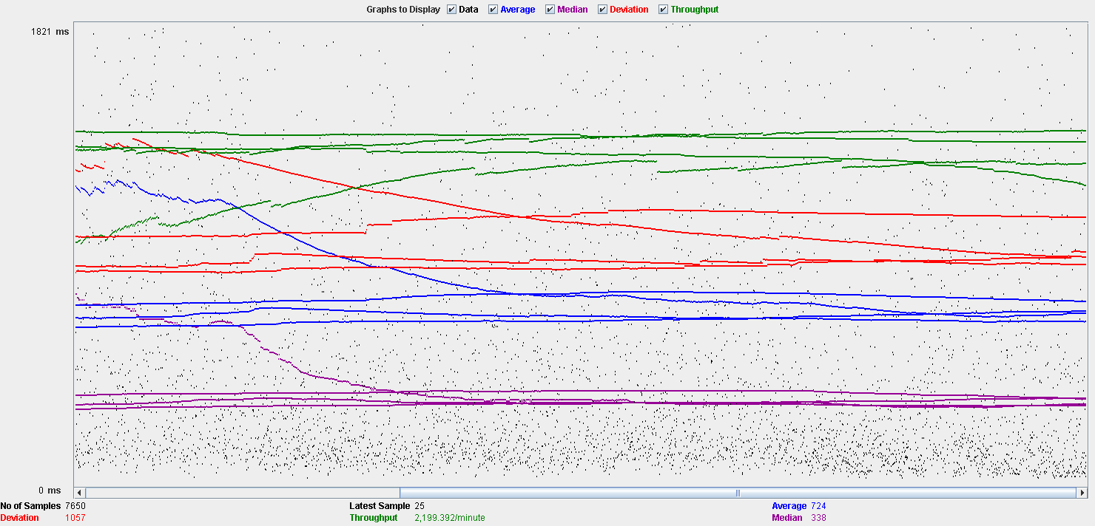

Performance Results:

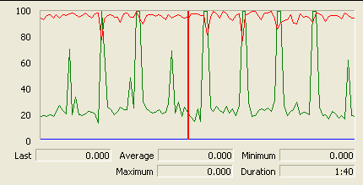

The CPU is always being used and physical disk usage show some peaks.

## Conclusion

The test was performed using:

CPU: i5 2500k (2 cores in the virtual machine)

RAM: 2 GB (virtual machine)

For this use case we can say that the limitation occurs during the edition process, being the maximum of concurrent users 85.

# TODO DE AQUI PABAJO SE BORRA

# Position

## Create

Sequence:

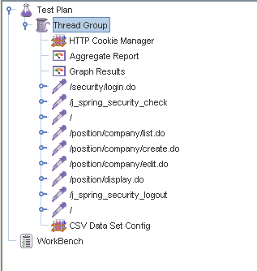

Aggregate Report:

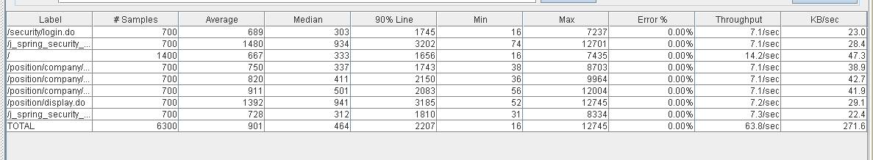

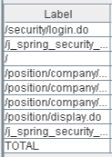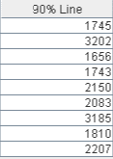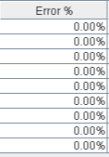

Thread properties:

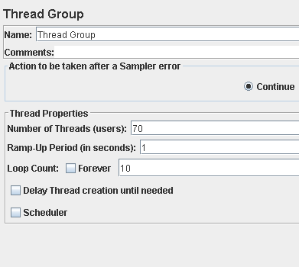

Graph Results:

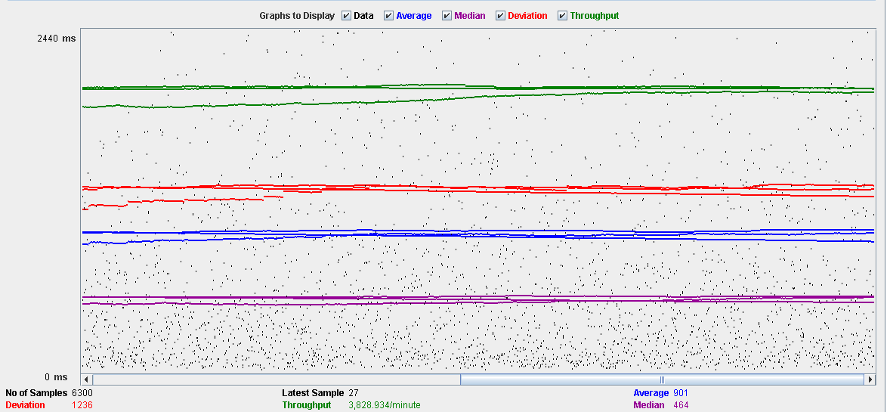

Performance Results:

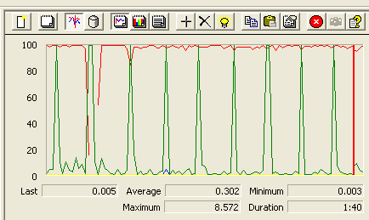

The CPU was always at its limit while the disk usage showed many peaks.

## Edit

Sequence:

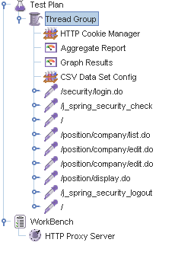

Aggregate Report:

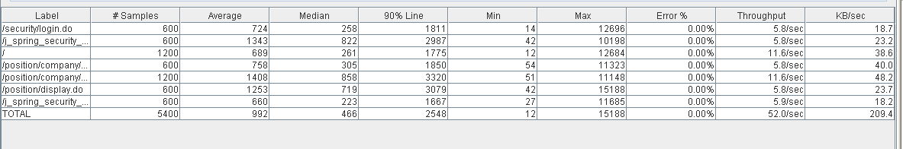

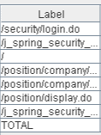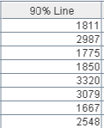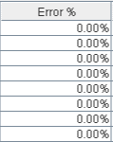

Thread properties:

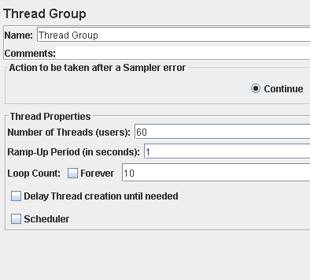

Graph Results:

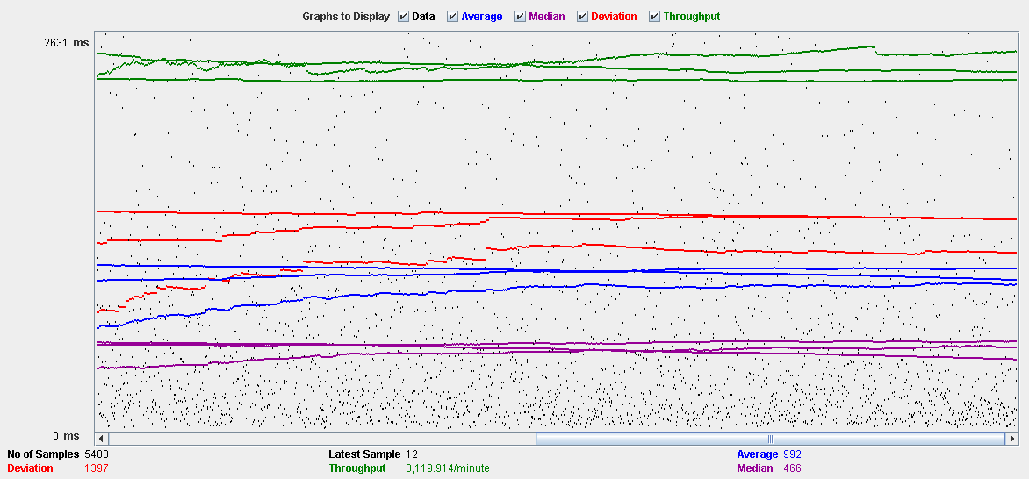

Performance Results:

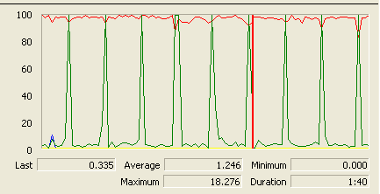

Again we can see that the CPU is always being used while the disk usage shows some periodic peaks.

## Delete

Sequence:

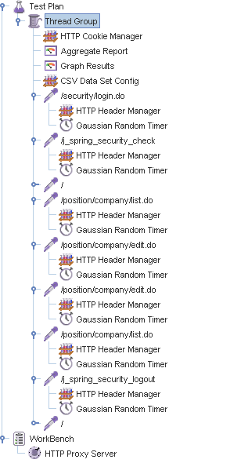

Aggregate Report:

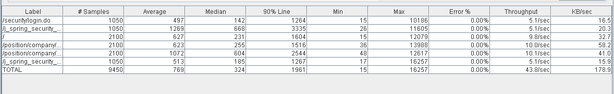

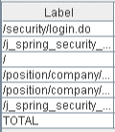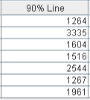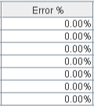

Thread properties:

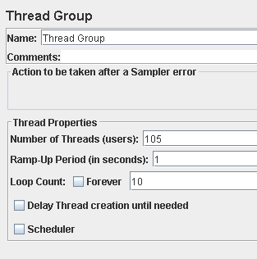.

Graph Results:

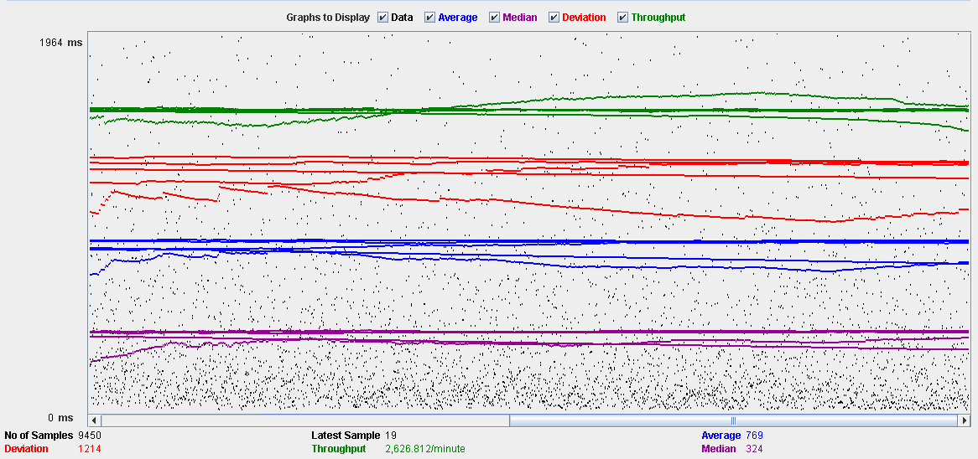

Performance Results:

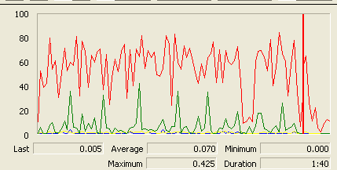

Again we can see that the CPU is always being used while the disk usage shows some peaks.

## Conclusion

The test was performed using:

CPU: 5 2500k (2 cores in the virtual machine)

RAM: 2 GB (virtual machine)

For this use case we can say that the limitation occurs during the edit process, being the maximum of concurrent users 60 because the time of respond starts to be very high at that point.

# Mess

## Search by tags, list by that tag and display a mess

Sequence:

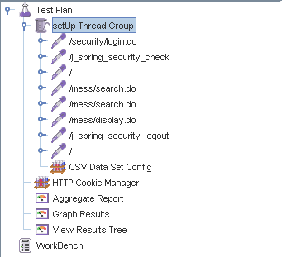

Aggregate Report:

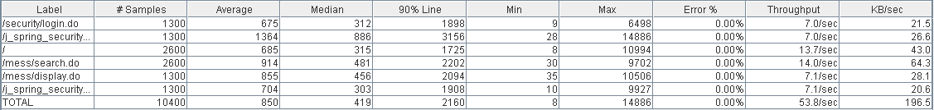

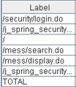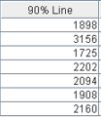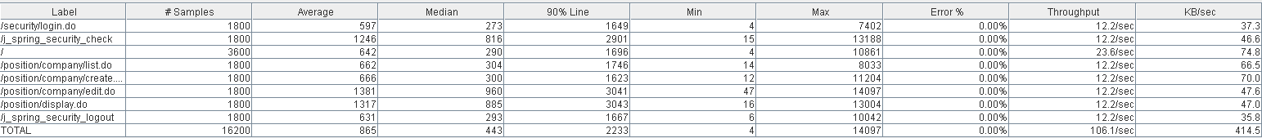

Thread properties:

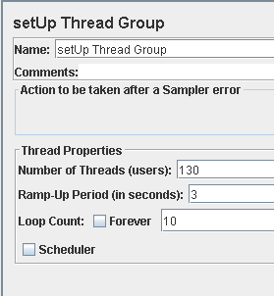

Graph Results:

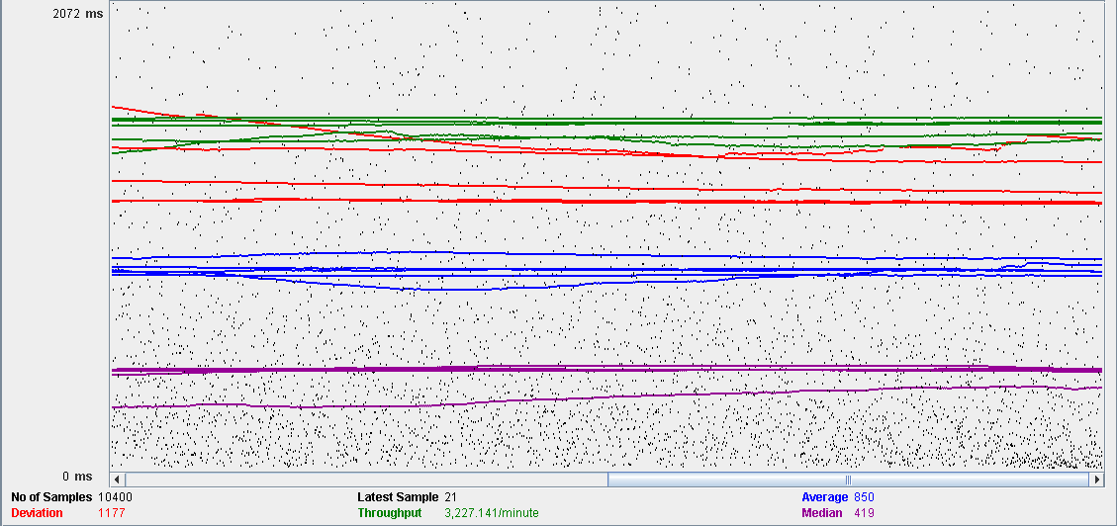

Performance Results:

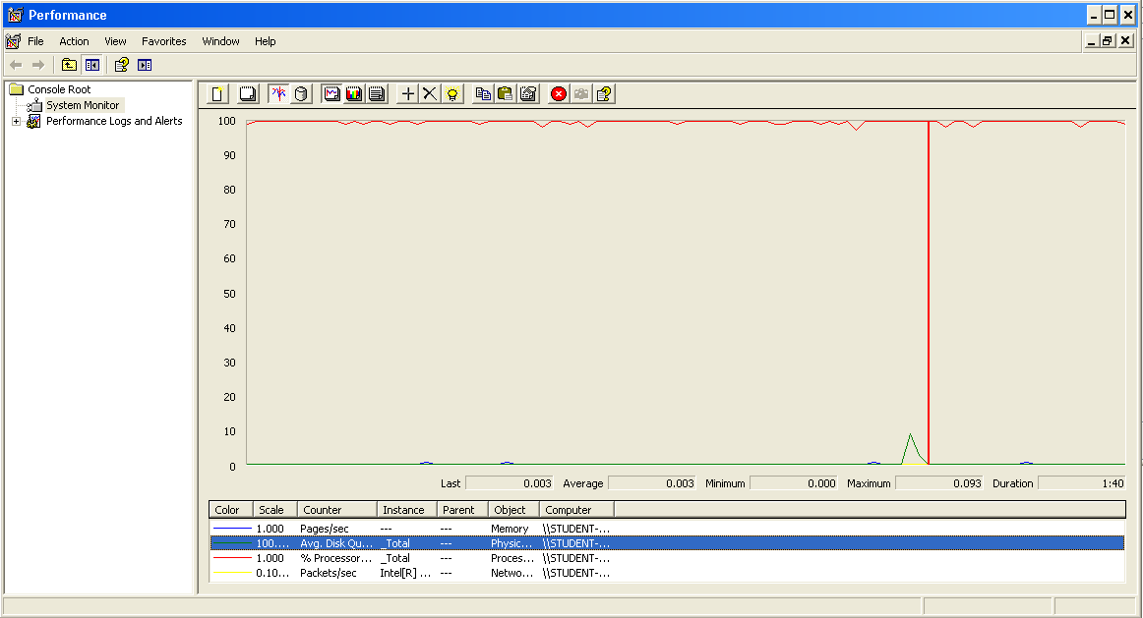

The CPU was always at its limit while the disk usage showed many peaks.

## Send a message

Sequence:

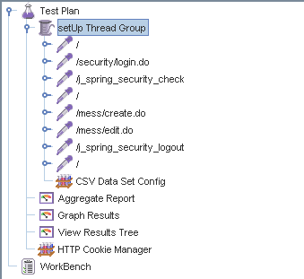

Aggregate Report:



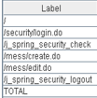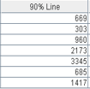

Thread properties:

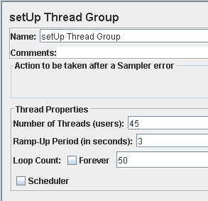

Graph Results:

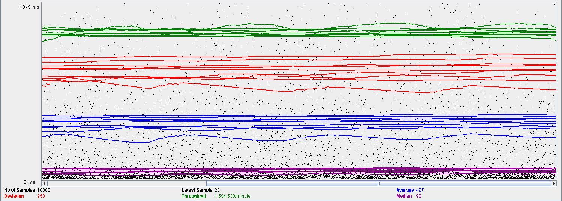

Performance Results:

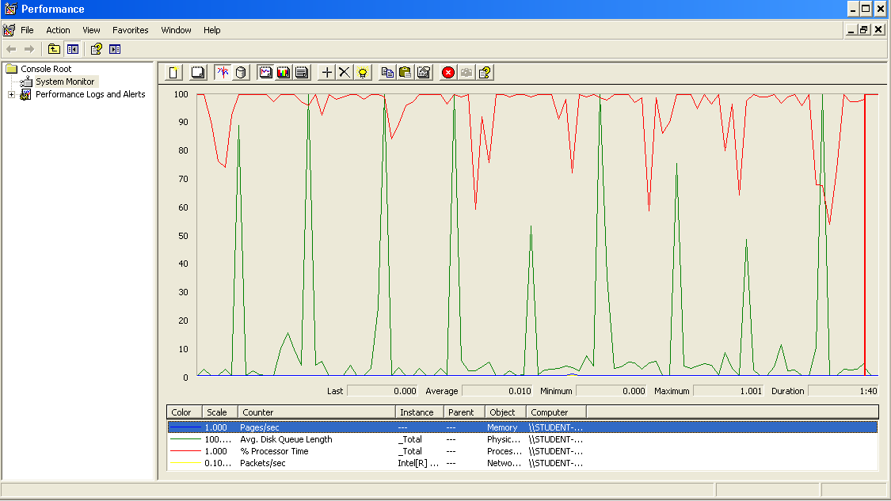

Again we can see that the CPU is always being used while the disk usage shows some periodic peaks.

## Delete a message

Sequence:

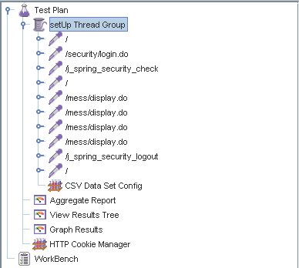

Aggregate Report:

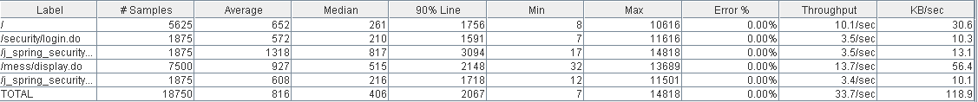

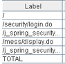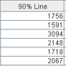

Thread properties:

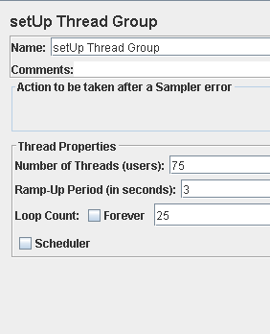

Graph Results:

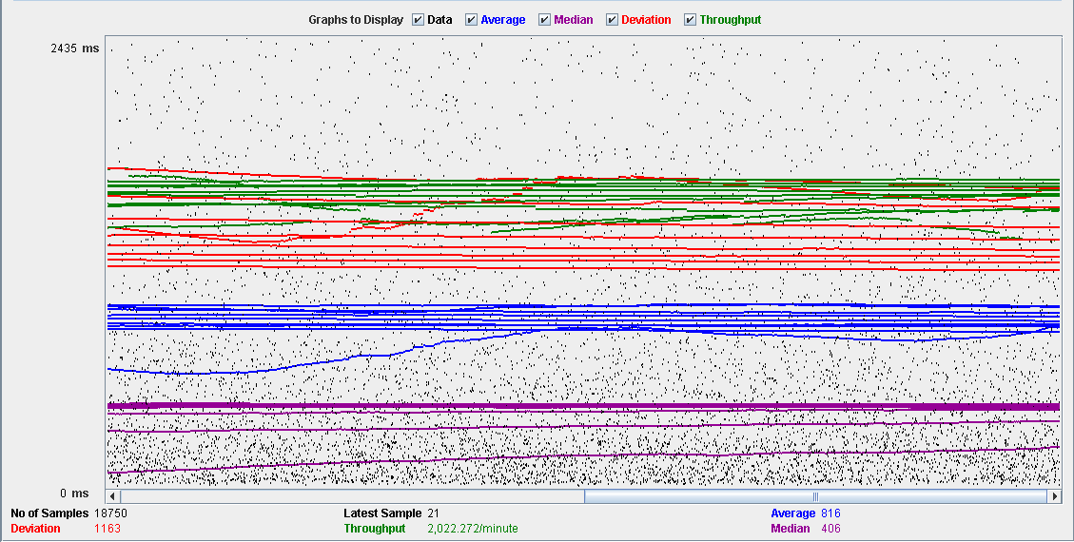

Performance Results:

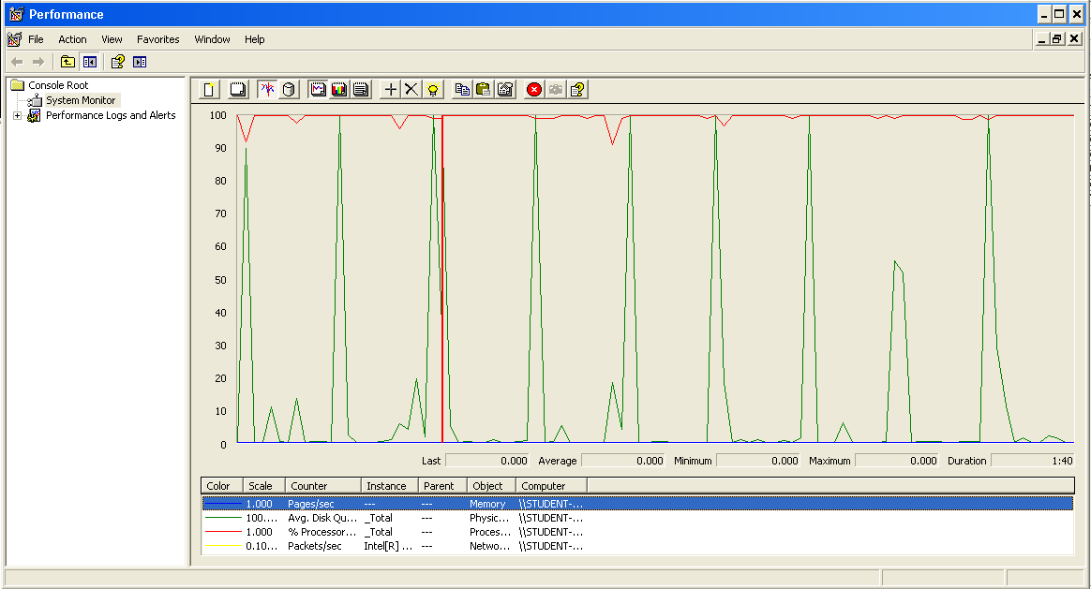

Again we can see that the CPU is always being used while the disk usage shows some periodic peaks.

## Send a broadcast mess

Sequence:

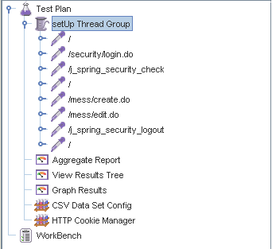

Aggregate Report:

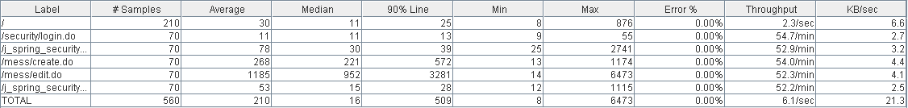

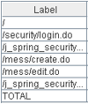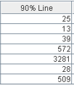

Thread properties:

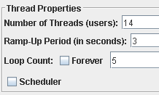

Graph Results:

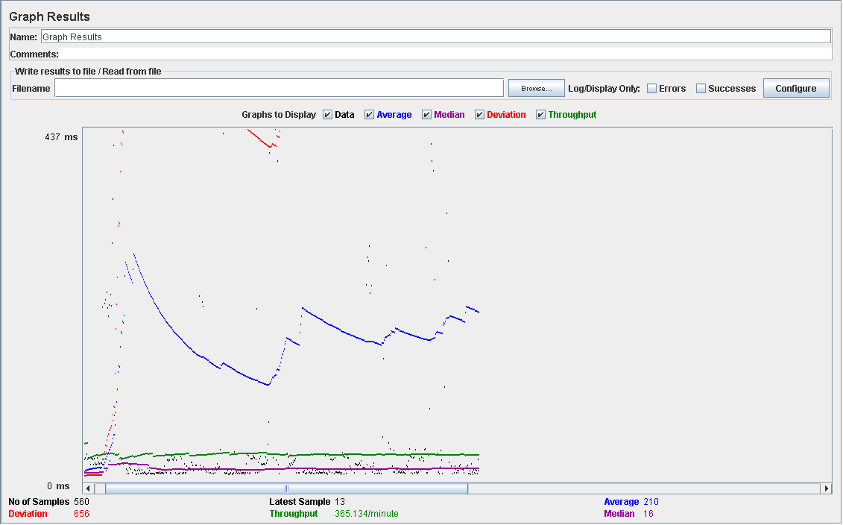

Performance Results:

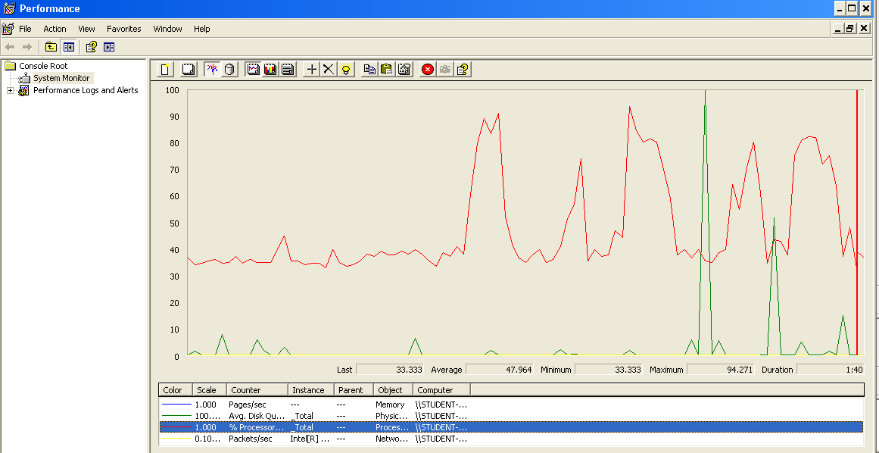

Again we can see that the CPU is always being used while the disk usage shows some peaks.

## Conclusion

The test was performed using:

CPU: i7 7700HQ (2 cores in the virtual machine)

RAM: 2 GB (virtual machine)

For this use case we can say that the limitation occurs during the creation process, being the maximum of concurrent users 14.

# Dashboard

## Display the dashboard and set the spammers

Sequence:

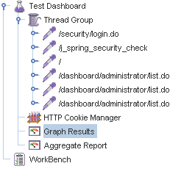

Aggregate Report:

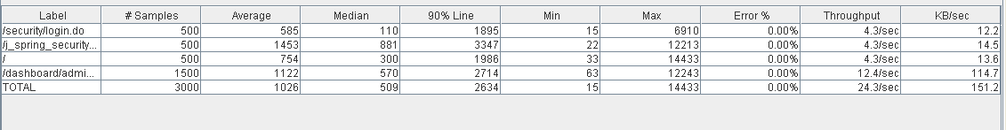

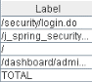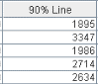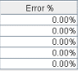

Thread properties:

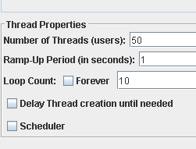

Graph Results:

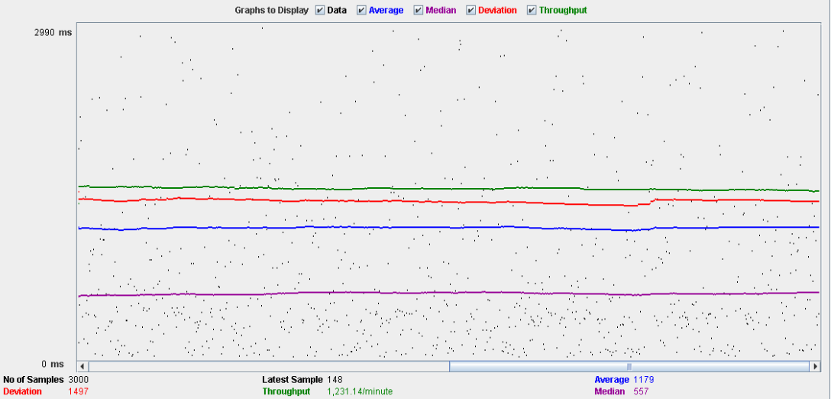

Performance Results:

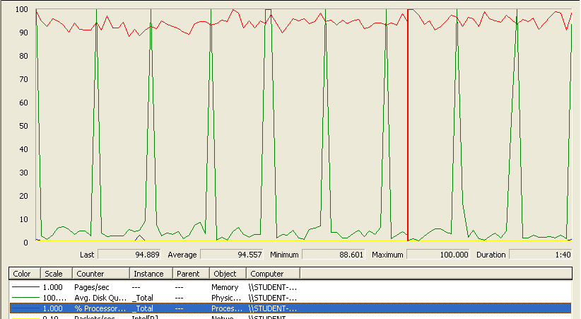

The CPU was always at its limit while the disk usage showed many peaks.

## Conclusion

The test was performed using:

CPU: i5 2500K (2 cores in the virtual machine)

RAM: 2 GB (virtual machine)

For this use case we can say that the limitation occurs around 50 users when the time of respond begins to be very high.

# Configuration

## Display the configuration and edit it

Sequence:

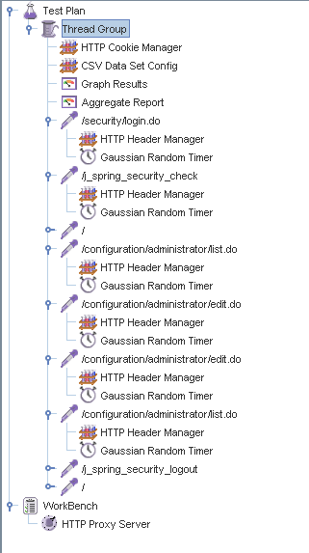

Aggregate Report:

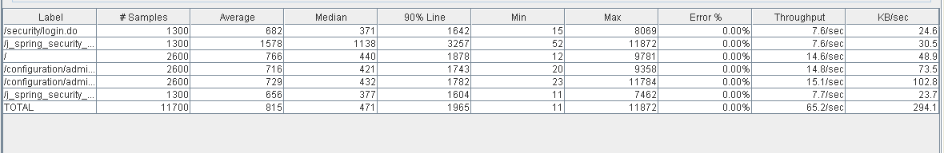

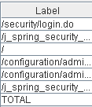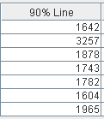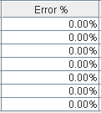

Thread properties:

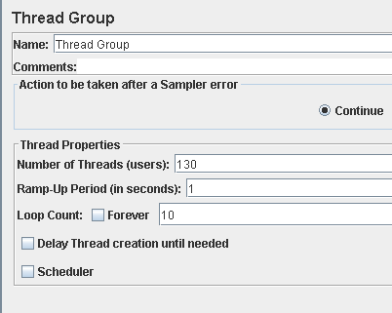

Graph Results:

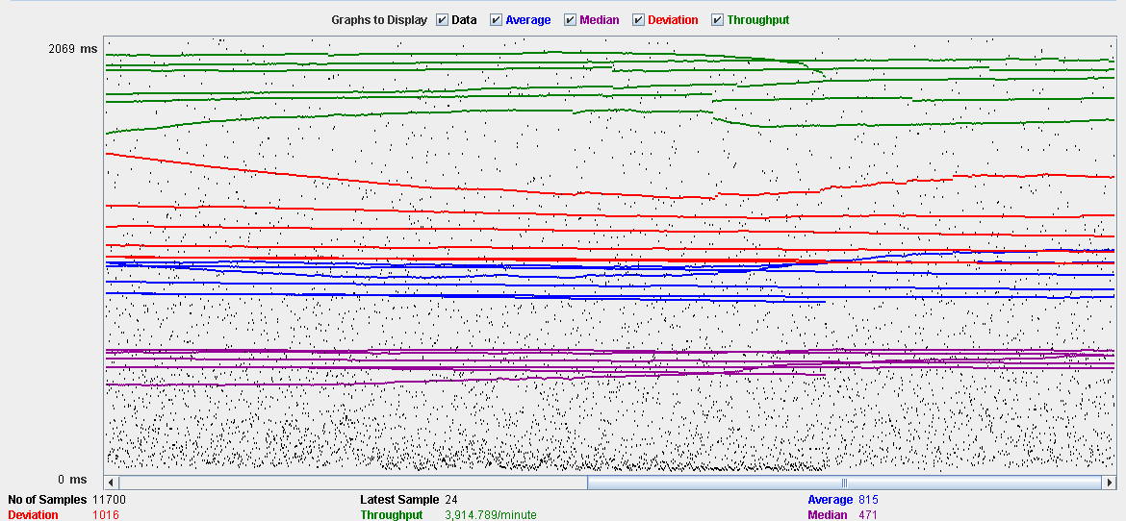

Performance Results:

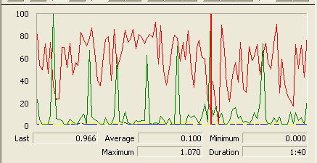

The CPU was always at its limit while the disk usage showed many peaks.

## Conclusion

The test was performed using:

CPU: i5 2500K (2 cores in the virtual machine)

RAM: 2 GB (virtual machine)

For this use case we can say that the limitation occurs around 130 users when the time of respond begins to be very high.

# Problem

## Create

Sequence:

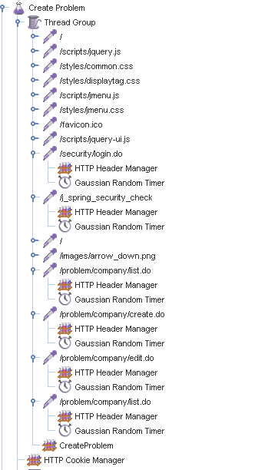

Aggregate Report:

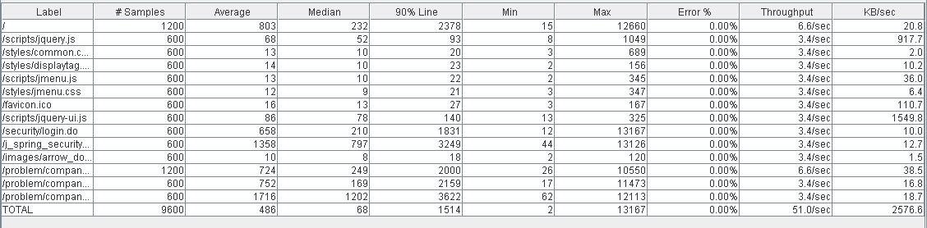

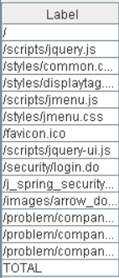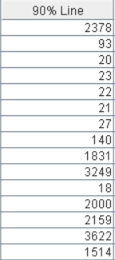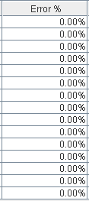

Thread properties:

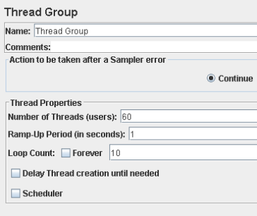

Graph Results:

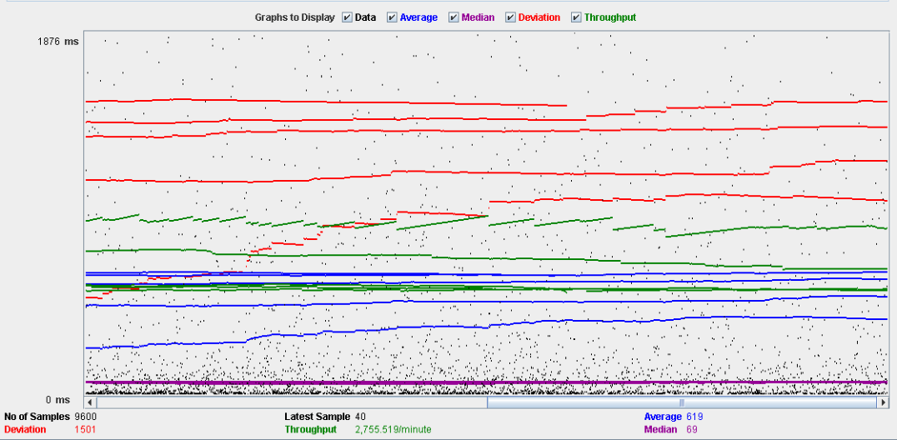

Performance Results:

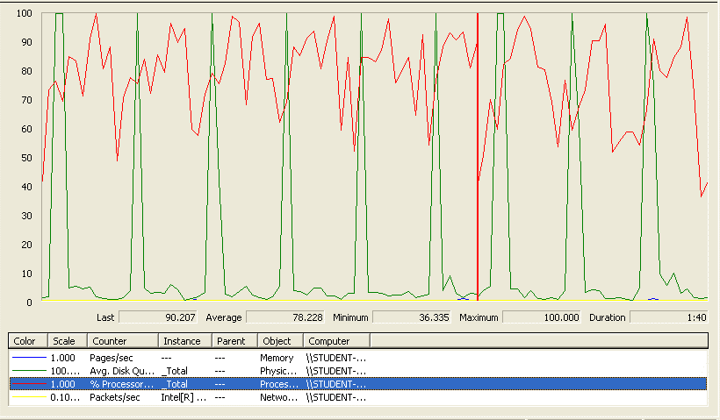

The CPU was always at its limit while the disk usage showed many peaks.

## Edit

Sequence:

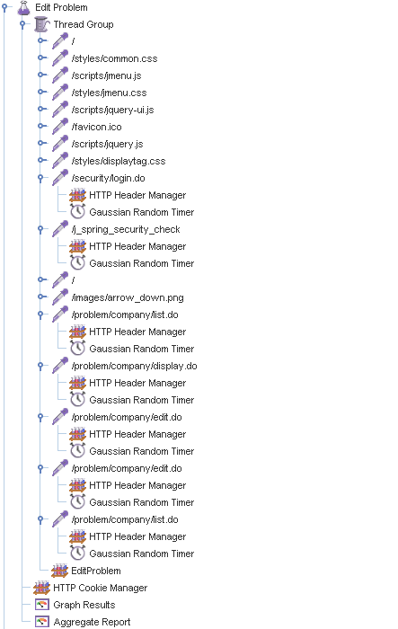

Aggregate Report:

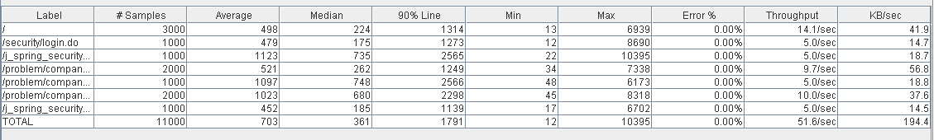

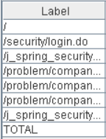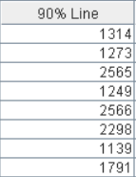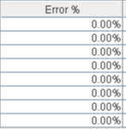

Thread properties:

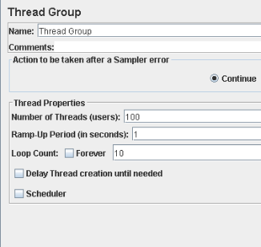

Graph Results:

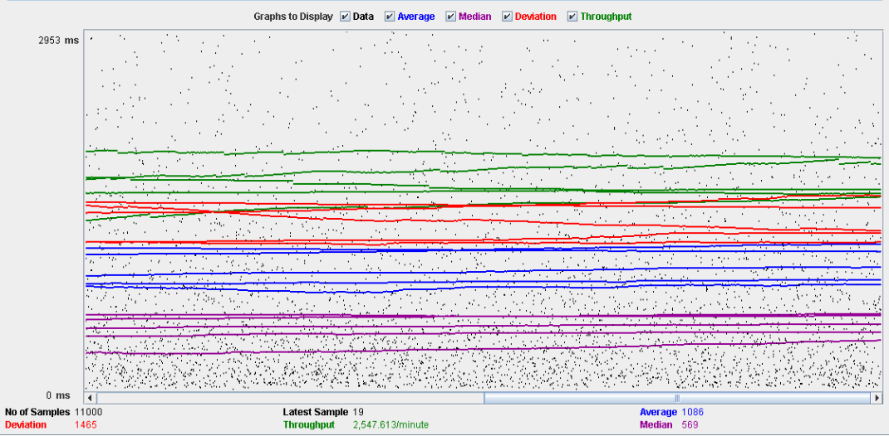

Performance Results:

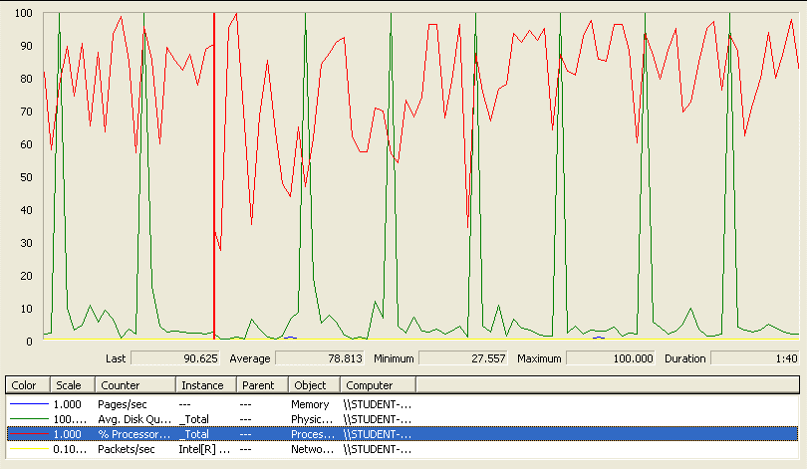

Again we can see that the CPU is always being used while the disk usage shows some periodic peaks.

## Delete

Sequence:

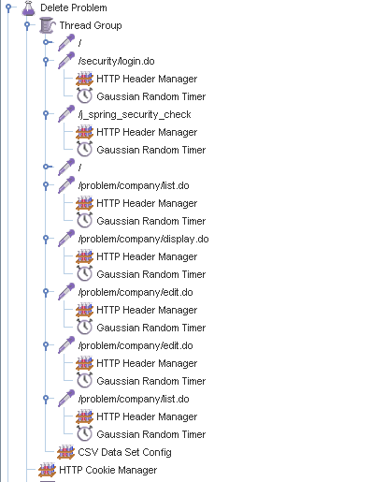

Aggregate Report:

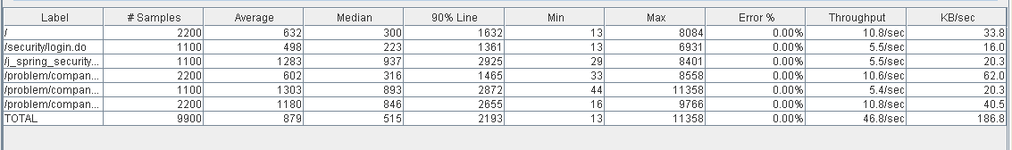

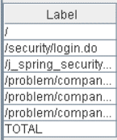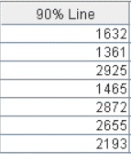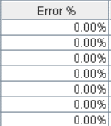

Thread properties:

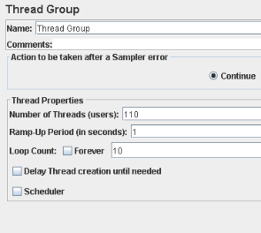

Graph Results:

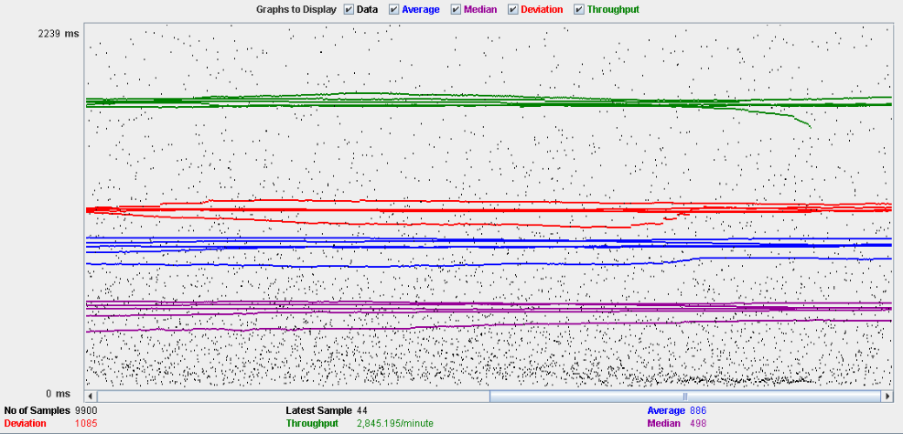

Performance Results:

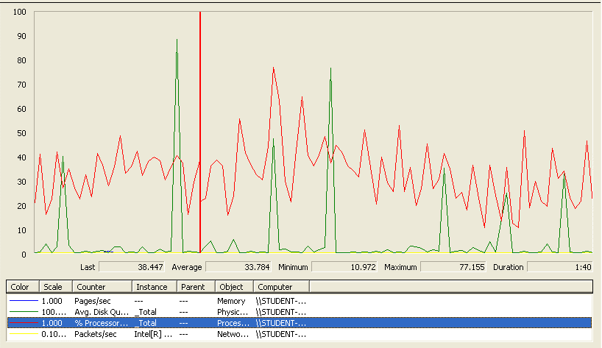

Again we can see that the CPU is always being used while the disk usage shows some periodic peaks.

## Conclusion

The test was performed using:

CPU: i5 2500k (2 cores in the virtual machine)

RAM: 2 GB (virtual machine)

For this use case we can say that the limitation occurs during the create process, being the maximum of concurrent users 60 because the time of respond begins to be very high.

# Finder

## Search and clear

Sequence:

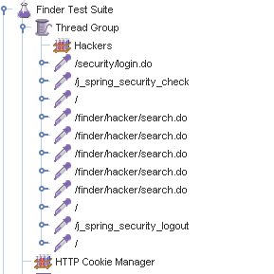

Aggregate Report:



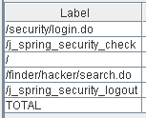 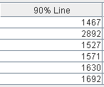 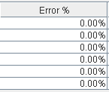

Thread properties:

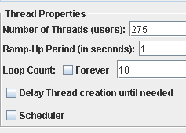

Graph Results:

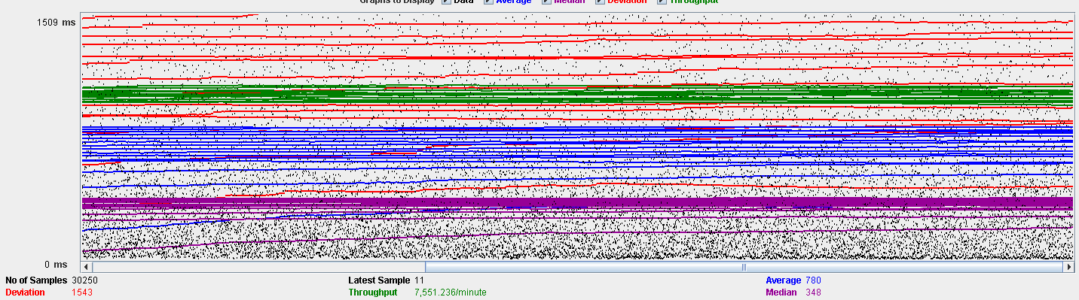

Performance Results:

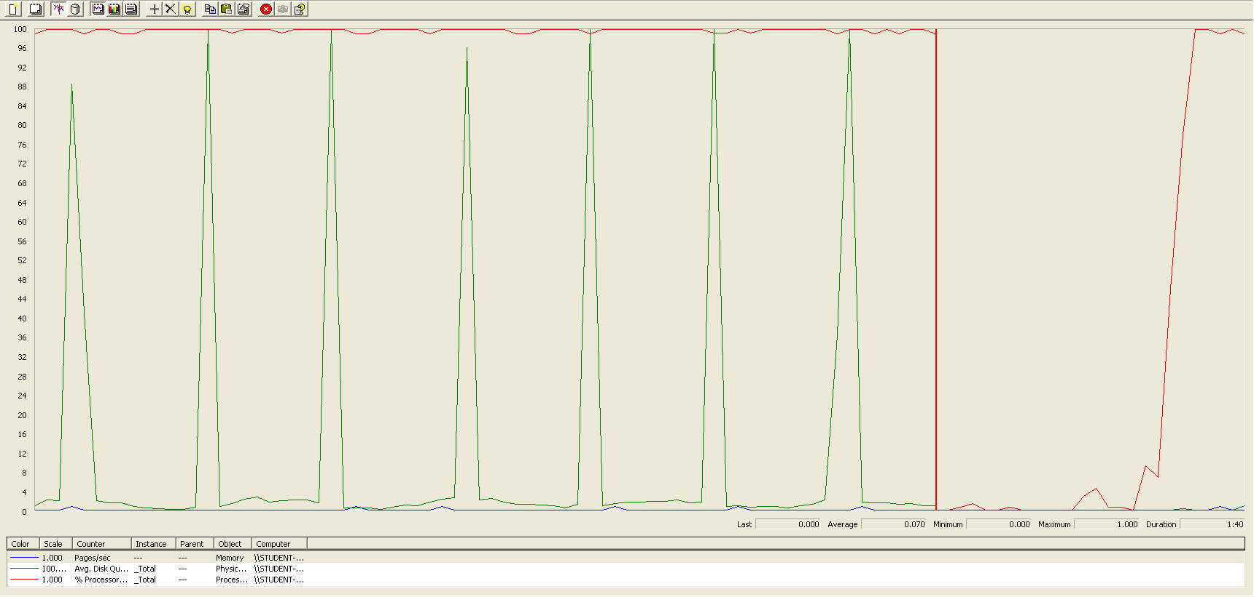

The CPU was always at its limit while the disk usage showed many peaks.

## Conclusion

The test was performed using:

CPU: i7 7300hq (2 cores in the virtual machine)

RAM: 2 GB (virtual machine)

For this use case we can say that the limitation is with a maximum of 275 concurrent users.

# Curricula

## Create a curriculum

Sequence:

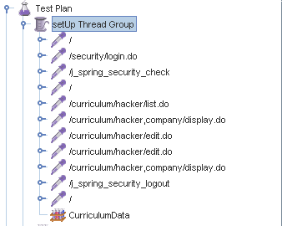

Aggregate Report:

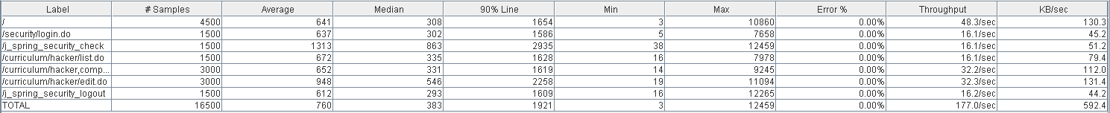



Thread properties:



Graph Results:

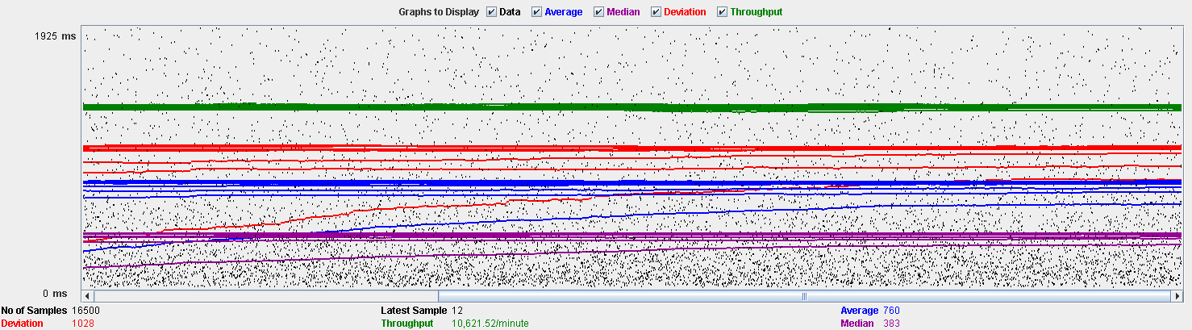

Performance Results:



The CPU was always at its limit while the disk usage showed many peaks.

## Delete a curriculum

Sequence:

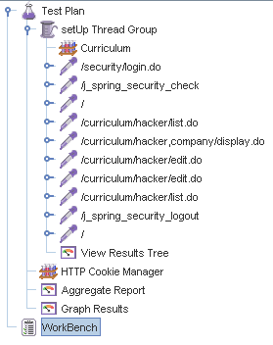

Aggregate Report:

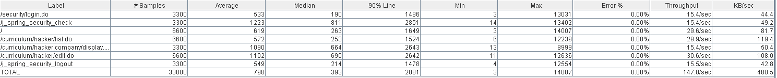



Thread properties:

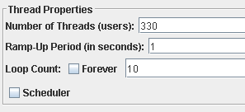

Graph Results:

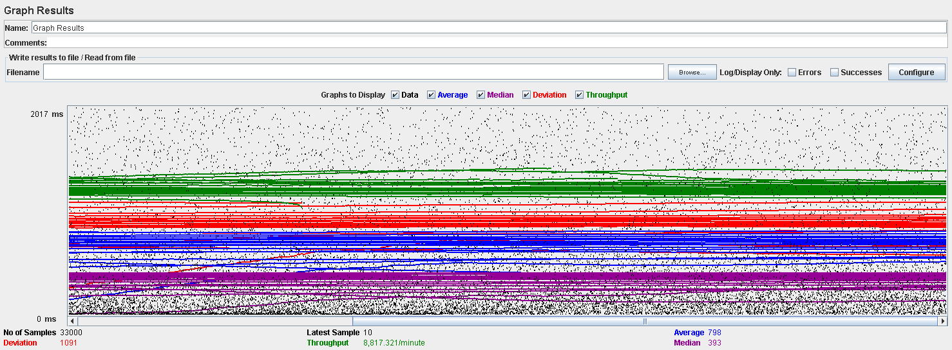

Performance Results:

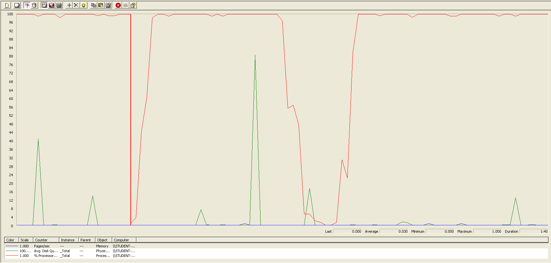

Again we can see that the CPU is always being used while the disk usage shows some little peaks.

# Datas (Personal, Education, Position and Miscellaneous data)

## Create all datas

Sequence:

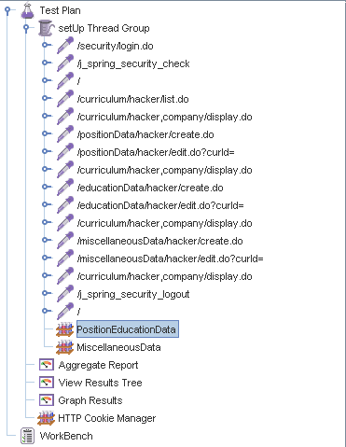

Aggregate Report:

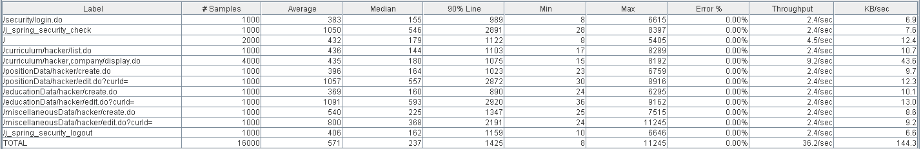

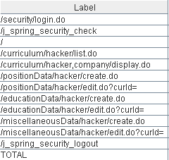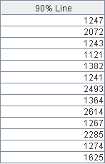

Thread properties:

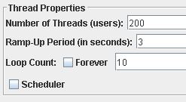

Graph Results:

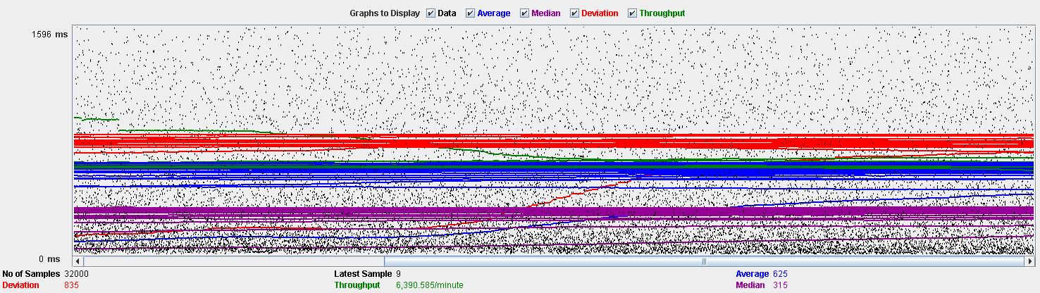

Performance Results:

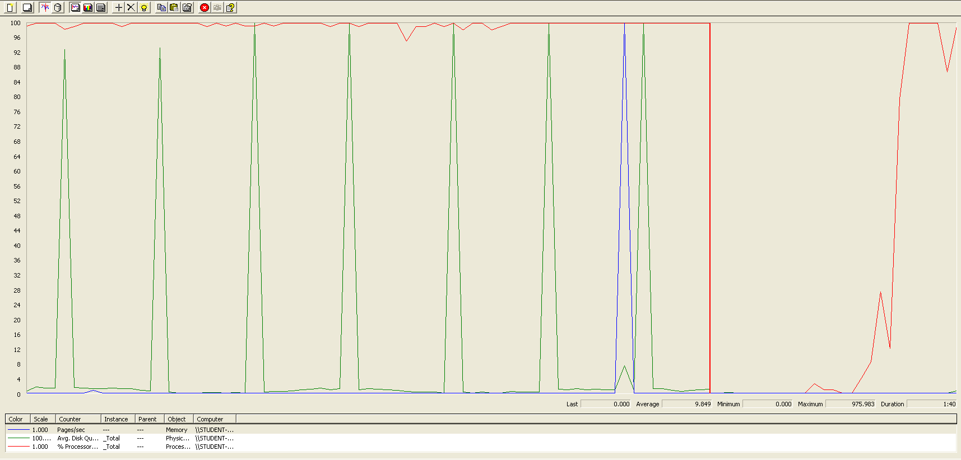

Again we can see that the CPU is always being used while the disk usage shows some periodic peaks.

## Edit a position data

Sequence:

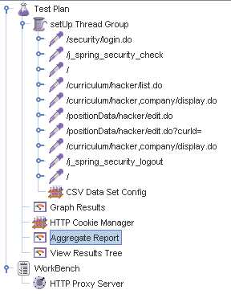

Aggregate Report:

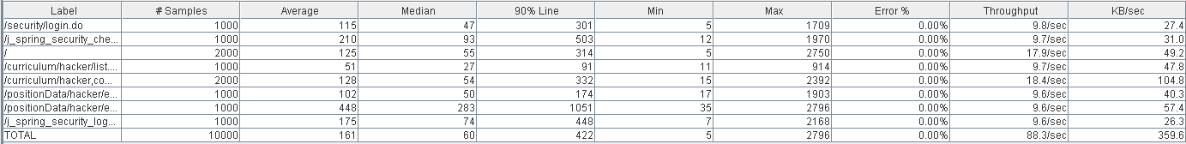

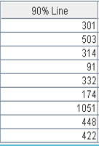

Thread properties:

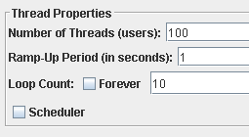

Graph Results:

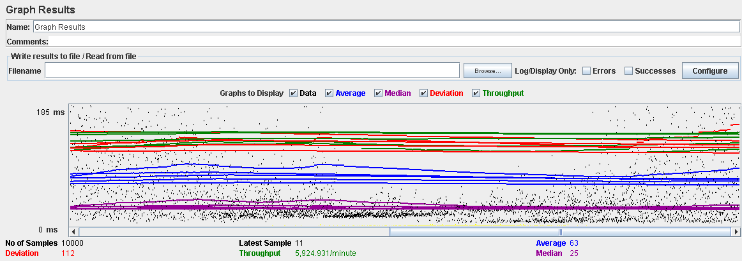

Performance Results:

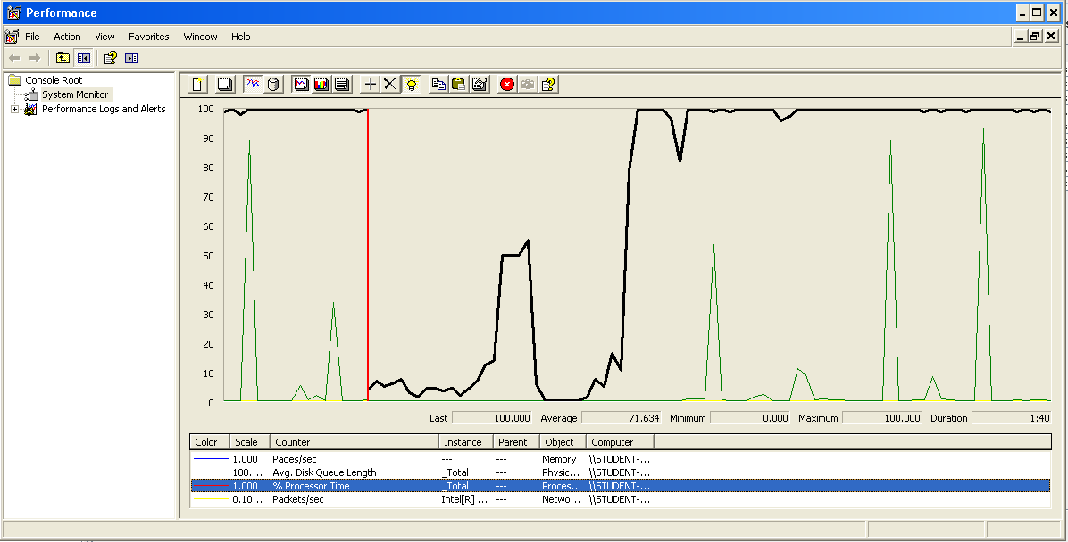

Again we can see that the CPU is always being used while the disk usage shows some peaks.

## Edit a education data

Sequence:

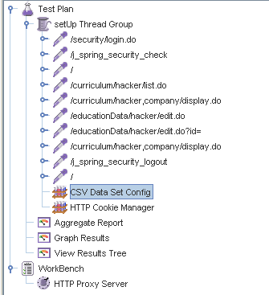

Aggregate Report:

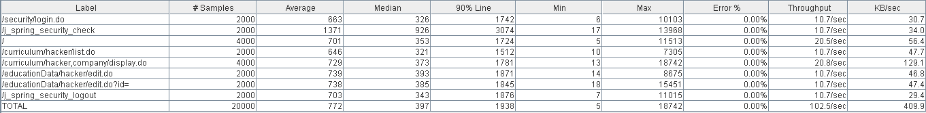

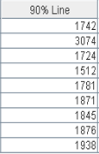

Thread properties:

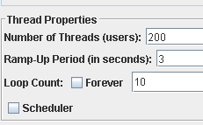

Graph Results:

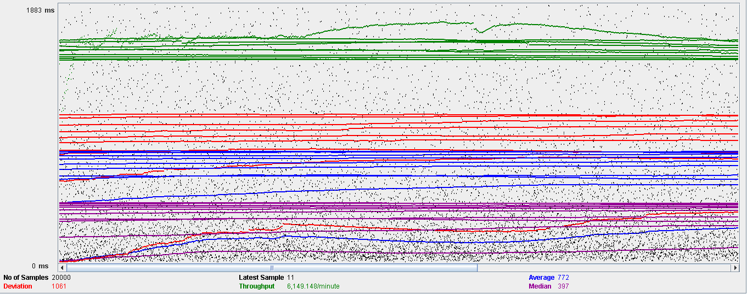

Performance Results:

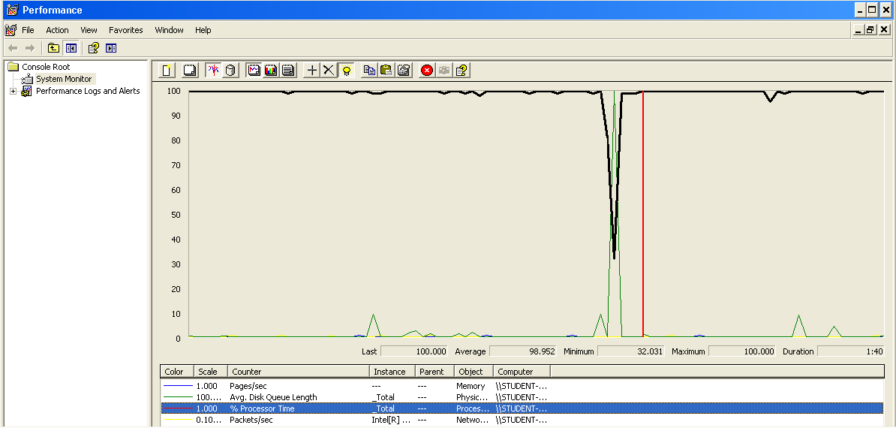

Again we can see that the CPU is always being used while the disk usage shows some peaks.

## Edit a miscellaneous data

Sequence:

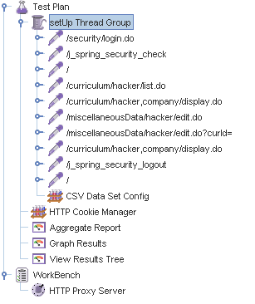

Aggregate Report:

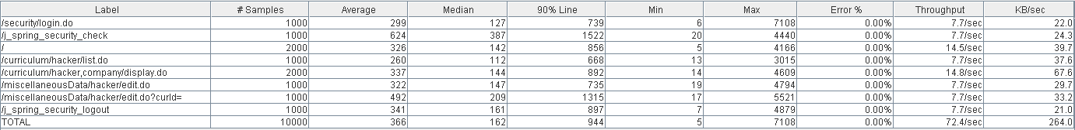

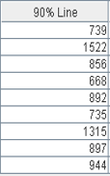

Thread properties:

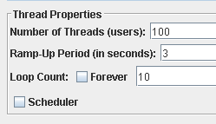

Graph Results:

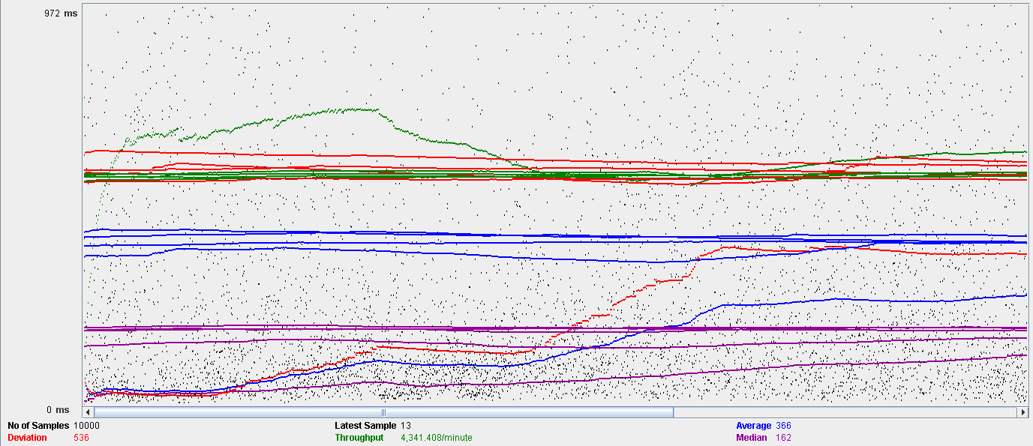

Performance Results:

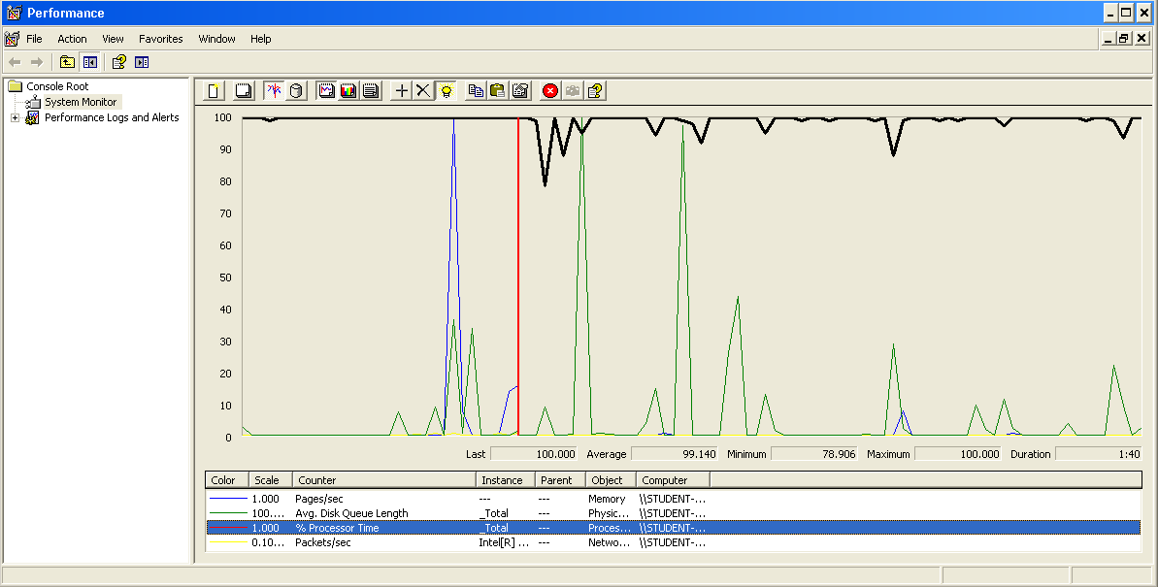

Again we can see that the CPU is always being used while the disk usage shows some peaks.

## Delete a position data

Sequence:

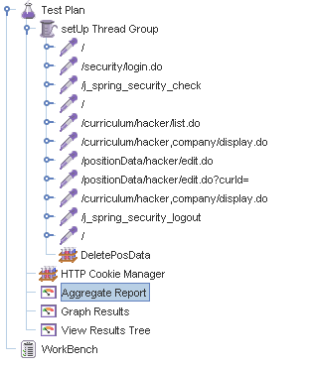

Aggregate Report:

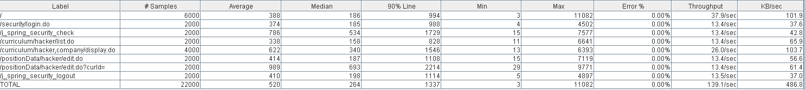

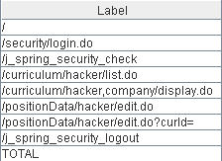 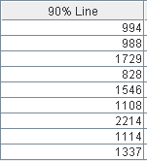

Thread properties:

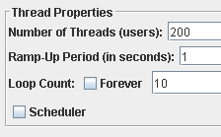

Graph Results:

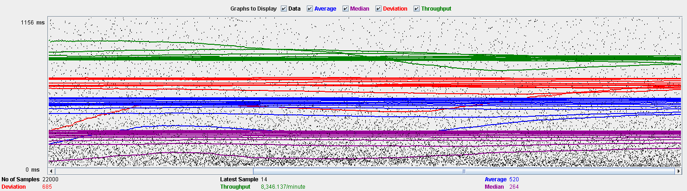

Performance Results:

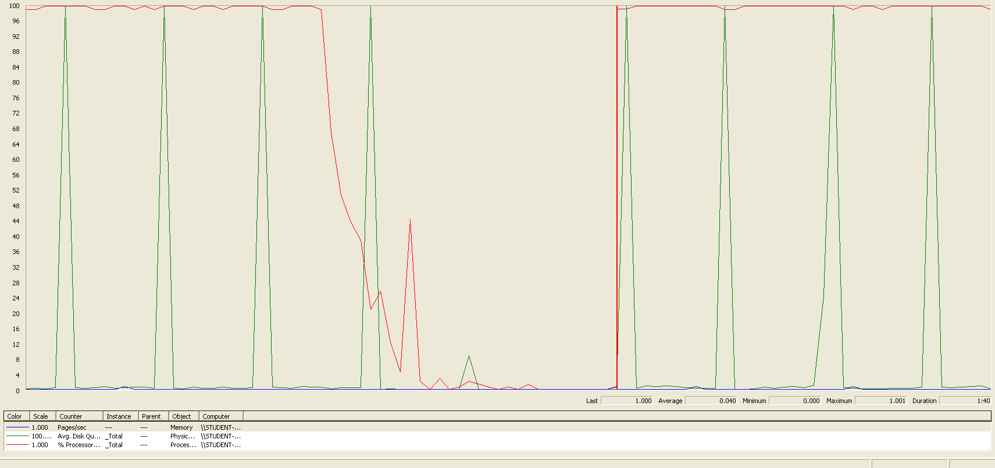

Again we can see that the CPU is always being used while the disk usage shows some peaks.

## Delete a education data

Sequence:

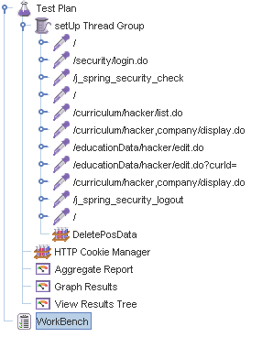

Aggregate Report:

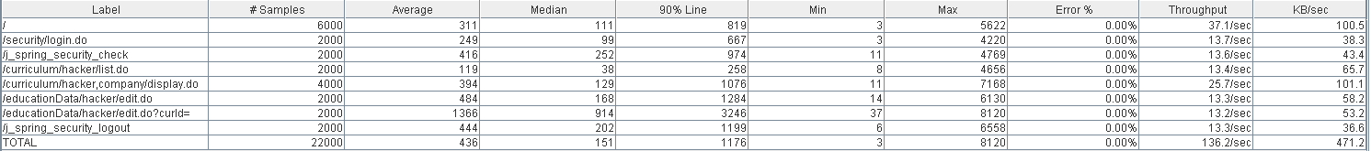

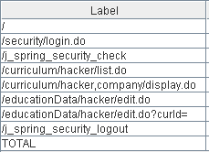 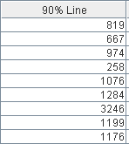

Thread properties:



Graph Results:

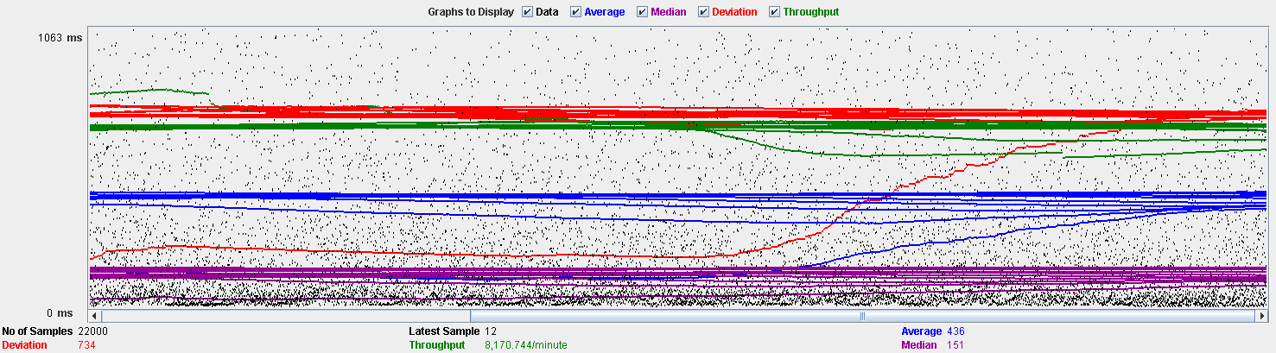

Performance Results:

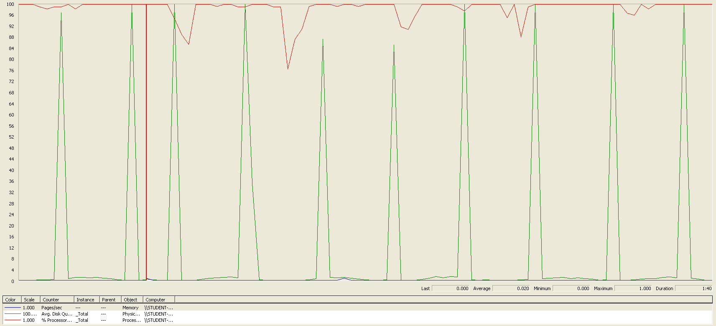

Again we can see that the CPU is always being used while the disk usage shows some peaks.

## Delete a miscellaneous data

Sequence:

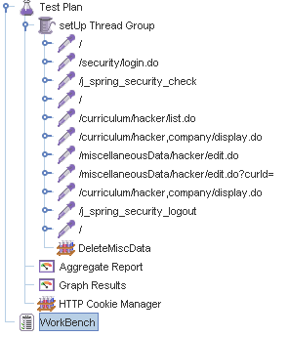

Aggregate Report:

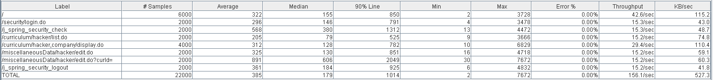

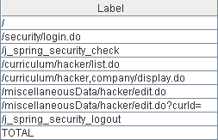 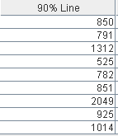

Thread properties:



Graph Results:

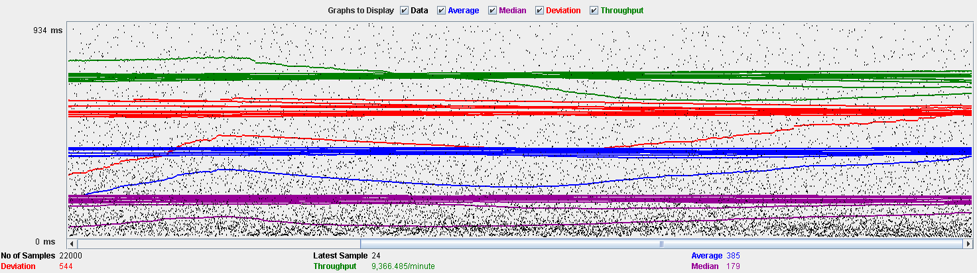

Performance Results:

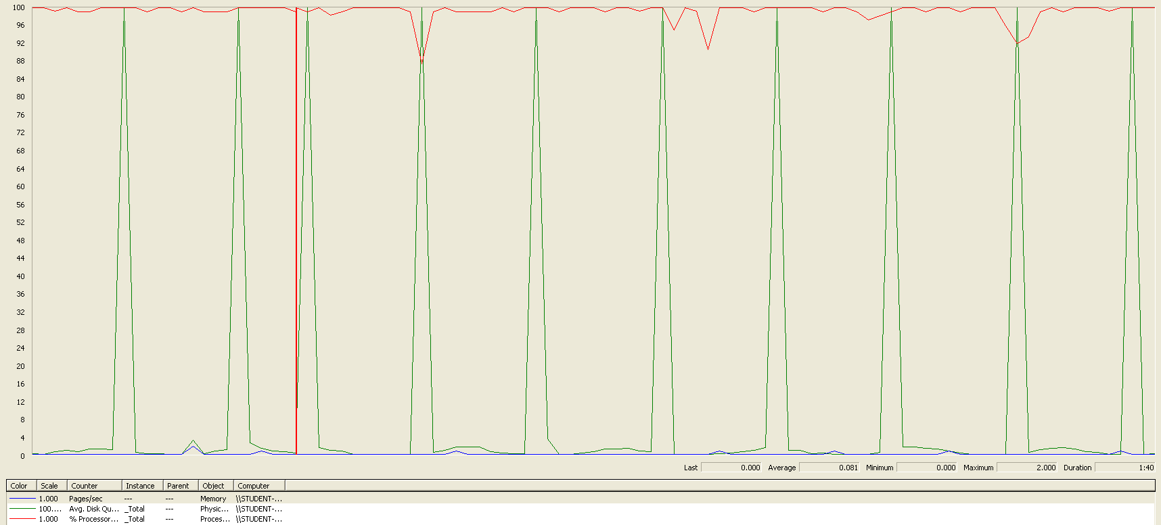

Again we can see that the CPU is always being used while the disk usage shows some peaks.

## Conclusion

The test was performed using:

CPU: i7 6700hq (2 cores in the virtual machine)

RAM: 4 GB (virtual machine)

For this use case we can say that the limitation occurs during the creation process, being the maximum of concurrent users 180.

# Social profile

## Create

Sequence:

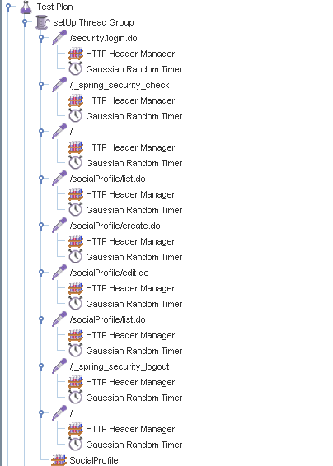

Aggregate Report:

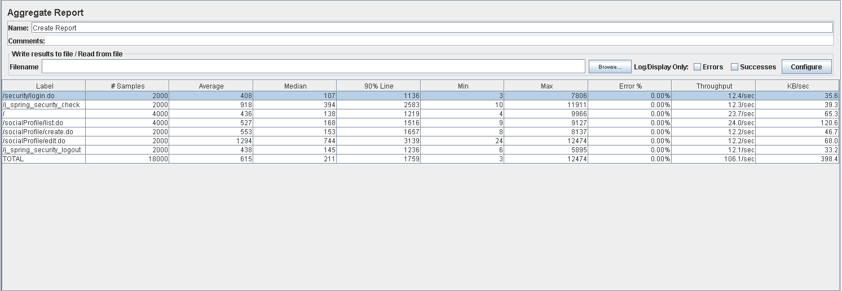



Thread properties:

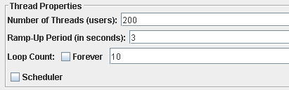

Graph Results:

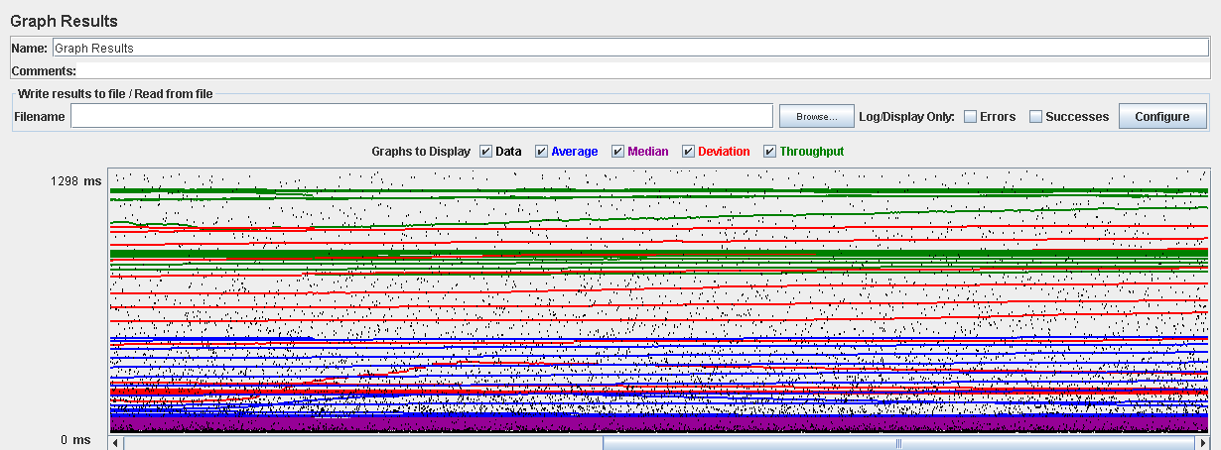

Performance Results:

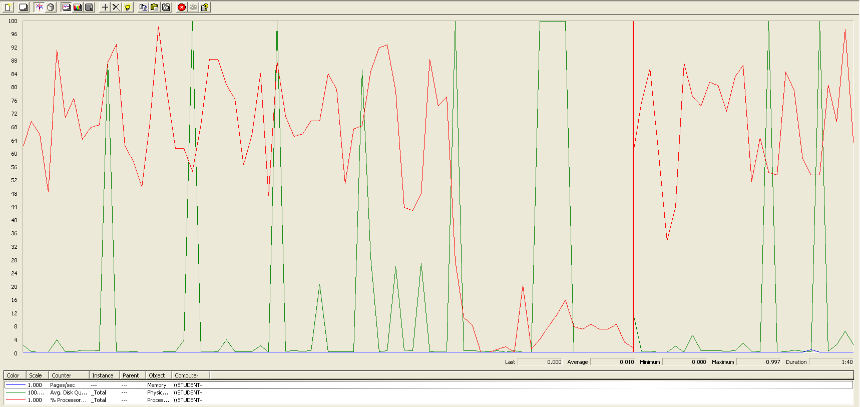

The CPU was always at its limit while the disk usage showed many peaks.

## Edit

Sequence:

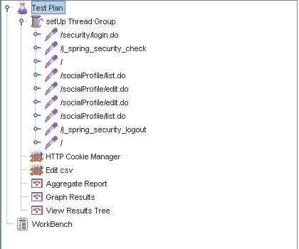

Aggregate Report:

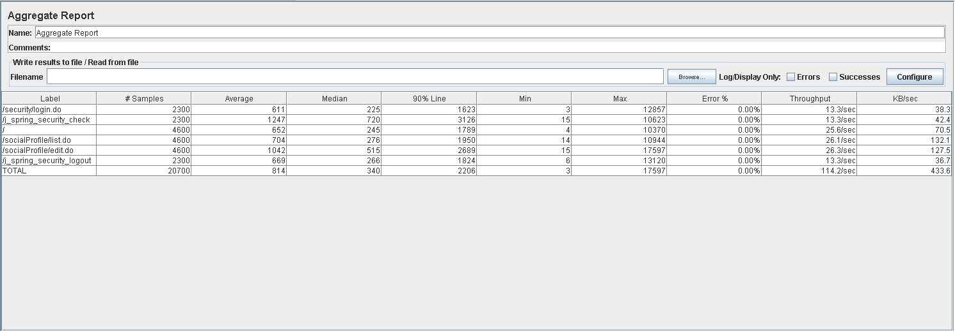

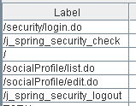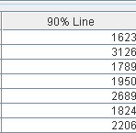

Thread properties:

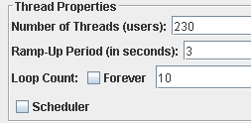

Graph Results:

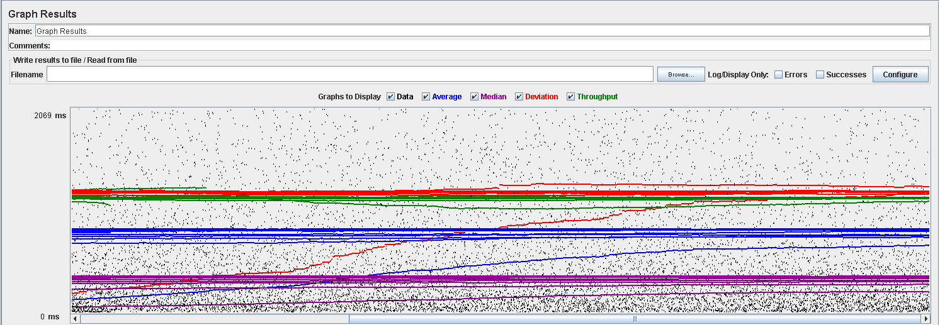

Performance Results:

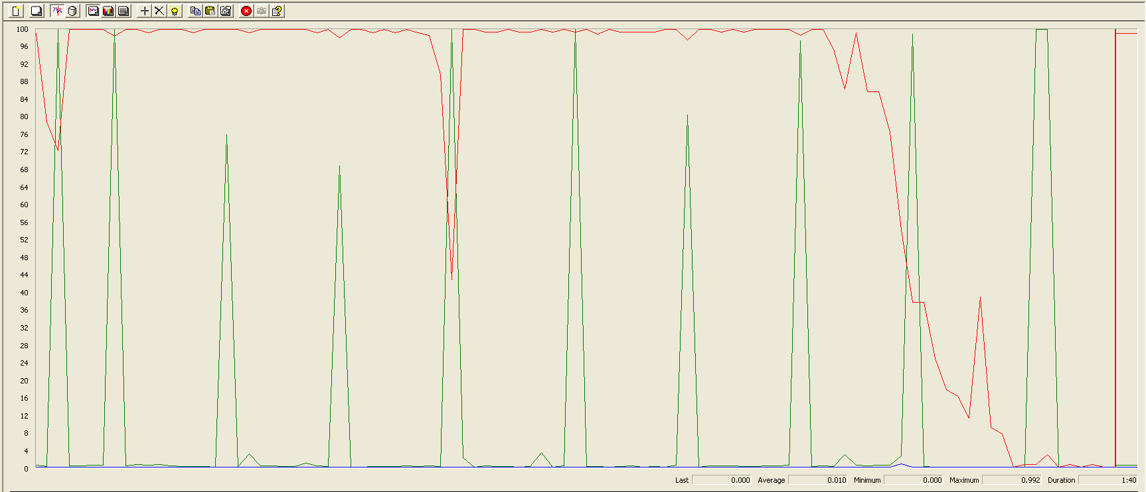

Again we can see that the CPU is always being used while the disk usage shows different peaks at times.

## 

## Delete

Sequence:

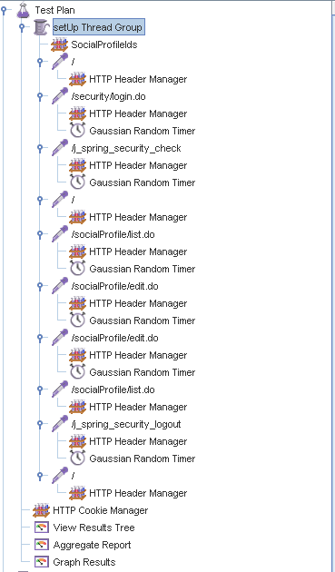

Aggregate Report:

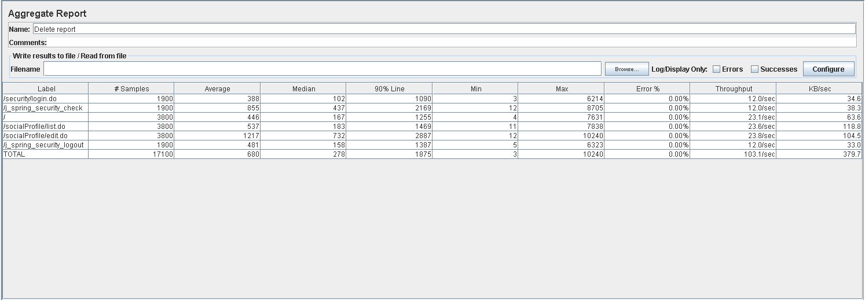

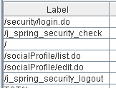

Thread properties:

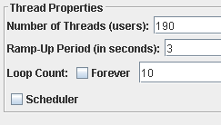

Graph Results:

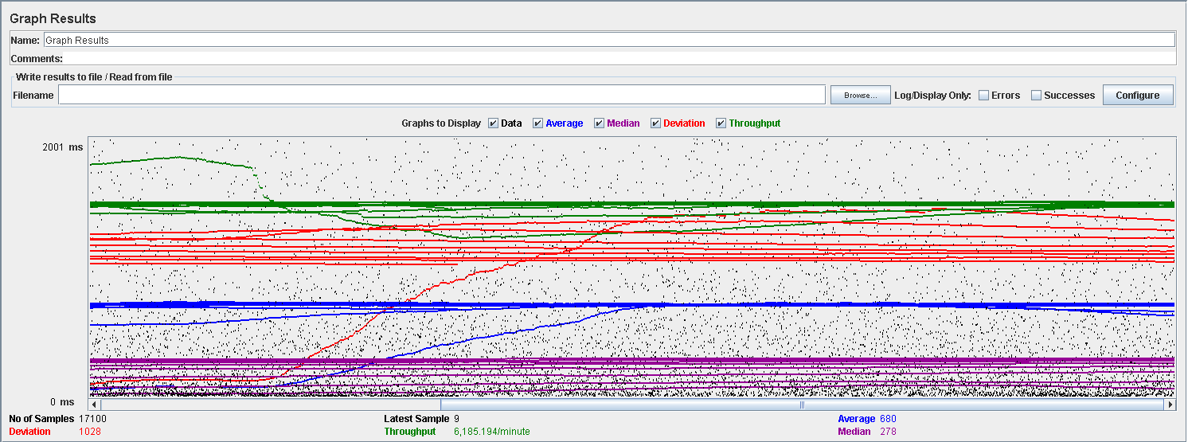

Performance Results:



Again we can see that the CPU is always being used while the disk usage shows some periodic peaks.

## Conclusion

The test was performed using:

CPU: i7 7700hq (2 cores in the virtual machine)

RAM: 4 GB (virtual machine)

For this use case we can say that the limitation occurs during the creation process, being the maximum of concurrent users 190.

# Actor

## Create

Sequence:

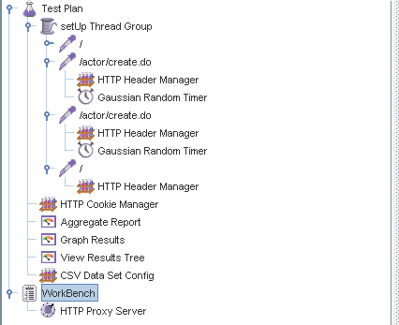

Aggregate Report:



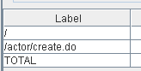 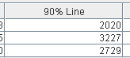 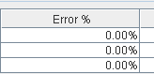

Thread properties:



Graph Results:

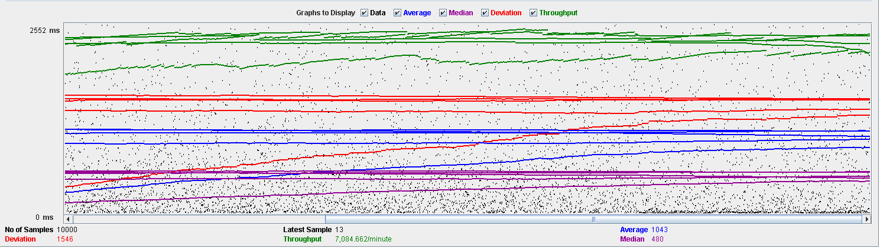

Performance Results:

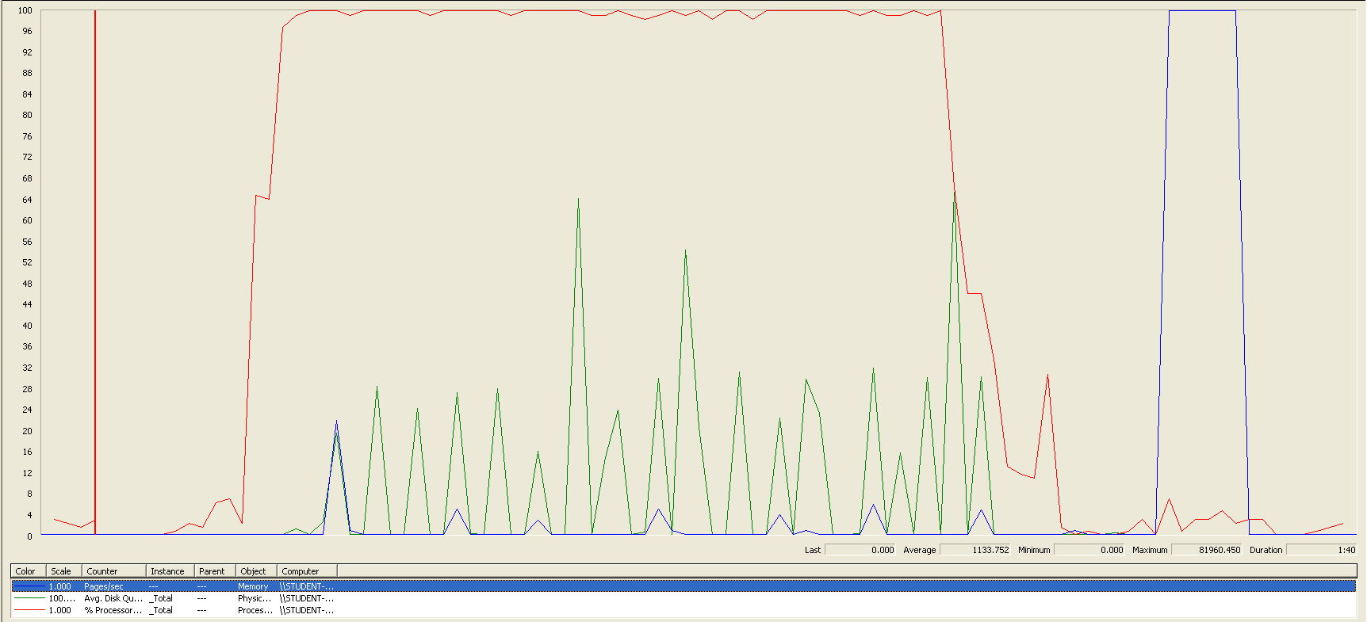

The CPU was always at its limit while the disk usage has a lot of peaks.

## Edit

Sequence:

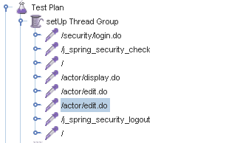

Aggregate Report:





Thread properties:

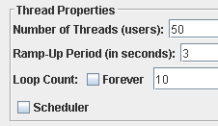

Graph Results:

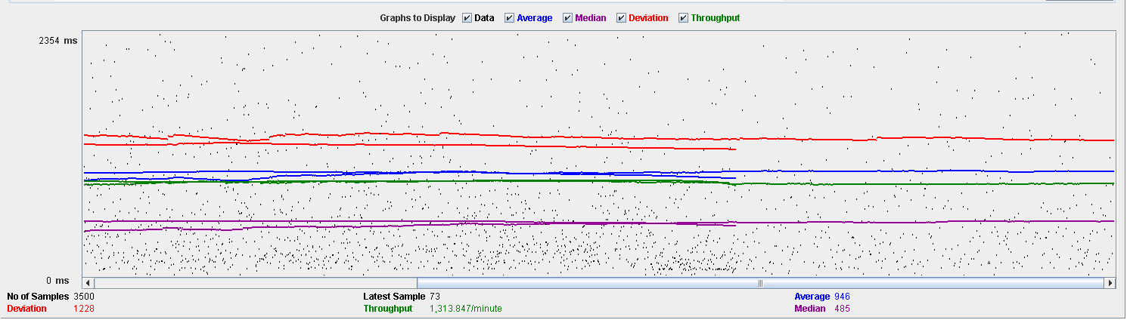

Performance Results:

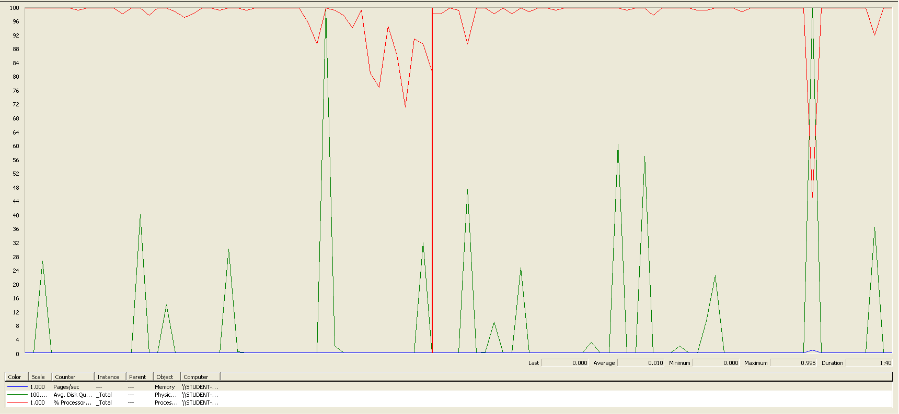

Again we can see that the CPU is always being used while the disk usage has some peaks at times.

## Delete

Sequence:



Aggregate Report:



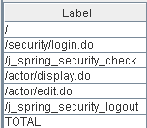

Thread properties:

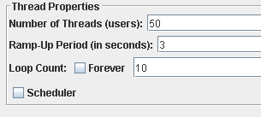

Graph Results:

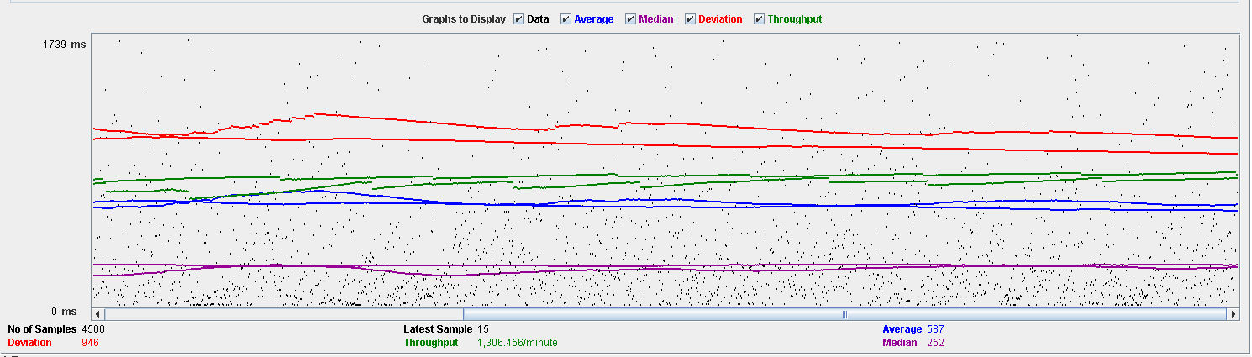

Performance Results:

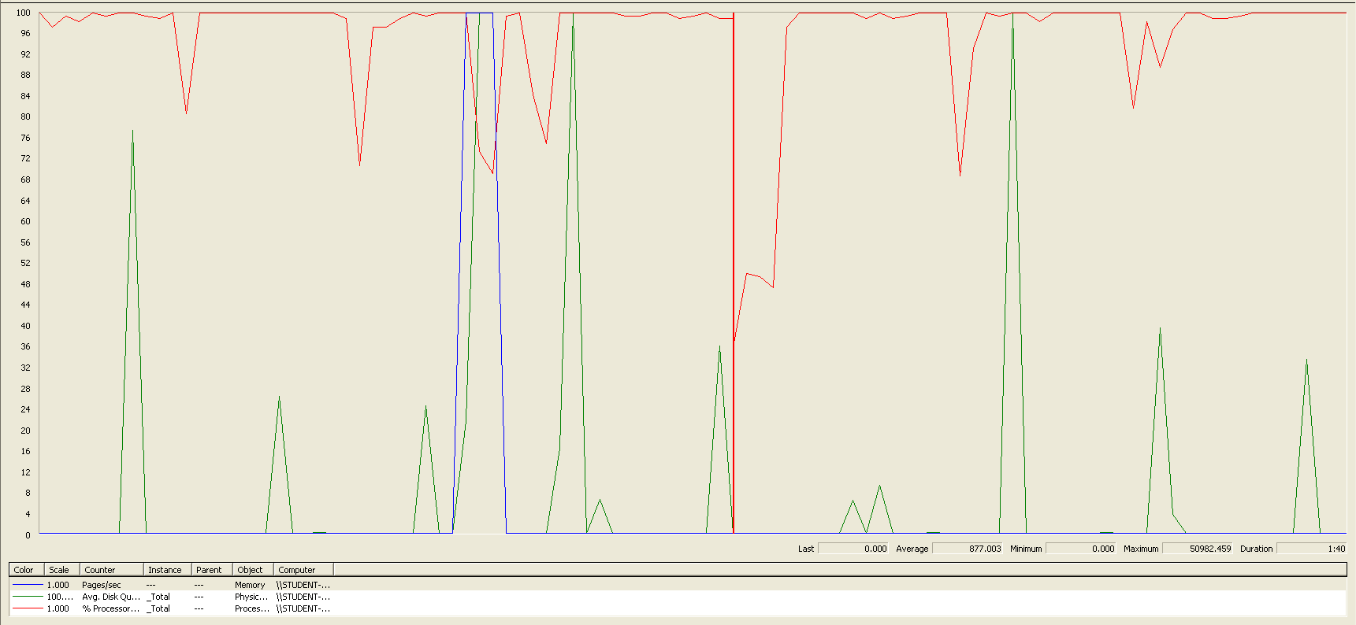

Again we can see that the CPU is always being used while the disk usage has different peaks.

## Conclusion

The test was performed using:

CPU: i7 7700hq (2 cores in the virtual machine)

RAM: 4 GB (virtual machine)

For this use case we can say that the limitation occurs during the creation process, being the maximum of concurrent users is 50.

# Application

## Create

Sequence:

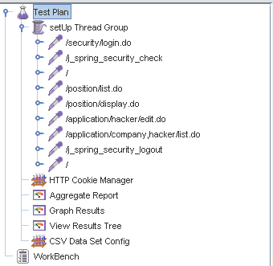

Aggregate Report:

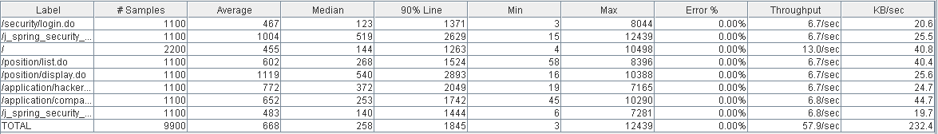

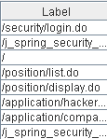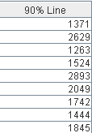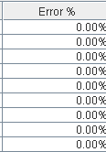

Thread properties:

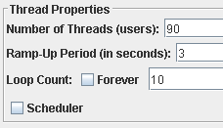

Graph Results:

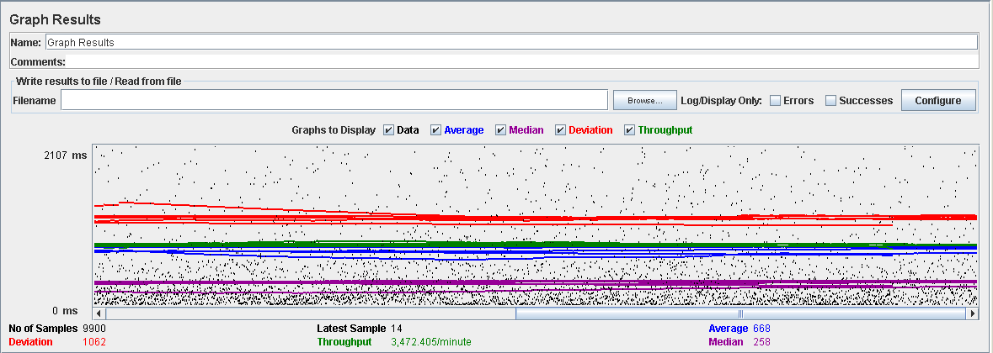

Performance Results:

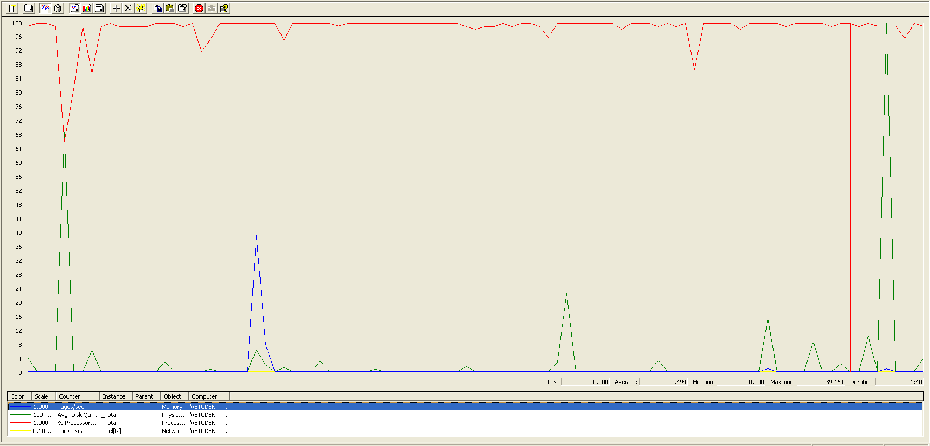

The CPU was always at its limit while the disk usage has some peaks.

## Edit

Sequence:

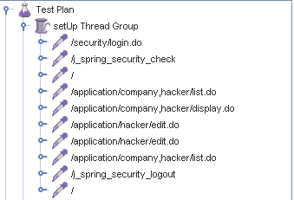

Aggregate Report:

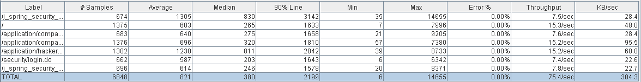

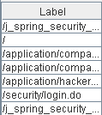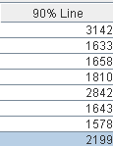

Thread properties:

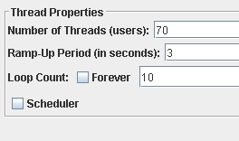

Graph Results:

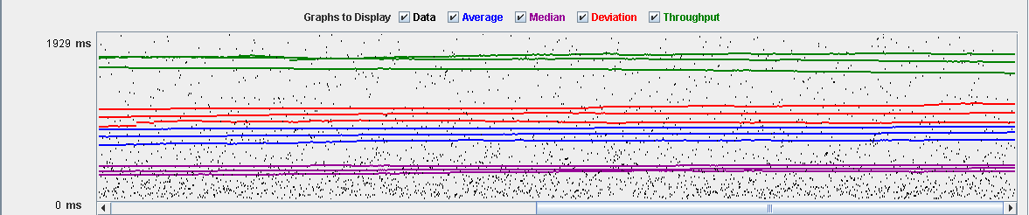

Performance Results:

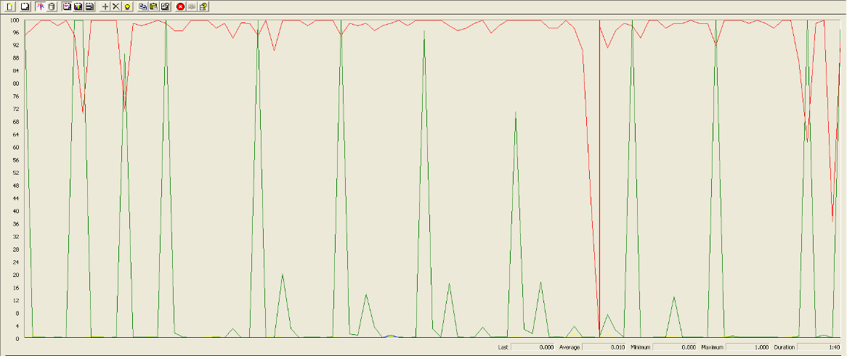

Again we can see that the CPU is always being used while the disk usage has low peaks at times.

## Delete

Sequence:

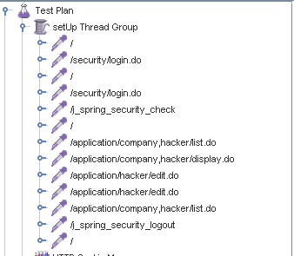

Aggregate Report:

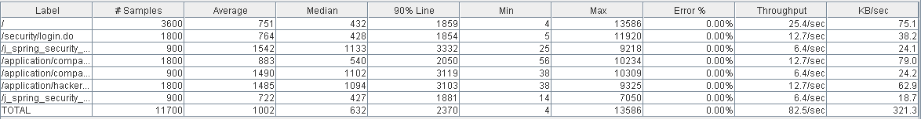

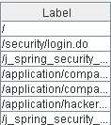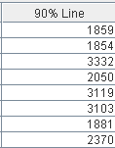

Thread properties:

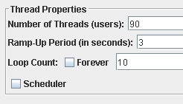

Graph Results:

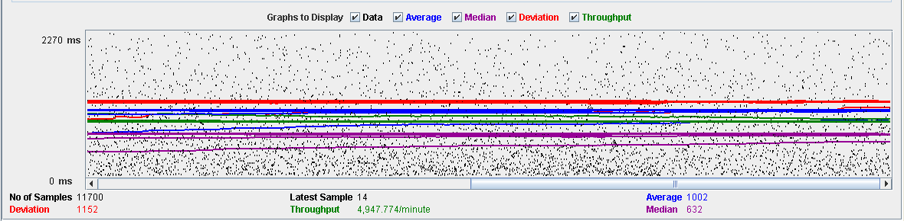

Performance Results:

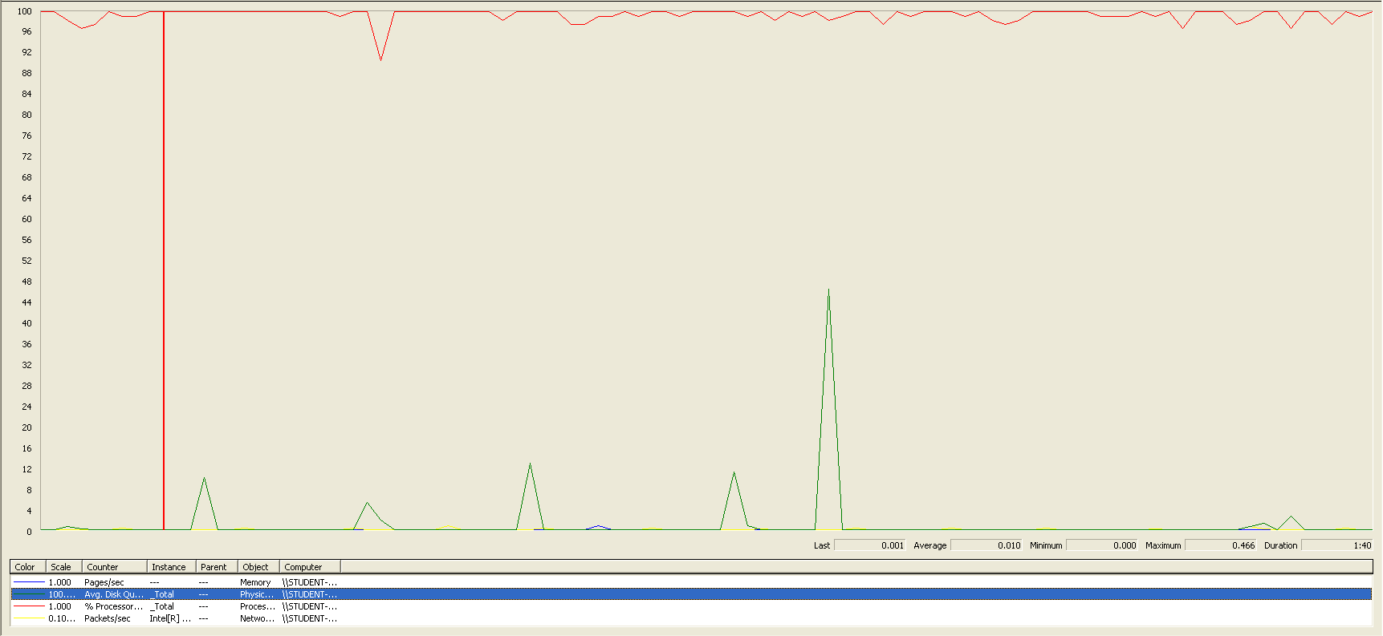

Again we can see that the CPU is always being used while the disk usage has different peaks.

## Conclusion

The test was performed using:

CPU: i7 7700hq (2 cores in the virtual machine)

RAM: 4 GB (virtual machine)

For this use case we can say that the limitation occurs during the creation process, being the maximum of concurrent users 70.

# Audit

## Assign

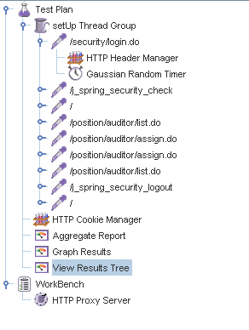

Aggregate Report:

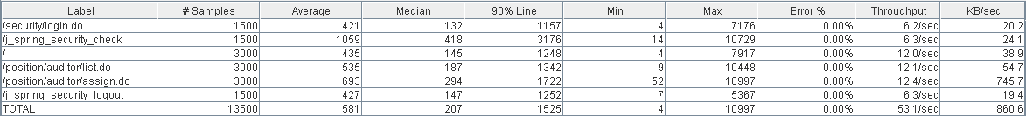



Thread properties:

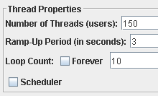

Graph Results:

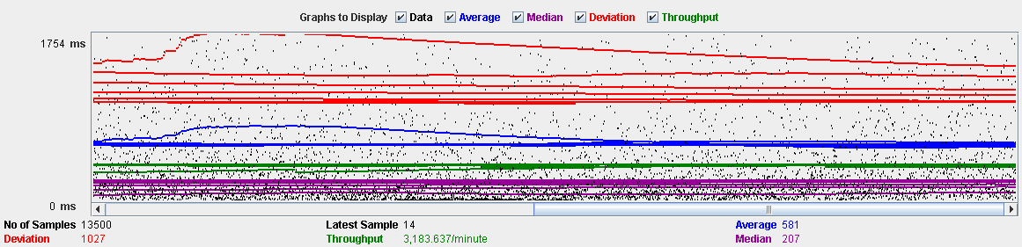

Performance Results:

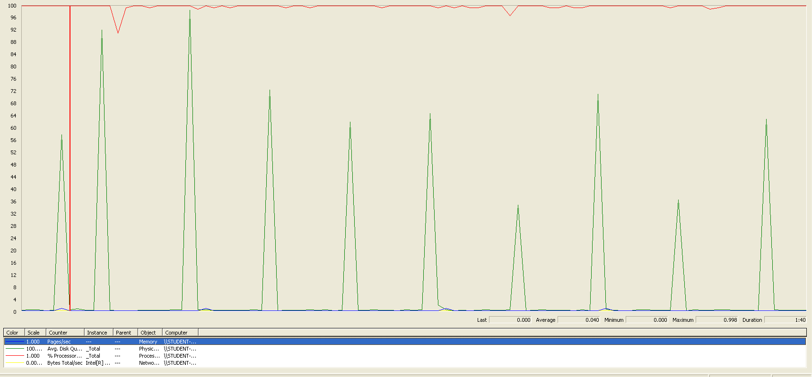

The CPU was always at its limit while the disk usage showed many peaks.

## Create

Sequence:

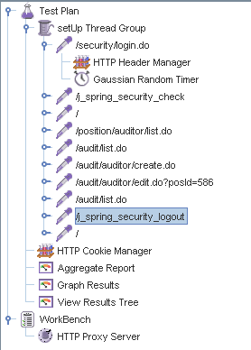

Aggregate Report:

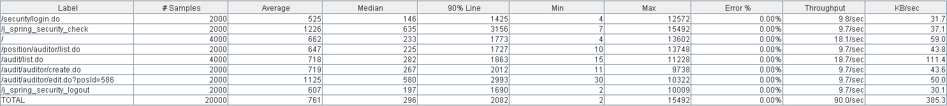



Thread properties:

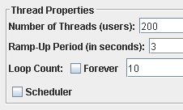

Graph Results:



Performance Results:

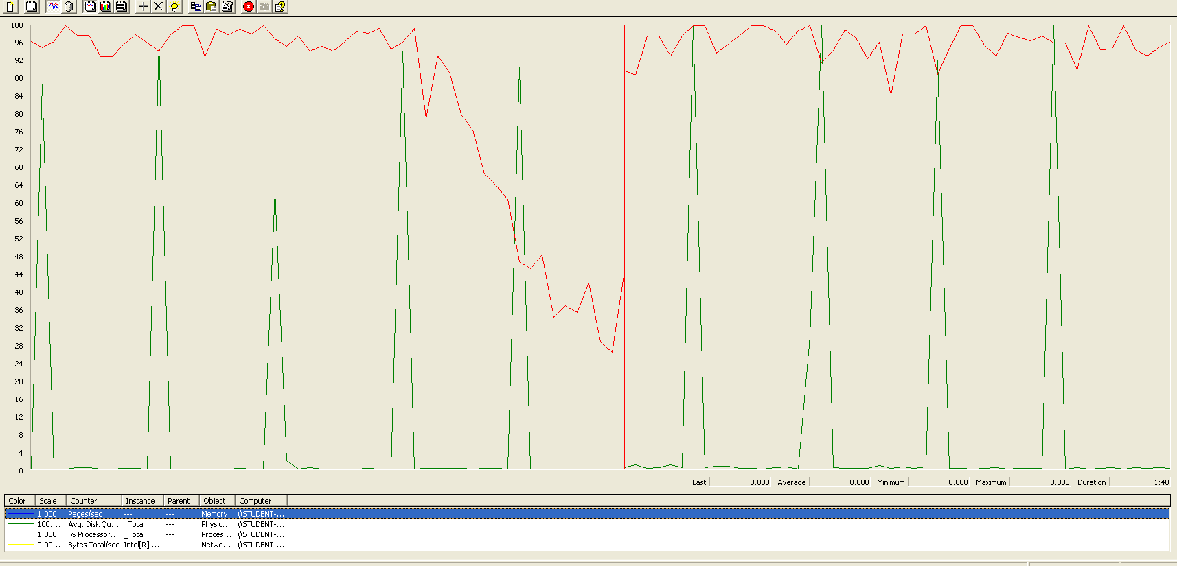

The CPU was always at its limit in various points of the execution while the disk usage showed many peaks.

## Edit

Sequence:

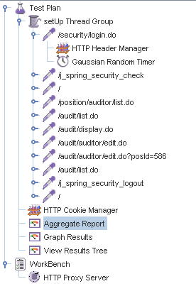

Aggregate Report:

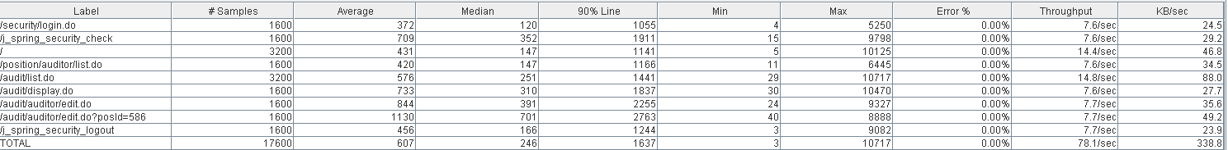



Thread properties:

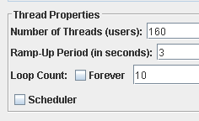

Graph Results:

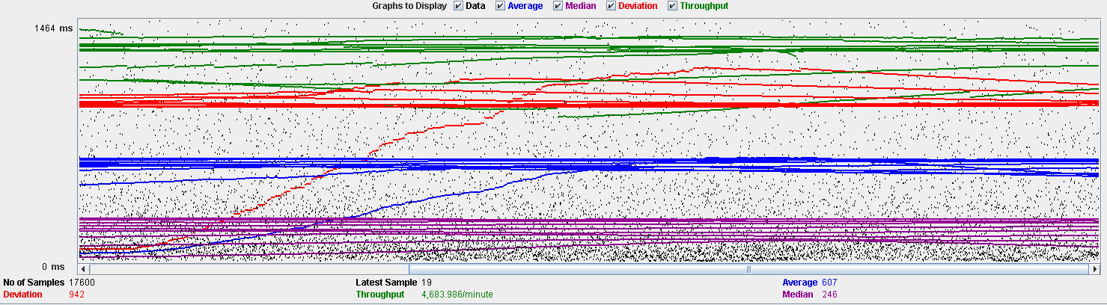

Performance Results:

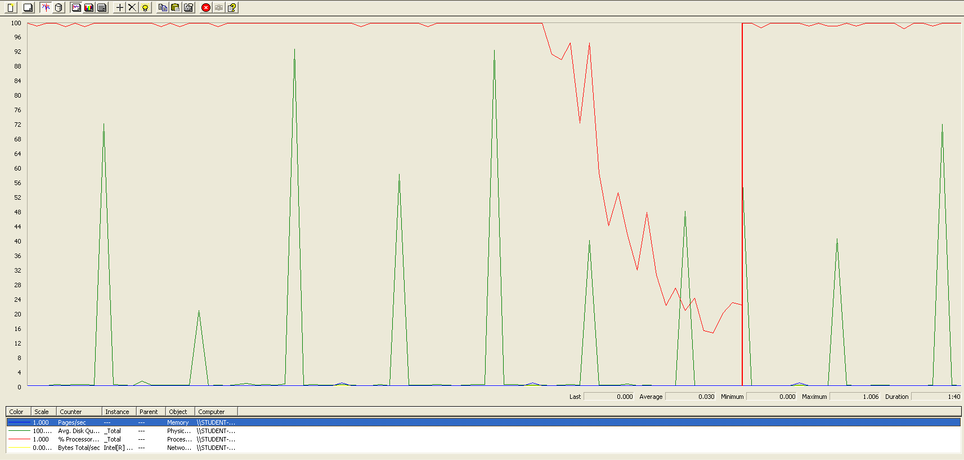

The CPU was always at its limit while the disk usage showed many peaks.

## Delete

Sequence:



Aggregate Report:

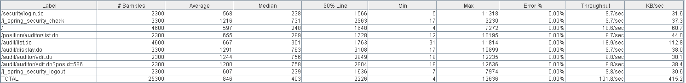



Thread properties:

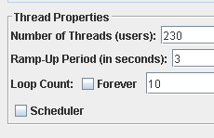

Graph Results:

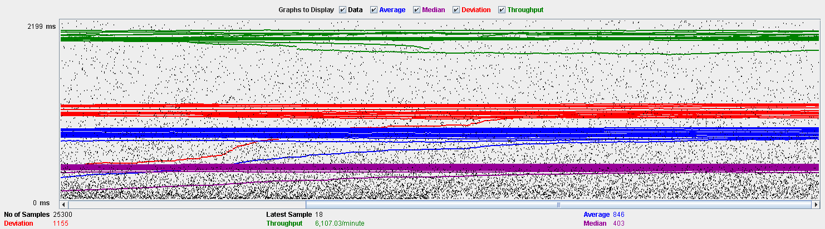

Performance Results:

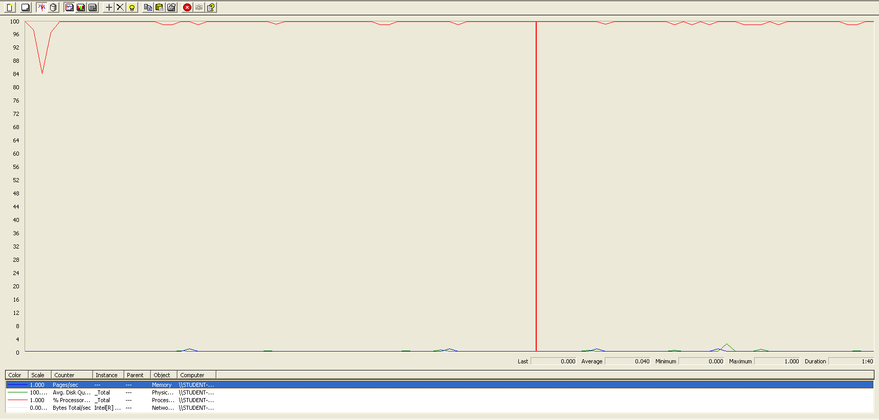

The CPU was always at its limit.

## Conclusion

The test was performed using:

CPU: i7 6700hq (2 cores in the virtual machine)

RAM: 4 GB (virtual machine)

For this use case we can say that the limitation occurs during the assign process, being the maximum of concurrent users 150.

# Sponsorship

## Create

Sequence:

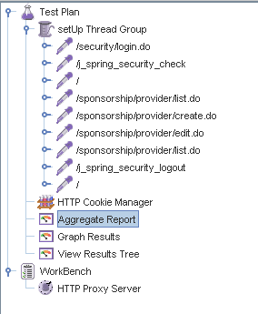

Aggregate Report:

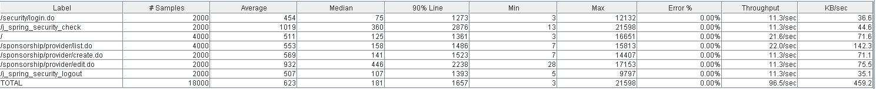



Thread properties:

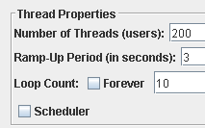

Graph Results:

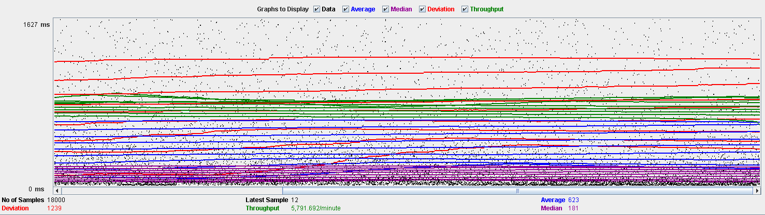

Performance Results:

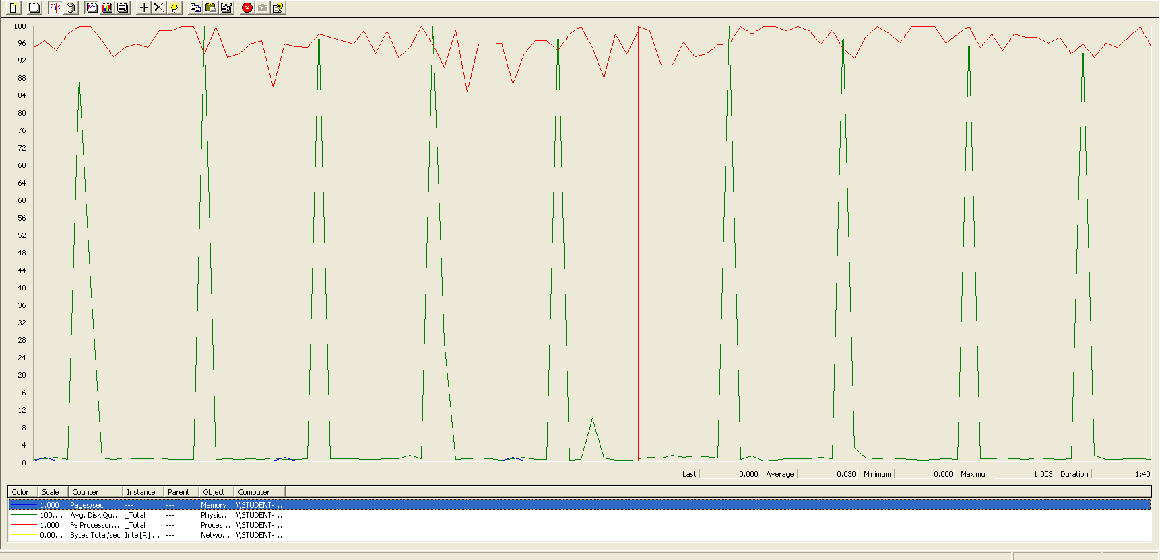

The CPU was always at its limit while the disk usage showed many peaks.

## Edit

Sequence:

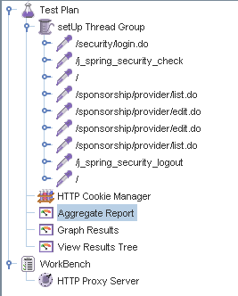

Aggregate Report:





Thread properties:

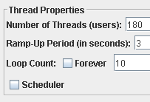

Graph Results:

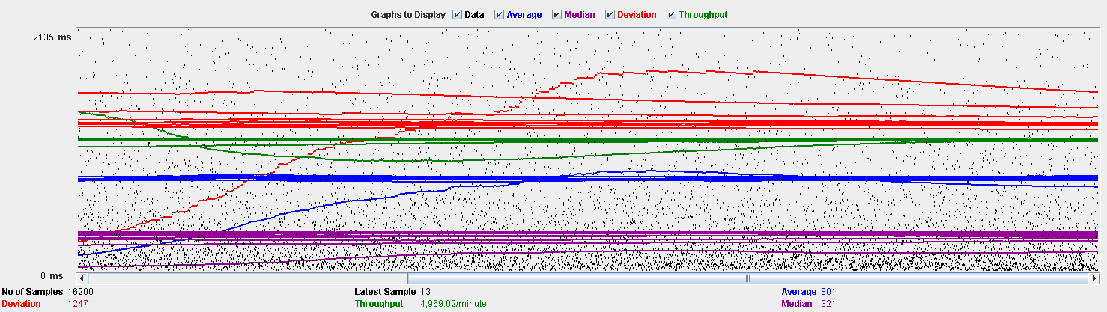

Performance Results:

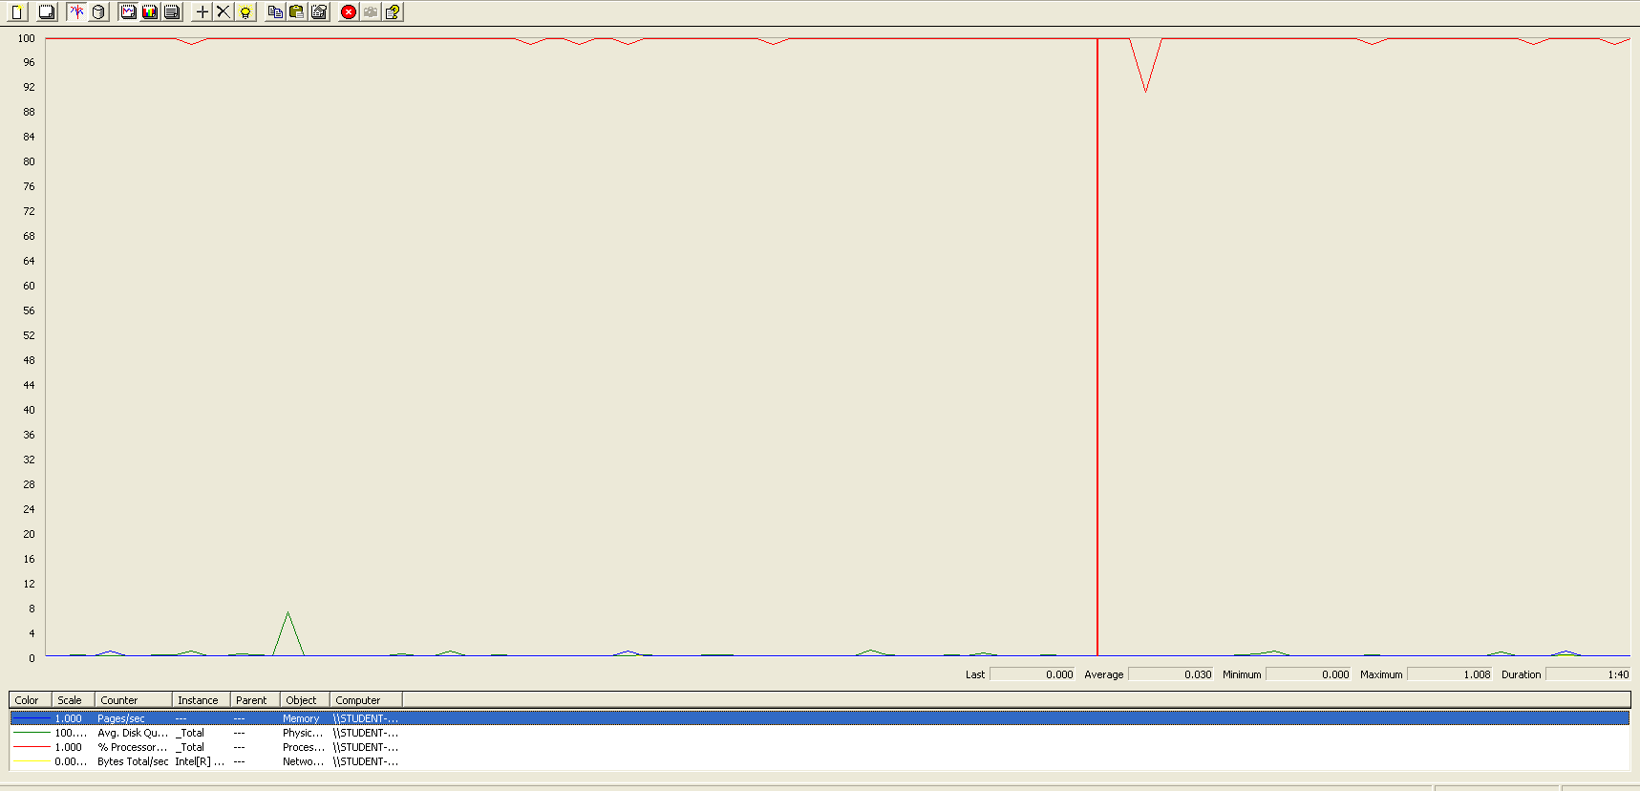

The CPU was always at its limit.

## Delete

Sequence:

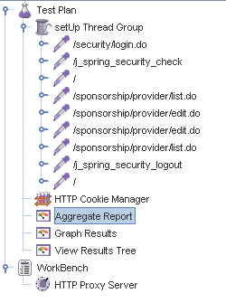

Aggregate Report:





Thread properties:

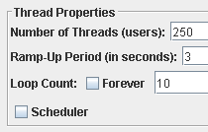

Graph Results:

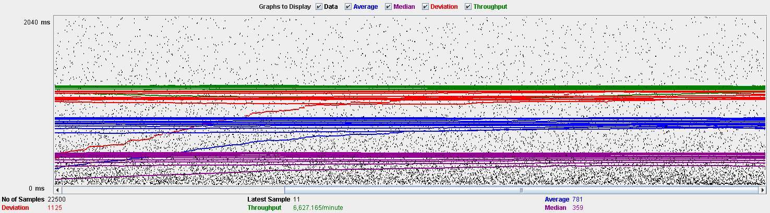

Performance Results:

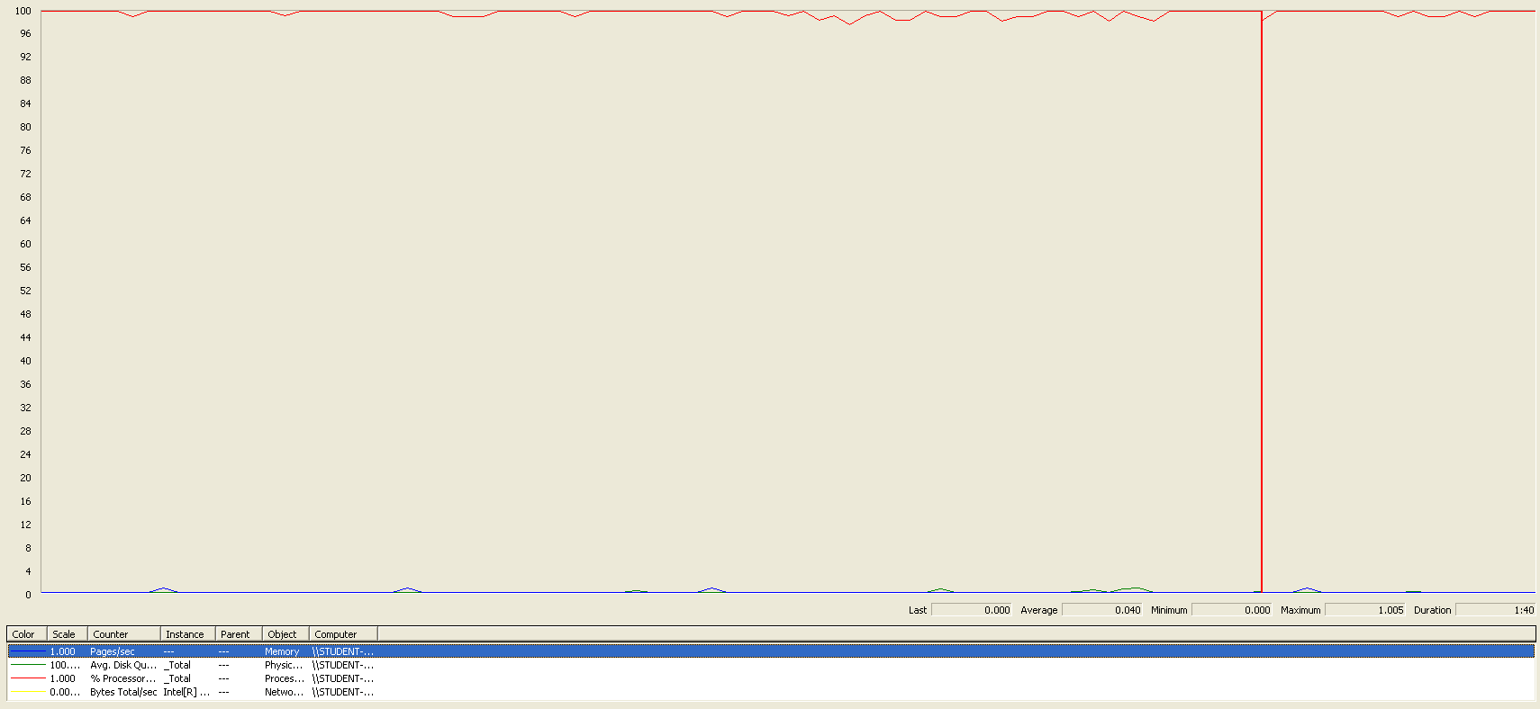

The CPU was always at its limit.

## Conclusion

The test was performed using:

CPU: i7 6700hq (2 cores in the virtual machine)

RAM: 4 GB (virtual machine)

For this use case we can say that the limitation occurs during the edit process, being the maximum of concurrent users 180.

# Item

## Create

Sequence:

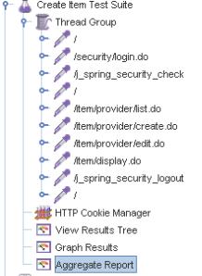

Aggregate Report:

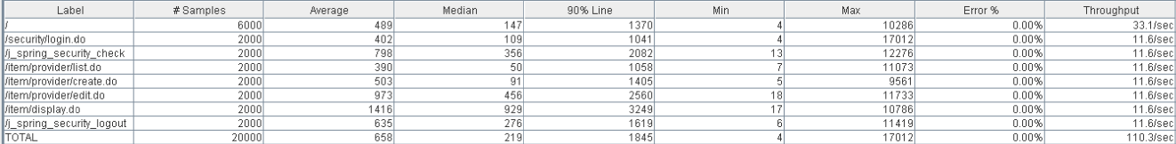

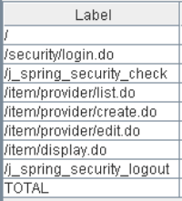 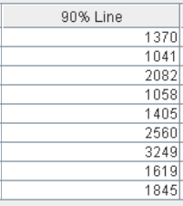 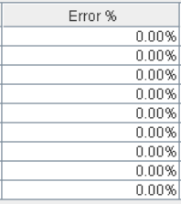

Thread properties:



Graph Results:

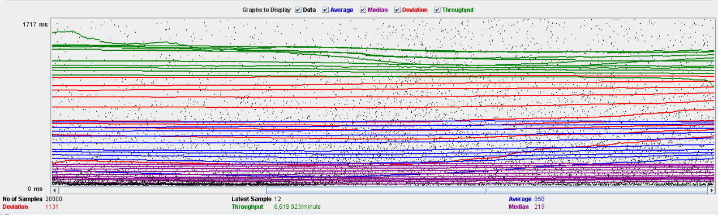

Performance Results:

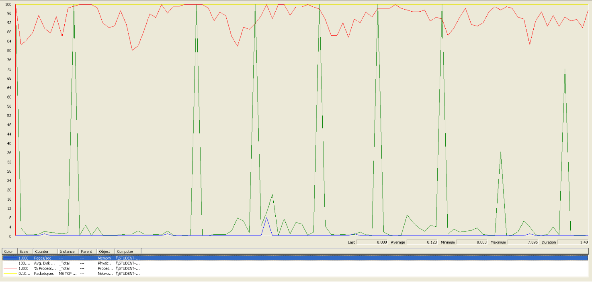

The CPU was always at its limit while the disk usage has some peaks.

## Edit

Sequence:

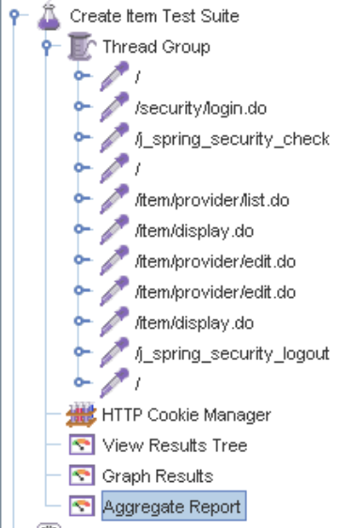

Aggregate Report:

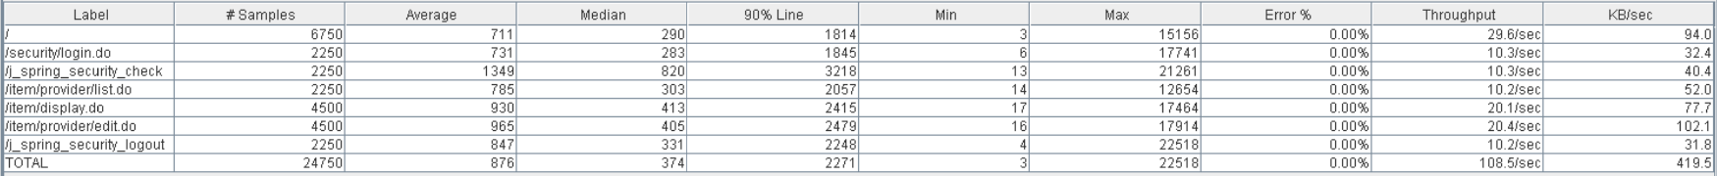

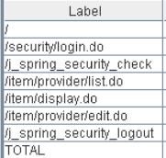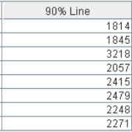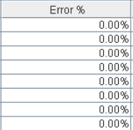

Thread properties:



Graph Results:

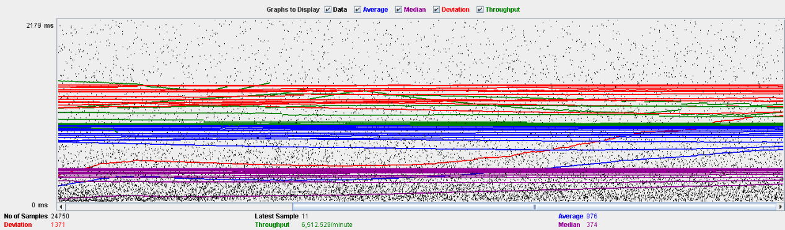

Performance Results:

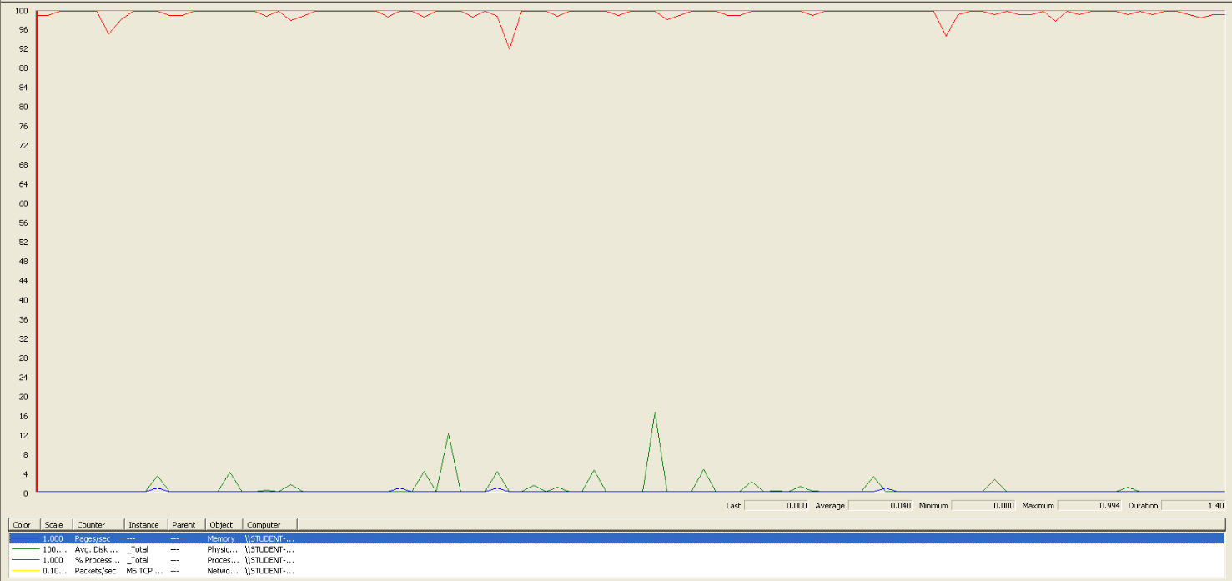

Again we can see that the CPU is always being used, is the problem in this use case.

## Delete

Sequence:

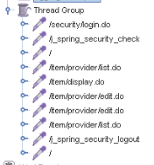

Aggregate Report:

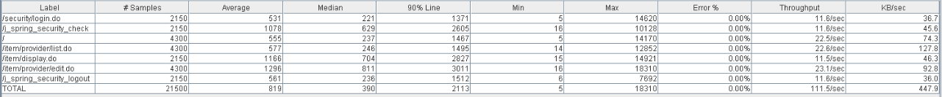

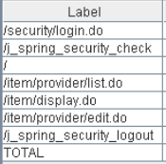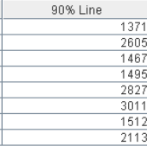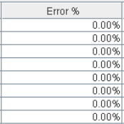

Thread properties:



Graph Results:

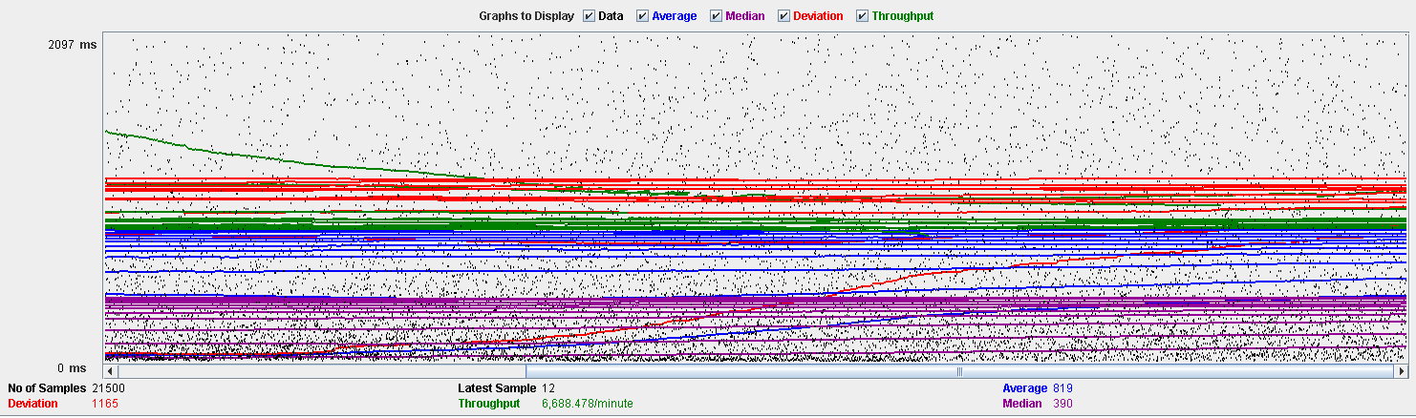

Performance Results:

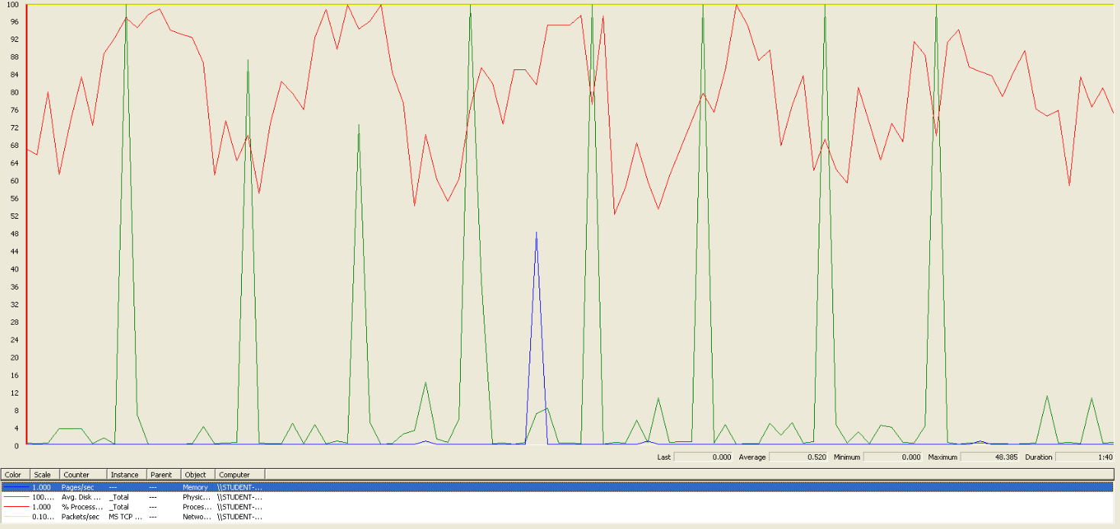

Again we can see that the CPU is always being used while the disk usage has different peaks.

## Conclusion

The test was performed using:

CPU: i5 7300hq (2 cores in the virtual machine)

RAM: 2 GB (virtual machine)

For this use case we can say that the limitation occurs during the creation process, being the maximum of concurrent users 190.

# Conclusion of the performance

As we can see in the tests above, the limitations of our system are in the message system, specially in the method of broadcasting a message (14 concurrent users). We think that this may be a bit unrealistic, because in a real environment won’t be many administrators sending multiple notifications. Due that, we consider that the limit of concurrent users for our system is 45 (sending a message).